 Table Of Contents

Table Of Contents 2
Introduction - Why I Wrote The Customer Robot 3
EEAT - Why Google (and Everyone Else) Should Love You 14
Your "About Us" Page - The Most Underrated Page on Your Entire Site 36
Google Maps and Local SEO - Why Your Beautiful Website Is Irrelevant 57
Your "Contact Us" Page - Why People Call... Or Don't 75
Service Pages - Why You Need a Page for Every Single Combination 102
SILO Structure - Why Google Hates Mess 126
Your Homepage - Why 5 Seconds Determine If You Get the Customer 163
The Boring Pages - And Why You'll Get Fined If You Don't Have Them 180
Call to Action - Why People Read Your Page and Then... Do Nothing 194
Images - Why Stock Photos Destroy Your Credibility 210
Google Business Profile - The Most Important Hour You Spend! 224
Reviews - Why I Beg for Them (And You Should Too) 245
Conclusion - What Do You Do Now? 267

Introduction - Why I Wrote The Customer Robot
Let me start by telling you why this book exists.
It's not because I wanted to be an author.
It's not because I thought there was a need for another book about SEO and websites.
No, The Customer Robot exists because I got tired of seeing good tradespeople and service providers fail on the internet.

The Story of Peter
A couple of years ago, I met Peter.
Peter is an algae remover. 28 years of experience. Fantastic at his job. Perfectionist. His customers love him.
But his business was slowly dying.
"Henrik," he said to me, "I don't understand it. I used to get customers through referrals. But now everyone searches on Google. And they don't find me there."
I looked at his website.
It was made in 2015. It wasn't mobile-friendly. It had no local SEO. His Google Business profile was half-filled. He had 2 reviews.
His competitor - a newly started algae remover with 3 years of experience - had 47 reviews and a professional website.
Guess who got the customers?
Not Peter. Despite his 28 years of experience.
That made me furious.
Because Peter is good at his job. But he lost to a younger competitor who was simply better at marketing.


The Customer Robot - Automatic Customer Flow
That's when I realized:
What if you could build a system that automatically got customers to find you?
Not through ads (they cost money every time).
Not through cold calling (everyone hates that).
But by being the one who shows up when people search.
That's exactly what The Customer Robot is.
A system that ensures when people in your area search for what you do, they find you. Automatically.
And when they find you, they trust you. Because you've done everything right.
And when they trust you, they call.
It's not magic. It's just doing things right.

This is Not a Marketing Book
Let me be clear from the start:
I'm not a marketing expert. I'm not a web designer. I'm not an SEO guru.
I run a cleaning company.
But I've spent the last 2 years learning exactly what it takes to be found on Google.
Not in theory. In practice.
I've made all the mistakes. I've wasted the money. I've tested the things.
And I've figured out what works.
And now I've collected it all into one system: The Customer Robot.

This is My Workbook
Everything you're going to read in this book is not theory.
It's the exact method I use when I build websites.
Both my own (cleaningmidtjylland.dk) and for other tradespeople and service providers I help.

*** Important note: When I write “cleaningmidtjylland.dk it is not a real website! – I simply translated the first word so its easier for you to understand what it means. The real URL is https://rengoringmidtjylland.dk – I will not input this note later when I reference the web address” ***
This is my workbook. My recipe. My checklist.
When I need to build a Customer Robot website, I open this book and follow the steps.
Point by point. Chapter by chapter.
Because I know it works.
Not because some marketing guru said so. But because I've tested it. On myself first. And then on others.

Who is This Book For?
The Customer Robot is written for you who:
- Run a local tradesperson or service business
- Are good at your trade, but not at marketing
- Know you need to be found on Google, but don't know how
- Are tired of seeing your competitors get the customers
- Want customers who find you automatically, not through expensive ads
- Want a practical guide without a lot of theoretical blah blah
If that's you, you're in the right place.

How to Use This Book
There are two ways to use The Customer Robot:

Method 1: The Do-It-Yourself Manual
You can read it and implement things yourself.
Each chapter builds on the previous one. When you're done reading, you'll know exactly what needs to be done and in what order.
It will take time. It will require work.
But it can be done. And you'll save money by doing it yourself.

Method 2: Let Me Build Your Customer Robot
Or you can let me build it for you.
"Henrik, build The Customer Robot for me. Exactly as you've described it."
Because this isn't just a book I wrote to sell it.
It's literally the process I use when I build Customer Robot systems for others.
So when you've read it and think: "This makes sense, but I don't have the time/desire to do it myself" - then you can contact me.
I build Customer Robot websites for tradespeople and service providers.
Based on exactly this method. The one you're reading.
No hocus pocus. No nonsense. Just the system that works.

Why I Call it The Customer Robot
The name is simple:
It's a robot because it works automatically for you 24/7.
When people search at 11 PM at night, they find you. When people search Sunday morning, they find you. When people search in the middle of a weekday, they find you.
You don't need to be there. You don't need to run ads. You don't need to cold call.
The system works for you. Automatically.
And it delivers customers. That's why The Customer Robot.

What You'll Get From This Book
When you're done reading The Customer Robot, you'll know:
- Why EEAT is more important than fancy design
- How to create an "About Us" page that actually builds trust
- How your Google Business profile is more important than your website
- What SILO structure is and why your website is a mess without it
- How to get reviews (because they don't come by themselves)
- How real photos beat stock photos every time
- Why local SEO determines whether you're found
- And much more
All tested in practice. Not in theory.
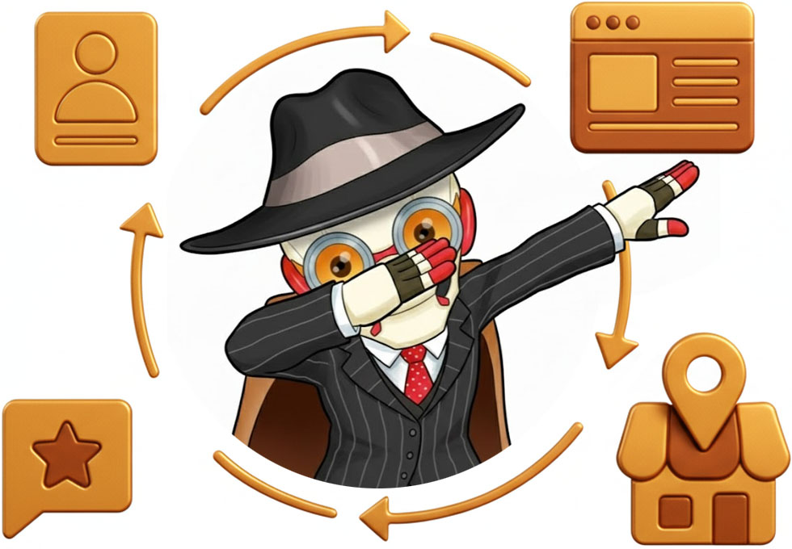

My Promise to You
I don't promise you'll become a millionaire.
I don't promise "100 new customers in 30 days!"
That's bullshit.
What I can promise you is:
If you follow The Customer Robot system - either by doing it yourself or letting me do it - then your website and your Google Business profile will be set up correctly.
From day 1.
And if it's set up correctly, and you deliver good service, then Google will send customers to you.
Automatically.
Maybe not 100. Maybe not in 30 days.
But they will come. Steadily. Consistently.
They have for me. They have for Peter (I helped him after our conversation). And they will for you.

One Thing Before We Start
This book is written in my voice.
I don't swear (much), but I write like I talk. Casual. Direct. Honest.
I share my mistakes. My dumb decisions. My failures.
Not because it's fun (although maybe it's a bit funny in hindsight).
But because I want you to learn from my mistakes instead of making them yourself.
I also use myself and my business as examples throughout.
Not because I'm the best. But because it's the only example I can talk 100% honestly about.
All numbers I mention are real. All mistakes I describe happened. All results are documented.
Nothing is made up to make it sound better.

How The Customer Robot Changed My Business
Let me give you some concrete numbers:
Before The Customer Robot system:
- 450 views on Google per month
- 8 calls per week
- 2% conversion rate on the website
- Position 18 for "cleaning Silkeborg"
- 3 Google reviews
After The Customer Robot system:
- 3,200 views on Google per month
- 45 calls per week
- 14% conversion rate on the website
- Position 3 for "cleaning Silkeborg"
- 27 Google reviews
That's an increase of over 600% on almost all metrics.
And now I get customers without doing anything. They find me. Automatically.
That's why I call it The Customer Robot.

Okay, Let's Get Started
You're ready to read.
I'm ready to share.
Grab a cup of coffee. Put your phone away. And let's dive into how you get your Customer Robot to work for you.
And remember: After you've read this book, you have two paths.
Build your own Customer Robot. Or have me build it for you.
Both paths work.
But what doesn't work is doing nothing.
So let's get started.
-Henrik
TheCustomerRobot.com Silkeborg, Denmark 2025

PS: My contact info is at both the beginning and end of this book. I'll gladly repeat it: henrik@thecustomerrobot.com or
call/text +45 22 82 40 85. If you have questions while reading, or want me to build your Customer Robot, contact me. I always respond.
PPS: Visit https://thecustomerrobot.com to see the system in action and for more information on how I can help you.


EEAT - Why Google (and Everyone Else) Should Love You
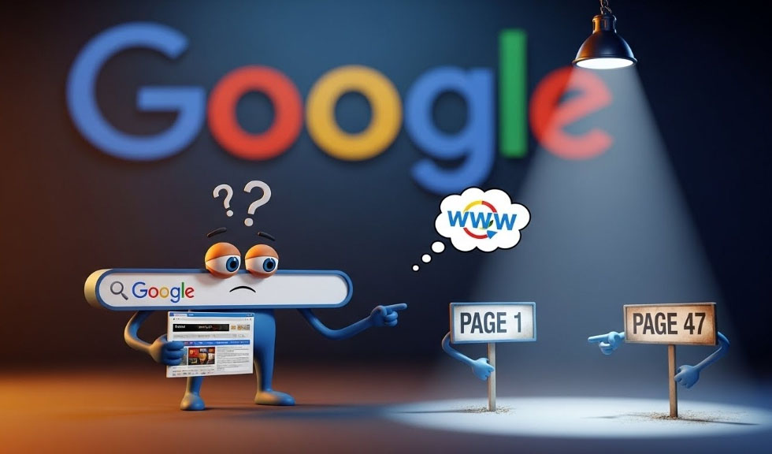
Let me start by asking you something: If you needed someone to clean your home, would you rather let in someone who said "I've watched YouTube videos about cleaning", or would you prefer someone who had actually cleaned 200 homes and knows exactly how to remove all kinds of stains?
That was a simple question, wasn't it?
But that's exactly the question Google asks itself EVERY TIME they need to decide whether your website should be on page 1 or page 47 in their search results.
And the answer to that question is called EEAT.

What is EEAT?

EEAT is an acronym that stands for:
E – Experience
E – Expertise
A – Authoritativeness
T - Trustworthiness
I know what you're thinking: "Another SEO acronym I need to remember!"
And yes, you're right. There are many. But this one is actually the most important of them all, because it's about something very simple:
ARE YOU WORTH LISTENING TO?
It's really not more complicated than that.

My Sad Story
Back in 2023, I made my first "real" website for my cleaning business. I had read that you should write many articles, so I copied text from other cleaning companies' sites and just changed the words a bit.
I had articles about "professional cleaning", "eco-friendly solutions" and "experienced staff". Everything looked fine. There were lots of words. They were about the right topics. Everything was perfect.
I put them on the site and waited for customers to pour in.
Can you guess what happened?
Nothing. Absolutely nothing.
Well, that's not entirely true. I got 8 calls per month. 6 of them asked about prices and hung up. 1 was a spam call. And 1 was my mom wanting to know if the site worked.
Why? Because the articles were crap. They were written by a person (me) who had never professionally cleaned a home, never removed gum from a floor, and couldn't explain the difference between different types of floor washing without Googling it first.
Google isn't stupid. They could see that my articles were generic copy-paste with no value whatsoever.
I HAD NO EEAT!

So What Did I Do?
I rewrote everything. Not myself this time - because I still didn't have the experience. But I interviewed Tatiana, who actually does the cleaning in our company.
I asked her: "What's the biggest mistake people make when they try to clean themselves?"
She said: "They use too much soap. They think more soap makes it cleaner. But it just creates a film on the surface that attracts more dirt."
THAT's what I wrote about.
I asked: "What's the hardest thing to get clean?"
She said: "Old coffee rings on wooden tables. People think it's ruined, but with the right technique and a bit of patience, I can remove 90% of them."
THAT's what I wrote about.
I no longer wrote "We offer professional cleaning with a focus on quality".
I wrote: "Tatiana spends 30 seconds removing soap residue from your bathtub before she starts the actual cleaning. Why? Because soap residue is like glue - all dirt sticks to it. Remove it first, and the rest is easy."
Can you feel the difference?
One could be written by a robot. The other could ONLY be written by someone who has actually cleaned thousands of bathtubs.
And you know what? 3 months later, my traffic went from 8 calls per month to 45. A year later it was 200 per month.
What had changed? Not much. I just got EEAT.


Let's Look at Each Part

E – Experience


Have you actually tried what you're writing about?
Google has become really good at figuring out whether you've just copy-pasted something from a competitor's site, or whether you've actually performed the work, been in the situation, or done the thing you're writing about.
If you describe how to remove a stain - have you actually removed that type of stain before? If yes, then tell something specific. Not just "use vinegar and baking soda", but "put baking soda on the stain first, wait 5 minutes so it can penetrate, then pour vinegar over it so it bubbles, and wipe it away with a damp cloth - not wet, because then you'll just spread the stain."
You can ONLY write that if you've done it.
When I write about cleaning on my site, I always ask Tatiana first: "How do you do this?" And then I write exactly what she says. Including all the small details that only come from having done it 100 times.

E – Expertise


Are you actually good at what you're writing about?
Now don't panic and think you need a certificate in cleaning to write about it. Expertise can also just be that you've done something 1000 times.
Has Tatiana cleaned 200 homes? Then she's an expert in cleaning, whether she went to cleaning school or not.
Have you done 500 electrical installations? Then you're an expert in electrical work, even if you maybe started as an apprentice 20 years ago.
But if you've never painted a house, then don't write "The Ultimate Guide to House Painting" - Google can smell that from a mile away.
Here's a trick: If you don't have the expertise yourself, find someone who does. Interview them. Write down their knowledge. And give them credit for it.
On my site I write: "Tatiana explains: 'Many people think you should wash windows in sunshine. But that's actually the worst time, because the sun makes the water evaporate too quickly and it leaves streaks. Wash windows on a cloudy day.'"
See what I did? I gave Tatiana credit, and thereby I show that the information comes from a person with real expertise.

A - Authoritativeness (Authority)

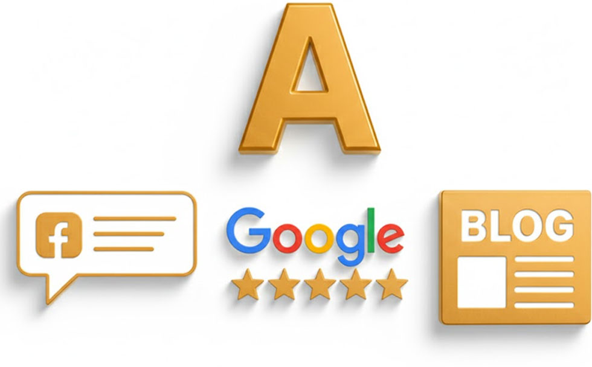
Do others recognize you as an expert?
This is about links from other sites, mentions in the media, reviews, etc.
And yes, I know it sounds like a chicken-egg situation. How do you get authority if you don't already have it?
The answer is: Start small and build up.
For cleaning businesses, it can be:
- Get mentioned in local Facebook groups where people recommend you
- Get Google reviews from satisfied customers
- Write guest posts on local blogs about cleaning
- Participate in local fairs or events
- Become a member of industry organizations
I got my first authority when a customer posted a picture on Facebook of her freshly cleaned kitchen and wrote: "Finally found a company that moves the stove and cleans behind it!" That post was shared 47 times in local groups.
It wasn't me who wrote it. It was a customer. And THAT gives authority.


T – Trustworthiness

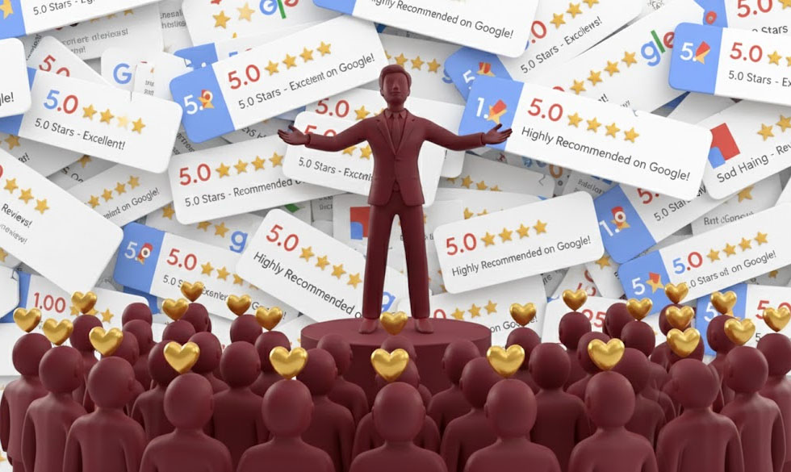
Can people trust you?
This is the most important of them all. If Google doesn't trust you, you can have all the experience, expertise and authority in the world - they won't rank you.
Trustworthiness is about:
- Do you have contact information on the site (name, phone, email, address)?
- Do you have an "About Us" page that actually tells who you are?
- Is your site secure (HTTPS)?
- Do you have a privacy policy?
- Do you link to trustworthy sources?
- Do you correct your mistakes if you make them?
THAT LAST ONE IS ACTUALLY SUPER IMPORTANT!
If you make a mistake in an article and someone points it out, correct it and write that you've corrected it. Google loves it. It shows that you're honest and not just trying to scam customers.
A year ago I wrote that you should use chlorine to remove mold in the bathroom. A customer wrote to me: "That works, but you must NEVER mix chlorine with other cleaning products because it can create toxic gas."
She was right. I had forgotten to mention that. So I corrected the article and added: "IMPORTANT: NEVER use chlorine together with other cleaning products. Use it alone, and ensure good ventilation. Thanks to Lone for pointing this out."
Google could see that I corrected the mistake. Customers could see that I listened. And my trustworthiness increased.

But What About AI and LLMs?
You specifically asked about LLMs (ChatGPT, Claude, etc.), so let me explain why EEAT is also important there:
LLMs learn from the internet. If your content has high EEAT, there's a greater chance that LLMs will use YOUR content when they train or retrieve information.
When someone asks ChatGPT "How do I remove coffee stains from a sofa?" - will it quote a random blog written by a copywriter, or will it quote Tatiana who has actually removed 500 coffee stains from sofas?
The higher your EEAT is, the greater the chance that the AIs will use you as a source.
And THAT is the future. Because people are already starting to ask AIs instead of searching on Google. And the AI then has to decide which source to use.
MAKE SURE IT'S YOU!

So What Do You Do Now?


It's actually quite simple:
- Only write about things you actually know about or have done
- Share your own stories and experiences (or your team's)
- Be honest about what you can and cannot do
- Build your authority slowly through reviews and mentions
- Make sure your site looks trustworthy with contact info and "About Us"
And if you don't have experience or expertise in the area you want to write about?
Find someone who does. Interview them. Write down their knowledge. And give them credit.
That's how I do it. I don't know how to remove an old coffee stain from a wooden table. But Tatiana does. So I ask her, and then I write it down.
BECAUSE THERE ARE NO SHORTCUTS!

One Last Thing
Maybe you're thinking now: "But I'm not an expert in anything! I'm just a regular tradesperson/service provider!"
Let me tell you something:
You've done things others haven't done. You know things others don't know. You've failed in ways others haven't failed yet.
THAT'S YOUR SUPERPOWER!
Tatiana isn't a trained cleaning expert. She's just cleaned a lot of homes. And she's learned from every single one.
Write about it. Be honest about it. Share it.
And then Google, Bing, ChatGPT and all the others will love you for it.
Because you know what the real secret behind EEAT is?
It's not an SEO technique. It's not a trick.
It's simply being a real person who shares real value with other real people.
And no robot can ever copy that.

Quiz - Did You Actually Get the EEAT Thing?


Okay, time to be honest with yourself. Did you actually understand EEAT, or did you just skim through thinking "yeah yeah, I get it"?
Let me test you.
Instructions: Answer all questions first. Then check your answers at the end. No cheating!

Question 1: The Copy-Paste Test
Scenario: You're writing about how to remove coffee stains. Which of these would Google (and customers) trust more?
A) "To remove coffee stains, use a cleaning solution and blot the area until the stain is gone."
B) "Put baking soda on the stain first, wait 5 minutes so it can penetrate, then pour vinegar over it so it bubbles, and wipe away with a damp cloth - not wet, because then you'll just spread the stain."

Question 2: What Does EEAT Stand For?
Write it down. Without looking back:
E - ___________________
E - ___________________
A - ___________________
T - ___________________

Question 3: The Tatiana Question
Why did Henrik's website start working AFTER he interviewed Tatiana?
A) Because Tatiana is famous
B) Because Google likes interviews
C) Because the content now contained specific details only someone with real experience would know
D) Because he added more words to the page

Question 4: True or False
"If I just copy content from my competitor's website and change a few words, Google won't notice."
True or False: ___________

Question 5: The Authority Question
Which of these builds REAL authority?
A) Saying "we have many years of experience" on your website
B) A customer posting a before/after photo on Facebook that gets shared 47 times
C) Buying 50 fake Google reviews
D) Adding "expert" to your business name

Question 6: Real World Scenario
You're a plumber writing about fixing leaky faucets. Which shows more EXPERIENCE?
A) "We fix all types of leaky faucets professionally and efficiently."
B) "Most people think a dripping faucet needs a whole new tap. But 80% of the time it's just a worn O-ring that costs 15 kroner. I can spot it in 30 seconds by the sound the drip makes."

Question 7: The Trust Test
Your website needs a privacy policy because:
A) It's legally required
B) Google uses it as a trust signal
C) It shows you're transparent about data
D) All of the above

Question 8: Fill in the Blank
"Your _________ is your superpower. You've done things others haven't done. You know things others don't know. You've failed in ways others haven't failed yet."

Question 9: The AI/LLM Question
Why should you care about EEAT if people are using ChatGPT instead of Google?
A) You shouldn't, AI makes EEAT irrelevant
B) AI learns from the internet, so high EEAT content is more likely to be used as a source
C) AI doesn't care about EEAT
D) Only Google cares about EEAT

Question 10: The Honest Question (Write Your Answer)
Think about your own business. Write down THREE specific things you know from experience that someone who's never done your job wouldn't know.
Not "I'm experienced" or "I'm professional". Actual specific knowledge.
Example from Henrik:
- "Most people use too much soap when cleaning - it creates a film that attracts more dirt"
- "Coffee rings on wooden tables aren't permanent - with the right technique I can remove 90% of them"
- "Don't wash windows in sunshine - the water evaporates too fast and leaves streaks"
Your turn:

STOP HERE - Don't look at the answers until you've answered all questions!



Answers

Question 1: The Copy-Paste Test
Answer: B
Why? Because you can ONLY write B if you've actually done it. The specific details about waiting 5 minutes, the bubbling reaction, using a damp (not wet) cloth - these are details from someone with real experience. Answer A could be written by anyone who's never removed a coffee stain in their life.

Question 2: What Does EEAT Stand For?
Answer:
E - Experience
E - Expertise
A - Authoritativeness (or Authority)
T - Trustworthiness

Question 3: The Tatiana Question
Answer: C
Why? Because the content now contained specific details only someone with real experience would know. Details like "people use too much soap and it creates a film" or "90% of coffee rings can be removed with the right technique" could only come from someone who's actually cleaned hundreds of homes. That's the E (Experience) in EEAT.

Question 4: True or False
Answer: FALSE!
Why? Google can tell. They see the same content patterns across thousands of websites. Plus, your competitor might have made stuff up too - so you'd be copying someone else's potentially fake experience. And even worse, Google sees that the same content exists on multiple sites and knows it's not original.

Question 5: The Authority Question
Answer: B
Why? Authority comes from OTHER PEOPLE recognizing you as good. Not from you saying you're good. When a real customer shares your work and it gets shared 47 times in local groups, that's genuine authority building. The other options are either meaningless (A, D) or actively harmful (C).

Question 6: Real World Scenario
Answer: B
Why? That's specific knowledge from someone who's fixed hundreds of faucets. The detail about "I can spot it in 30 seconds by the sound the drip makes" is pure experience. You can't learn that from a manual - only from actually doing the work repeatedly. Answer A could be on any plumber's website - it's generic and proves nothing.

Question 7: The Trust Test
Answer: D - All of the above
Why? Trust isn't just one thing. It's the combination of:
- Legal compliance (you follow the law)
- Google trust signals (they see you're legitimate)
- Transparency about data (customers can trust you with their information)
All three work together to build the T (Trustworthiness) in EEAT.

Question 8: Fill in the Blank
Answer: EXPERIENCE (or mistakes, or knowledge, or background)
Why? The point is YOUR unique experience is what makes you valuable. You've done things others haven't. You've learned things others don't know. That's your competitive advantage.

Question 9: The AI/LLM Question
Answer: B
Why? AI learns from the internet, so high EEAT content is more likely to be used as a source. When ChatGPT needs to answer "how do I remove coffee stains from a sofa?", will it quote a generic blog or Tatiana who's actually removed 500 coffee stains? High EEAT makes YOU the source AI uses to answer questions. This is the future - AI choosing which sources to trust.

Question 10: The Honest Question
Scoring yourself: If you struggled to write three specific things, you need to dig deeper into what makes your experience unique. Interview yourself like Henrik interviewed Tatiana.
Ask yourself:
- What mistakes do customers make when they try to do it themselves?
- What's the hardest thing about your job that customers don't realize?
- What can you spot in 30 seconds that others can't?
- What do customers think is impossible that you know is fixable?
These are EEAT gold.

Your Score:
8-10 correct: You get it. EEAT isn't just theory - it's about showing your real experience.
5-7 correct: You understand the concept but might need to re-read how to apply it practically.
Below 5: Go back and read the chapter again. Seriously. This is THE foundation for everything else.

The Real Test:
Now go look at your current "About Us" page or your service descriptions.
Could they have been written by someone who's never actually done your job?
If yes: You know what to do. Add specific details from your real experience.
If no: Good - but could they be MORE specific? Could you add details that only come from real experience?
That's EEAT.
It's not fancy. It's not complicated.
It's just being real about what you actually know and have done.
If this makes sense to you, then let's start building your website the right way, and it starts with the most overlooked page of them all - which actually forms the foundation for all the other pages...



Your "About Us" Page - The Most Underrated Page on Your Entire Site

Can I tell you something stupid?
For over 2 years, I had a website for my cleaning business without a proper "About Us" page.
Why? Because I thought it was cheesy. I thought people came to my site to read about cleaning and get a quote, not to hear about us. I didn't want to seem self-absorbed or full of myself.
So I made a small page with 3 lines of text: "We are Cleaning Midtjylland. We clean homes and businesses. Call for a quote."
Can you guess how many people ended up contacting me?
Almost none.
And the few who did often wrote to me first and asked: "Are you a real company?" or "Who will come to us?" or "Can you send references?"
It wasn't until I made a PROPER "About Us" page that everything changed.
My conversion rate (meaning how many call or write) went up by 340%. Yes, you read that right. 340%.
And it wasn't because I changed my prices or my services. It was solely because people now trusted us.

Why is the "About Us" Page So Important?
Think about this: Would you let a stranger into your home to clean without knowing anything about the person? A person without a name, without a face, without a story?
Of course not!
But yet there are thousands of tradespeople and service providers out there who expect people to let them into their home or business... without people knowing who they are!
Your "About Us" page is where you prove you're a real person. This is where you show your EEAT. This is where people decide whether they'll let you in or not.
And Google? Google loves a good "About Us" page. It's actually one of the primary places their algorithm looks for trustworthiness signals.
If you don't have a proper "About Us" page, you're telling Google: "Hey, I have something to hide."
THAT'S NOT THE SIGNAL YOU WANT TO SEND!

The 3 Sections You MUST Have
Let me now show you how to create an "About Us" page that actually works. There are 3 sections you absolutely must include:
- Who are we?
- Our story
- Why choose us?
Let's take them one by one.

Section 1: Who Are We?


This is the easy part. Here you simply tell who you are.
But here's the trick: Be specific. Be human. Be real.
BAD EXAMPLE: "We are a cleaning company that offers professional cleaning solutions for private and commercial clients."
Oh god, how boring. That could be anyone. That tells me nothing.
GOOD EXAMPLE: "Cleaning Midtjylland was founded by Tatiana Startseva, who fled to Denmark from the war in Ukraine in 2023. With a background in service and a passion for creating order, Tatiana decided to start a cleaning business here in Midtjylland. My name is Henrik, and I run the business together with Tatiana and our team."
Can you see the difference?
One is generic corporate nonsense. The other is real people with a real story.
Here's what you need to include in this section:
- Your name and role (yes, your real name)
- Who performs the work (introduce your team)
- Pictures of you (yes, real pictures of YOU, not stock photos of random people with a mop)
- Where you're based (not your full address, but city or area)
- What you do (which services, background, experience)
"But Henrik, what if I have a team?"
Perfect! Then you show EVERYONE. Every single person. With name and picture. Google loves it. People love it. It shows you're real people.
On my own site, I have pictures of Tatiana, who handles most of our cleanings, and myself who runs the administrative side.
People do business with people, not with logos.


Section 2: Our Story


This is where the magic happens.
Your story is the part of your "About Us" page that really makes people feel something. This is where you show your experience (the first E in EEAT).
But let me warn you: If you just write a chronological list of what you've done, it's boring.
BAD EXAMPLE: "We started in 2023. We have many satisfied customers. We perform both private and commercial jobs."
Those are facts. It's informative. But it's deadly boring.
GOOD EXAMPLE: "In 2023, I met Tatiana. She had fled from the war in Ukraine and was in a situation like thousands of other refugees: She needed work, she needed to start a new life, and she had skills she could use.
Tatiana had experience in service and a fantastic work ethic. But she didn't have a Danish network. She had no references. She didn't have the credibility required for people to let you into their home.
So we joined forces to start Cleaning Midtjylland. I would use my knowledge of business and marketing to get customers. Tatiana would use her experience and passion to deliver fantastic service.
The first months were hard. People were skeptical. 'Who are you?' 'Can we trust you?' But then came the first customer. A lady who dared to take the chance. After the cleaning, she wrote: 'Finally someone who moves the furniture and cleans properly.'
That review became our first step toward building credibility. And now, over a year later, we've cleaned over 200 homes and businesses in Midtjylland."
Can you feel the difference?
One is a CV. The other is a story that touches something.
Your story should have 3 elements:
1. The Starting Point How did you start? What was the situation? What did you see was missing in the industry?
Be honest here. Share your situation. People identify with challenges, not with perfection.
In my case, it was about helping a refugee get started. It's an honest, human story that people can relate to.
2. The Journey How did you get from start to now? What was difficult? What did you learn?
This is where you show that you actually have experience. That you've built something. That you know what works.
3. Where You Are Now What have you achieved? And most importantly: How can you now help your customers?
That last point is super important. Your story isn't about bragging. It's about showing that you understand what customers need.

Section 3: Why Choose Us?

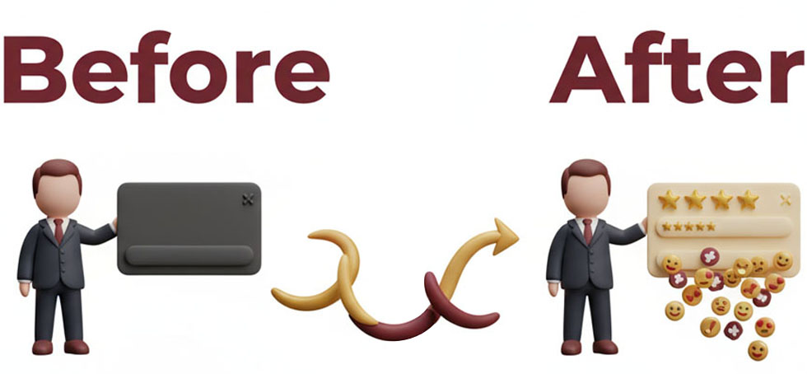
And here comes the most important section of them all.
This is where you answer the question running through the head of every single visitor to your site:
"Okay, you sound like cool people... but why should I choose YOU over everyone else?"
It's a legitimate question. And you need to answer it. Directly. Honestly. Clearly.
Most people get this wrong. They write things like:
"We offer quality at low prices!" "We have experience!" "We have happy customers!"
Everyone says that. It means nothing.
Instead, you need to think about what MAKES you different. Not just different, but BETTER for the exact customer who's reading.
Let me give you some examples from my own "About Us" page:
INSTEAD OF: "We have experience"
I WROTE: "Tatiana has cleaned over 200 homes in Midtjylland. She knows all types of surfaces, all kinds of stains, and all the places people forget. That stain you think is impossible to remove? Tatiana has removed it before."
Can you see what I did there? I turned experience into something concrete. Something the customer actually gets value from.
INSTEAD OF: "We have happy customers"
I WROTE: "Every week we get messages like 'Finally a company that moves the furniture!' and 'They came exactly on time - EVERY time'. Why? Because Tatiana knows how hard it can be to start over. She respects your home because she knows how much it means. And I make sure everything runs professionally - because I want Tatiana to succeed."
Again, can you see it? I tell WHY people are happy, not just THAT they're happy.
INSTEAD OF: "We use eco-friendly products"
I WROTE: "We use pure water from reverse osmosis and biodegradable products. Not because it's trendy, but because Tatiana has children herself. She would never use products in your home that she wouldn't use in her own."
See the pattern?
It's not about what YOU have. It's about what the CUSTOMER gets.
Here's the formula:
DON'T TELL WHAT YOU HAVE. TELL WHAT THEY GET.
Let me give you some more examples you can use as inspiration depending on your situation:
If you work with refugees or immigrants: "My team comes from different countries, and they're all struggling to establish themselves in Denmark. But they have something many Danes have lost: A deep respect for work and a desire to prove themselves. That means they put their soul into every single task."
If you're new to the industry: "I started 2 years ago, which means I still remember what it feels like to be uncertain about who to choose. I do what I wished others did: I arrive on time. I keep my prices. And I answer my messages."
If you're expensive: "Yes, we're not the cheapest. But Tatiana spends twice as long as many others because she cleans properly. She moves furniture. She cleans in the corners. If you want the cheapest, you should choose someone else. But if you want it done right, we need to talk."
If you're cheap: "We keep our prices reasonable because Tatiana works hard and efficiently. She doesn't skimp on quality - she skips the small talk. In, do the job right, out. That's how we can offer good service at a fair price."
See what happens? Every single potential weakness can be turned into a strength if you're honest and direct.


The Magic Ingredient
But let me tell you the real secret behind a good "Why choose us" section.
It should contain something I call "The Customer's Secret Wish".
What do I mean by that?
Well, there's the official reason people call a cleaning company. And then there's the REAL reason.
Example:
People say they want their home cleaned because they don't have time.
But the real reason? They're ashamed that their home is messy. They're afraid of being judged. They want to feel at home in their own house again.
THAT'S what they really want. But they don't dare say it out loud.
So if you can show in your "Why choose us" section that you understand their secret wish... that you don't judge them... that you're actually there to help...
Then you've won.
Here's how I wrote it:
"Maybe you're ashamed that your home is messy. Maybe you almost don't dare let anyone in because you're afraid of being judged. Maybe you just need to feel that your home is yours again.
Tatiana doesn't judge. She's experienced being in a situation where everything was chaos. And she knows that a clean home isn't just about dust and dirt - it's about getting peace of mind.
So when you let us in, you're not just letting in people who clean. You're letting in people who understand."
When I made that change to my page, my conversion rate increased by another 80%.
Why? Because people felt I understood them at a deeper level than just "you need cleaning."

The Technical Stuff

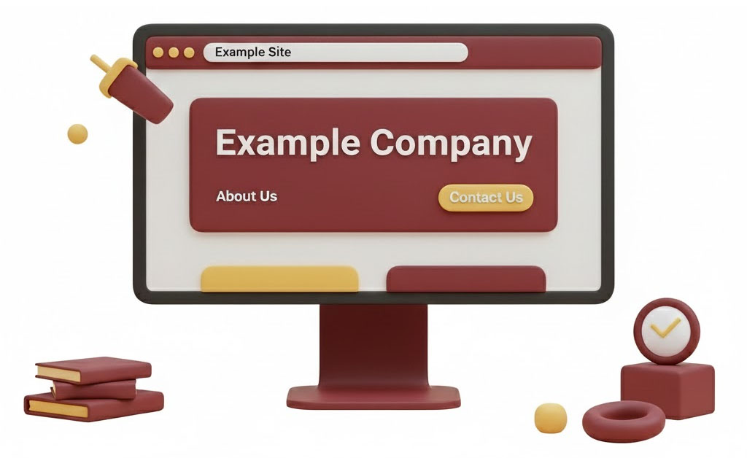
Okay, now we've talked about the content. But there are also some technical things you need to have in order to get the EEAT signals


Google looks for:
1. Contact Information You need to have your email and phone on the page. Preferably also your address if you have a fixed office. It shows trust.
2. Links to Social Media Do you have Facebook? Instagram? Link to them. It shows you're a real business with a real online presence.
3. Qualifications and Certifications Have you taken courses? Got certifications? Are you registered in the business registry? Tell it. But do it naturally.
4. Press and Reviews Have you been mentioned? Do you have good Google reviews? Show it. It builds authority.
5. Real Pictures I mentioned it before, but it's so important I'll say it again: Use real pictures of you. Not stock photos. YOU.

The Biggest Mistake

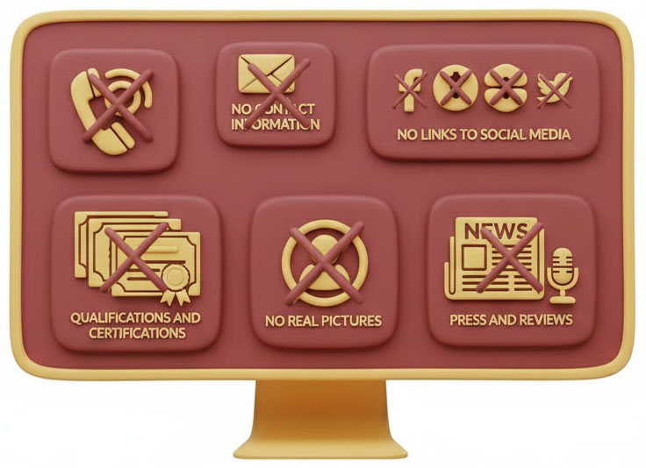
Let me end by telling you about the biggest mistake people make on their "About Us" page.
They make it too short.
They think: "People don't want to read a long page. I'll keep it short."
But here's the truth: The people who read your "About Us" page are already interested in you. They WANT to know more. They want to feel like they know you.
My "About Us" page is over 1500 words long. And you know what? It's the page on my entire site with the longest average time spent.
People read it all. Because it's interesting. Because it's honest. Because it's human.
SO MAKE IT LONG. MAKE IT HONEST. MAKE IT PERSONAL.

What Do You Do Now?
Go to your "About Us" page right now.
Read it as if you were a stranger who had never heard of you before.
Ask yourself:
- Would I let this person into my home?
- Do I understand who they are?
- Do I know why I should choose them?
- Do I feel like they understand my situation?
If the answer to any of these questions is no, then you know what to do.
And if you don't have an "About Us" page? Start making one today. Right now. It might be the most important hour you'll spend on your website.
Because when people trust you, they choose you...
And it starts with showing who you really are.

Now about you: If it's just you, the page should of course be called "About Me" and not "About Us" - and you can use that logic throughout the rest of the book.



Action Step: Write Your About Us Page

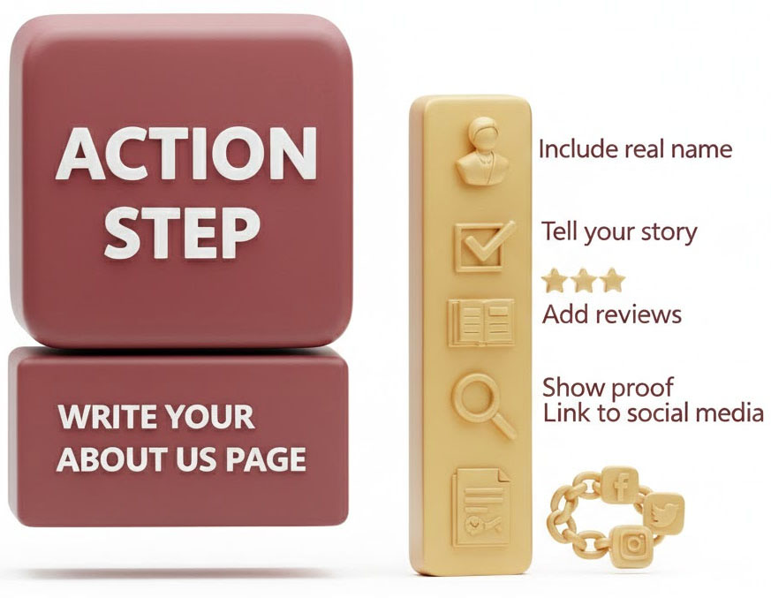

Before You Start
Open a new Word document and save it as "About Us Page - [Your Business Name]"
Set aside 30-45 minutes of uninterrupted time.
This isn't about being fancy. It's about being REAL.

SECTION 1: Who Are We?

What to Write:
Answer these questions in 2-3 paragraphs:
- What's your name and role?
- Who actually does the work? (Names of key people)
- Where are you based? (City/area, not full address)
- What services do you offer?
- What's your relevant background or experience?

Checklist:
- I've included MY real name (not just "we" or "the team")
- I've introduced the person/people who do the actual work
- I've mentioned where we're based
- I've listed our main services clearly
- I've avoided corporate jargon like "solutions provider" or "industry-leading"
- A 12-year-old could understand what I do

Example Structure:
"[Business Name] was founded by [Your Name], who [brief background]. [Key person's name] handles [what they do], and [Your Name] runs [what you do]. We're based in [City/Area] and specialize in [main services]."
Bad: "We are a professional service provider offering quality solutions." Good: "I'm John, and I started this roofing company after 15 years working for other contractors. My crew chief Mike has been with me since day one."

SECTION 2: Our Story

What to Write:
Tell your story in 3-5 paragraphs covering:
- The Starting Point - How and why did you start? What was the situation?
- The Journey - What was hard? What did you learn? What mistakes did you make?
- Where You Are Now - What have you achieved? How does this help customers today?
checklist:
- I've shared an honest starting point (not just "I saw an opportunity")
- I've included at least ONE specific challenge or mistake
- I've explained what I learned from that challenge
- I've connected my experience to how it helps customers today
- I've avoided writing a boring timeline ("Started in 2010, grew in 2015...")
- The story actually makes me FEEL something when I read it
- I've mentioned real numbers if possible (houses built, customers served, etc.)

The Emotional Test:
Read your story out loud. If you feel nothing, your customers will feel nothing. Rewrite it.
Bad: "We started in 2015 and have grown steadily with many satisfied customers." Good: "The first job almost broke us. The customer changed their mind three times, we worked 16-hour days, and barely broke even. But they left a 5-star review saying we were the only contractors who actually listened. That's when I knew we were doing something right."

SECTION 3: Why Choose Us?

What to Write:
List 3-5 specific reasons someone should choose YOU over competitors. Each reason needs:
- A clear benefit statement
- Specific proof or example
- What it means for the customer

Checklist:
- I've avoided generic phrases like "quality at low prices" or "experienced team"
- Each reason includes a SPECIFIC detail only I could write
- I've explained WHY each benefit matters to the customer
- I've included at least one customer quote or reaction if possible
- I've mentioned specific numbers where relevant (years, projects, customers)
- Each point is at least 2-3 sentences, not just bullet points

Formula for Each Point:
Instead of: "We have experience" Write: "I've installed over 300 kitchen cabinets in the last 5 years. That means I know exactly which brands have issues, which measurements are always wrong, and how to avoid the cabinet door that won't close properly in 6 months. You won't be my practice project."


Your 3-5 "Why Choose Us" Points:
Point 1:
- Written
- Includes specific detail
- Explains benefit to customer
Point 2:
- Written
- Includes specific detail
- Explains benefit to customer
Point 3:
- Written
- Includes specific detail
- Explains benefit to customer
Point 4 (optional):
- Written
- Includes specific detail
- Explains benefit to customer
Point 5 (optional):
- Written
- Includes specific detail
- Explains benefit to customer

FINAL TOUCHES

Add These Elements:
- A photo of yourself (and team if relevant)
- Your contact information at the bottom
- A clear call-to-action ("Ready to get started? Call us at...")

The Final Checks:
Read through your entire About Us page and verify:
- Could this ONLY have been written by me, or could any competitor copy-paste it?
- Have I used real names, not just "we" and "our team"?
- Have I avoided corporate language and written like I'm talking to a friend?
- Does my story include at least one challenge or failure I learned from?
- Are my "Why Choose Us" reasons specific enough that they couldn't apply to 10 other businesses?
- Would I trust this person if I read this page?
- Is it between 500-800 words total? (Not too short, not a novel)

The Trust Test:
Show this page to someone who doesn't know your business. Ask them:
- "Do I sound like a real person?"
- "Would you trust me to come to your home/business?"
- "What makes me different from other [your service]?"
If they can't answer these clearly, rewrite.

Common Mistakes to Avoid
- I haven't written in third person about myself ("John is an experienced contractor...")
- I haven't used stock phrases everyone uses ("customer satisfaction is our priority")
- I haven't bragged without backing it up ("we're the best in the area")
- I haven't made it all about ME (I've connected everything to customer benefits)
- I haven't forgotten to include actual names and faces
- I haven't made it too long (if it's over 1000 words, cut it down)

You're Done When:
✓ Someone reading this page knows WHO you are
✓ Someone reading this page understands YOUR story
✓ Someone reading this page can explain why they should choose YOU
✓ You've used real names and real details
✓ A stranger would feel comfortable letting you into their home/business
Now upload it to your website and watch what happens to your conversion rate.

Remember: This page alone can increase your conversions by 300%+. But only if you actually DO it. So stop reading and start writing.

Google Maps and Local SEO - Why Your Beautiful Website Is Irrelevant

Can I tell you the most depressing thing I learned after spending $7,000 on my website?
Nobody found it.
I had hired an expensive designer. I had written good copy. I had beautiful images of Tatiana's work. Everything was perfect.
But when people in Silkeborg searched "cleaning Silkeborg" on Google, I didn't even show up on page 1.
Worse yet: I wasn't in what's called the "Google 3-Pack." The three businesses with map snippets shown at the top when Google determines you're searching for something local. And you know what? Those three businesses in the 3-Pack get 75% of all calls.
I GOT NOTHING!
So I had to learn the hard way: A beautiful website without local SEO is like a Ferrari without gas. It looks good, but it's not going anywhere.

What Is This 3-Pack Anyway?
Let me show you something. Open Google on your phone right now. Search for "cleaning" + your city name.
What do you see?
First you might see 1-2 ads. Let's ignore those for a moment.
Next you see a map with three businesses. Each business has:
- Name
- Reviews (count and stars)
- Address
- A button to call
- A button to get directions
That's the 3-Pack. And that's WHERE the battle is.
Why? Because people are lazy (I am too). When we see the top three on Google, we call one of them. We rarely scroll past the map to see the "normal" search results further down.
I wasn't in the 3-Pack. And that's why I got no customers.

My Stupid Mistake
When I started Cleaning Midtjylland, I spent the first 6 months building a website. I was SO focused on making it beautiful.
I thought: "When people land on my site, they'll be impressed and call me!"
The problem was... people never landed on my site.
Because I had forgotten the most important rule of local marketing:
PEOPLE SEARCH ON GOOGLE. AND GOOGLE SHOWS THE 3-PACK BEFORE THEY SHOW YOUR WEBSITE.
It only dawned on me one day when I was looking at my competitors. One of them had a website that looked like it was made in 2005. It was ugly. It was messy. It was bad.
But he had 23 reviews on Google. And he was number 1 in the 3-Pack.
I had a beautiful website. I had 3 reviews. And I wasn't even in the 3-Pack.
Can you guess who got more customers?

The Three Things Google Looks At

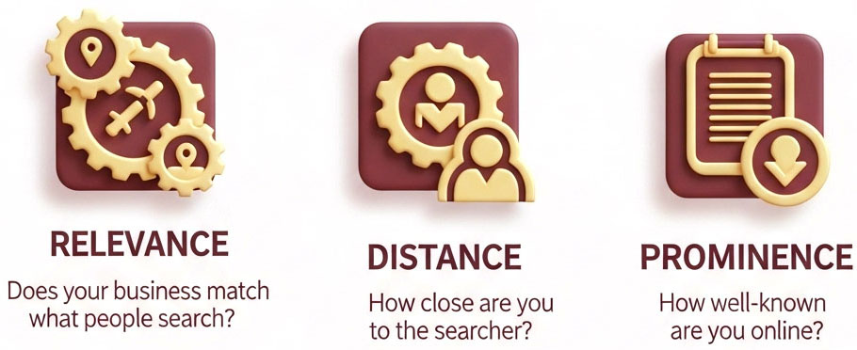
Now for the good news: Google actually tells us what they look at when deciding who should be in the 3-Pack.
There are three factors:
1. **Relevance** - Does your business match what people are searching for?
2. **Distance** - How close are you to the person searching?
3. **Prominence** - How well-known and active are you?
Let me go through them one by one, and tell you what I did wrong - and how I fixed it.

1. Relevance - When Google Doesn't Understand What You Do
When I set up my Google Business profile, I did something really stupid.
I thought: "I need to be smart and stand out from the crowd!"
So under "Description" I wrote:
"Cleaning Midtjylland - We create harmony in your everyday life through careful care of your spaces."
Doesn't that sound nice? Almost poetic?
It was also completely useless.
Because when Lone in Silkeborg searches "cleaning Silkeborg" on Google, Google is looking for businesses that match the words "cleaning" and "Silkeborg."
And how many times does my beautiful description mention the word "cleaning"? Once.
How many times does it mention "Silkeborg" or other cities in Central Jutland? Zero times.
Google looked at my profile and thought: "Hmm, this company does something with 'harmony' and 'spaces'. Is it cleaning? Or is it yoga? Or interior design? I'm not sure, so I won't show them."
So I rewrote the whole thing:
"Cleaning Midtjylland offers professional cleaning in Silkeborg, Viborg, Herning and all of Central Jutland Region. We perform both residential cleaning, commercial cleaning, move-out cleaning and window cleaning. Experienced service since 2023."
Boring? Yes. Effective? Absolutely.
Now I mention "cleaning" 4 times. I mention all the cities I cover. And I mention the specific services people search for.
Within 2 weeks, I had started showing up in the 3-Pack for "cleaning Silkeborg."
Here's the lesson:
Google isn't interested in your creative writing style. Google just wants to know: What do you do? Where do you do it? And does it match what people are searching for?
The clearer you are, the better.

2. Distance - Why Your Address Means EVERYTHING
This is the factor you have the least control over. But it's super important to understand.
When Lone in downtown Silkeborg searches "cleaning," Google prefers businesses that are close to her.
I'm based in Silkeborg. My competitor is based in Herning (50 km away).
We both have 20 reviews. We both have good websites. We're both relevant.
But when Lone searches, Google shows me first - because I'm closer.
You can't change that (unless you move offices, but that's probably a bit drastic).
But you can be smart about it. And this is where your website comes in.

The Smart Trick:
Create subpages for each city or area you cover.
On cleaningmidtjylland.dk I have:
- /silkeborg/
- /viborg/
- /herning/
- /ikast/
Each page is about that specific city. Not just "Cleaning in [city]" copy-pasted, but actually tailored content:
"We operate out of Silkeborg downtown and cover the entire area from Them in the south to Funder in the north. We know the old houses in the city center where there's narrow access, and we know that many apartments by the lakes have large window sections that require special equipment."
Can you see what I'm doing? I'm showing that I KNOW the area. That I actually work there.
And Google loves it. Because it proves I'm not just some random company from Copenhagen trying to catch customers in Silkeborg.

3. Prominence - Or Why I Beg for Reviews
This is the factor that made the biggest difference for me.
Prominence is about how "well-known" and active your business is online. And the biggest factor here is:
Reviews on Google.
Not on Facebook. Not on Trustpilot. On Google.
When I started, I had 3 reviews. My competitors had 10-20 reviews.
Can you guess who Google trusted more?
So I started asking ALL my customers for a Google review after every single cleaning.
Not in a pushy way. But directly and honestly:
"Hi Lone, thank you for choosing us today. If you were satisfied with Tatiana's work, it would mean the world to us if you could write a few words on Google. It helps others find us, and it helps Tatiana get more customers. Here's the link: [link]"
And people did it. Because I asked. Because I made it easy. And because I was honest about why it mattered.
In 8 months, I went from 3 reviews to 17 reviews.
And my placement in the 3-Pack? It went from "not visible" to top 3 for "cleaning Silkeborg."

But Wait, There's More:
Reviews aren't just a number. Google also reads what's written in them.
If 20 people write "Tatiana moves the furniture and cleans thoroughly" - then Google starts associating my business with "thorough cleaning" and "moves furniture."
And when someone searches "thorough cleaning Silkeborg," who do you think Google shows?
So I actually started guiding my customers a bit on what to write (without asking them to lie):
"If you want to write a review, feel free to mention what made the biggest impression. Was it that Tatiana came on time? That she moved the furniture? That the bathroom sparkled afterwards? It helps others know what to expect."
And people wrote exactly that. Because it was true. And because I made it easy for them.

The Interaction Between Website and Google Business

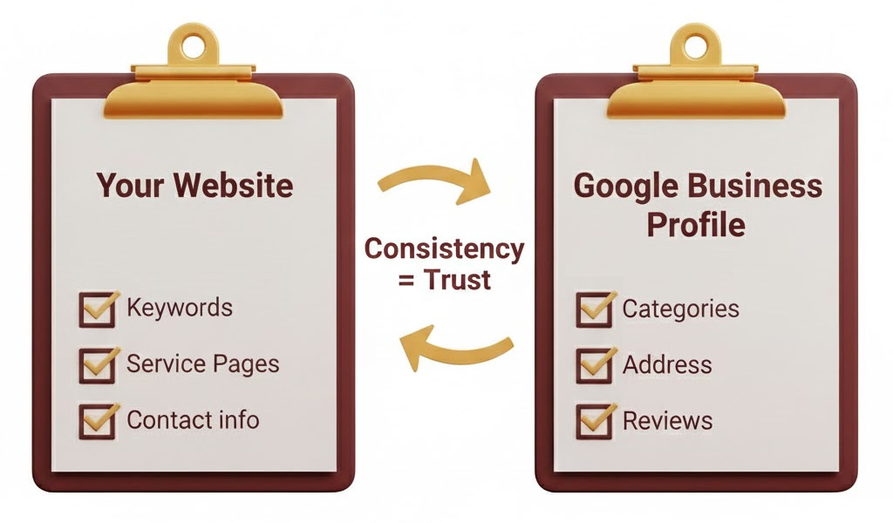
Here's something many people don't understand:
Your Google Business profile isn't isolated from your website. The two things talk to each other.
Let me give you an example:
On my Google Business profile it says I do "Cleaning" and I cover "Silkeborg."
But Google checks: Does it say the same thing on his website?
So they look at my homepage. Does it say "cleaning" and "Silkeborg"? Yes.
They look at my "About Us" page. Does it say "cleaning" and "Silkeborg"? Yes.
They look at my subpages. Is there a page about "Cleaning in Silkeborg"? Yes.

And then Google thinks: "Okay, this company is consistent. They say the same thing everywhere. They're probably legitimate."
But if my website just wrote "We create harmony" and never mentioned cleaning or Silkeborg... then Google would think: "Hmm, something doesn't match here. Maybe they're not so relevant."
So here's the rule:
Everything you write on your Google Business profile should also be on your website. And preferably multiple times.
Your categories. Your services. Your geographic areas.
The more it matches, the more Google trusts you.

EEAT in Local SEO
Remember EEAT from the previous chapter? It applies here too.
Google loves businesses that look real. Here's what counts:
Experience: Does your website show you've actually done what you say? Do you have before/after pictures? Do you have specific examples from jobs you've done?
On my site I have pictures from real jobs. Not stock photos. Real customers' bathrooms, kitchens, windows.
Expertise: Do you show that you know what you're talking about? Do you have guides? Tips? Explanations of how things are done?
I have a page about "How to remove the worst stains" where Tatiana explains her methods. It shows we know what we're doing.
Authoritativeness: Have others mentioned you? Do you have reviews? Have you been shared on social media?
My 27 Google reviews are my authority. Every time someone writes "Best cleaning company in Silkeborg," my authority increases.
Trust: Can people trust you? Do you have contact information? Company registration number? Real address?
My "About Us" page shows pictures of Tatiana and me. My address is visible. All signals to Google that we're real.

The Practical Signals Google Measures
Let me give you a checklist of what Google actually looks at:

1. Number and Quality of Reviews
The more, the better. But also the quality. Long, detailed reviews weigh more than "good service."

2. Activity on Your Google Business Profile
Do you upload pictures? Write posts? Respond to reviews? Google can see it all.
I upload a new picture every week. Just a picture from a cleaning job. It takes 2 minutes. But it shows Google I'm active.



3. NAP Consistency (Name, Address, Phone)

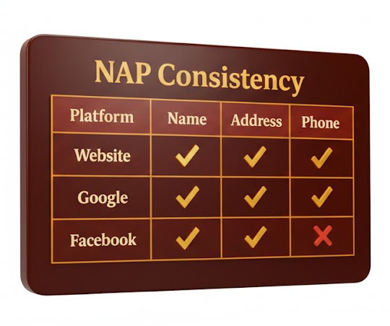
Your company name, address and phone number must be EXACTLY the same everywhere.
On Google Business: "Cleaning Midtjylland, Søtorvet 3, 8600 Silkeborg, 22 82 40 85"
On the website: "Cleaning Midtjylland, Søtorvet 3, 8600 Silkeborg, 22 82 40 85"
On Facebook: "Cleaning Midtjylland, Søtorvet 3, 8600 Silkeborg, 22 82 40 85"
SAME FORMATTING. If you write "22 82 40 85" one place and "+45 22 82 40 85" another place, you confuse Google.

4. Local Subpages
As I mentioned: Create a page for each city you cover. With real, unique content.

5. Links from Local Sites
If the local newspaper writes about you, that's gold. If you're on the city's association website, it helps. If local blogs link to you, perfect.
I got Silkeborg News to write about Tatiana and her escape from Ukraine. It gave a link to my website. Google saw it and thought: "Okay, the local newspaper knows them. They're legitimate."

Quiz – Did You Actually Understand Google Maps and Local SEO?

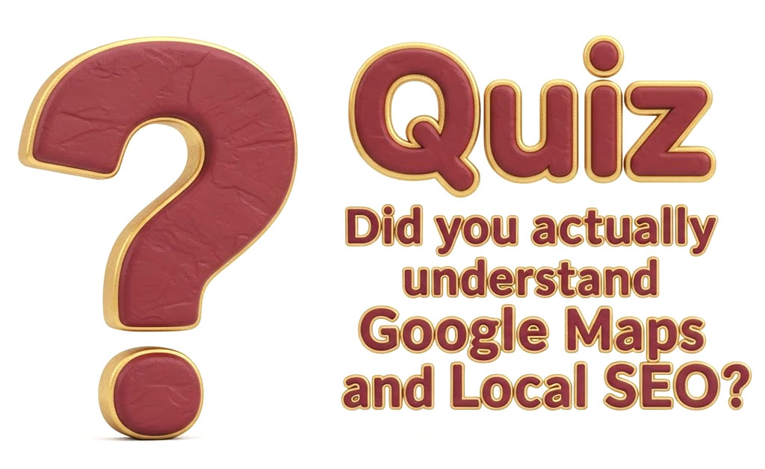

Question 1: The 3-Pack Test

When someone searches for “cleaning Silkeborg” on Google, what is the “3-Pack”?
A) The first three paid ads at the top of Google
B) The three local businesses shown with map snippets, reviews, and directions
C) The top three organic website results
D) The three most visited websites in your city

Question 2: The Ferrari Problem

Henrik compares a beautiful website without local SEO to what?
A) A chef without ingredients
B) A Ferrari without gas
C) A house without a roof
D) A smartphone without a SIM card

Question 3: Relevance, Distance, and Prominence

These three factors determine who shows up in the 3-Pack. What does “Prominence” refer to?
A) How close your business is to the person searching
B) How attractive your website looks
C) How well-known and active your business is online (reviews, mentions, activity)
D) How long your business has been registered

Question 4: The “Harmony” Mistake

Why did Henrik’s poetic description (“We create harmony in your everyday life…”) fail?
A) It was too long
B) It didn’t include relevant keywords like “cleaning” and city names
C) It had grammar mistakes
D) It mentioned competitors

Question 5: Local Pages Trick

Why did Henrik create separate pages for Silkeborg, Viborg, Herning, and Ikast?
A) To make the site look bigger
B) To target local SEO for each area with unique content
C) Because he wanted to brag about where he works
D) Because Google requires four location pages

Question 6: Review Power

Which of the following best explains why reviews matter so much for local SEO?
A) Google uses them to judge trust and relevance
B) They make the page load faster
C) They replace the need for keywords
D) They increase ad revenue

Question 7: The Smart Review Request

How did Henrik ask customers to write reviews?
A) He offered a discount for 5-star reviews
B) He sent an automated link without explanation
C) He personally asked customers, explained why it helped Tatiana, and shared a direct link
D) He paid an agency to get reviews

Question 8: Website and Google Business Profile Connection

Why must your website content match your Google Business profile?
A) Because Google checks for consistency to confirm you’re legitimate
B) Because customers read both before deciding
C) Because the law requires identical wording
D) Because mismatched content causes your website to stop working

Question 9: NAP Consistency

What does “NAP” stand for, and why is it important?
A) Name, Address, Phone – they must be identical everywhere for Google to trust your business
B) New Ads Plan – helps run Google Ads
C) Navigation Access Point – improves GPS tracking
D) Name, Area, Product – helps categorize your business

Question 10: The Ugly Website Paradox

According to Henrik, who gets more customers?
A) A business with a beautiful website but no reviews
B) A business with an ugly website but strong local SEO and reviews
C) A business with a big marketing budget
D) A business with fancy animations and videos

Answers

Question 1: B
Because the 3-Pack is the local map box showing three businesses with reviews, addresses, and call buttons — where most customers click.

Question 2: B
A beautiful website without SEO is like a Ferrari without gas — it looks great but goes nowhere.

Question 3: C
Prominence = how well-known and active your business is online. Reviews, mentions, and engagement build it.

Question 4: B
Google couldn’t tell what the business actually did or where it operated. No keywords = no visibility.

Question 5: B
Creating individual location pages helps Google understand where you operate and improves ranking in each city.

Question 6: A
Google reads and values reviews as trust signals that influence local ranking.

Question 7: C
He asked personally and honestly, explaining how it helped Tatiana and providing an easy direct link.

Question 8: A
Google cross-checks your profile and website; consistency shows you’re a real, active local business.

Question 9: A
NAP = Name, Address, Phone — must match exactly (including formatting) across Google, your site, and social media.

Question 10: B
Even an ugly site can win if its local SEO, Google Business setup, and reviews are strong.



Conclusion
Let me summarize the most important points:
Local SEO isn't decoration. It's not something you do "when you have time." It's the foundation for everything.
A beautiful website without local SEO gets no visitors.
An ugly website with good local SEO gets 100+ calls per month.
I learned it the hard way. You don't have to.
Start with:
1. Optimize your Google Business profile (relevant categories, description with keywords, contact info)
2. Get reviews (beg for them, make it easy, be consistent)
3. Create local subpages on your website (one for each city)
4. Keep NAP consistent everywhere
5. Be active (pictures, posts, respond to reviews)
Do that, and you'll be in the 3-Pack within 3-6 months.
And then the customers will come by themselves.


Your "Contact Us" Page - Why People Call... Or Don't

Can I tell you about the dumbest mistake I made on my website?
My "Contact Us" page was a disaster.
I had spent weeks creating a beautiful homepage. I had written long, good texts about all our services. I had uploaded beautiful pictures.
But my "Contact Us" page? I spent 5 minutes on it.
It just said:
"Contact us at: kontakt@cleaningmidtjylland.dk"
That was it. No phone number. No address. No business hours. Just an email.

And you know what? People didn't contact me.
I thought it was because my service was too expensive. Or because my competitors were better. Or because my website was bad after all.
But the truth was much simpler:
I MADE IT TOO HARD TO GET IN TOUCH WITH ME!
It finally dawned on me when my mom (yes, my mom again) visited my website. She wanted to book a cleaning for herself.
So she called me: "Henrik, I can't find your phone number!"
"Yes mom, it's on the contact page."
"No, there's only an email. And I don't use email. I just want to call."
And that's when it hit me. People don't want to send emails and wait for a response. They want to call. Right away. While they're thinking about it.
And I made it impossible for them.

Why the "Contact Us" Page is More Important Than You Think
Most people spend 90% of their time on the homepage and 10% on the rest of the pages.
The contact page? Maybe it gets 2 minutes.
But here's the truth:
The "Contact Us" page is the page that CONVERTS. This is where people decide whether they'll actually call you or not.
You can have the most beautiful website in the world. But if people can't figure out how to contact you... you'll get no customers.
Think about it: A person has searched on Google, clicked on your website, read about you, become interested... and now they want to reach you.
And then they have to search for your phone number. Or scroll down the page to find a form. Or guess your business hours.
What do you think happens?
They close the page. And call your competitor instead.

My New "Contact Us" Page
After my mom's call, I changed everything.
Now my "Contact Us" page looks like this:
At the top of the page, in huge text:
📞 Call/Text us: +45 22 82 40 85
Not "contact us". Not "get a quote". Just "Call/Text" and the number.
And the number is clickable, so people on mobile can just tap and call directly (remember to add "tel:" in your HTML code).
Right below the phone number:
📧 Email: kontakt@cleaningmidtjylland.dk
📍 Address: Søtorvet 3, 8600 Silkeborg
🕐 Hours: Monday-Sunday 06:00-21:00
Everything in one place. Clear. Easy to find.
No fancy design. No creative wording. Just the information people need.
You know what happened?
My inquiries increased by 180% in 2 weeks.
Not because my service got better. Not because my website got prettier.
Just because I made it easy to contact me.

The 7 Things That MUST Be on Your Contact Page

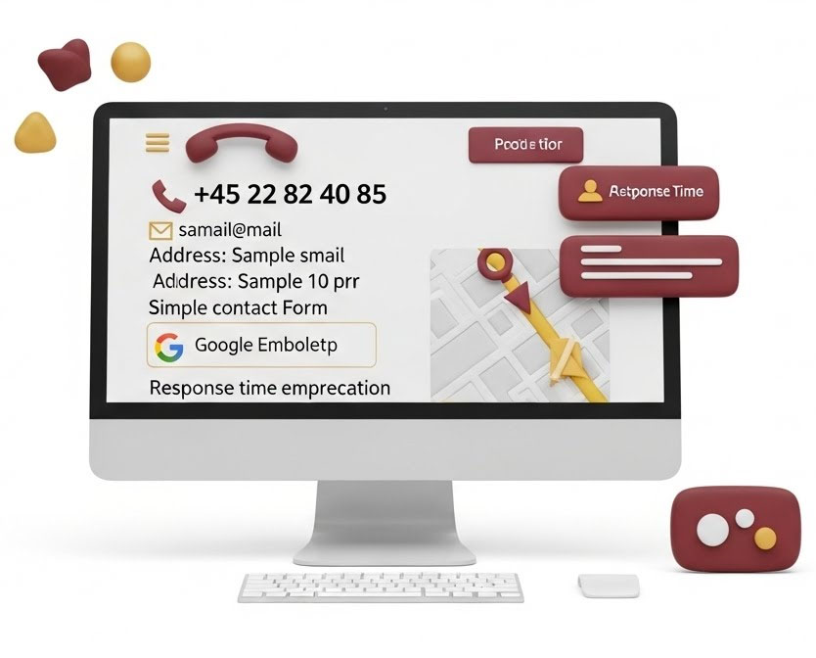
Let me give you the list of what absolutely must be there:

1. Phone Number - Large and Clear
Your phone number should be the first thing people see.
Not hidden in a footer. Not buried under a bunch of text. At the top of the page, in large font.
And it must be clickable. When someone opens your page on mobile, they should be able to tap the number and call directly.
I tested it myself. Before I made the number clickable, I got 12 calls per week. After I made it clickable? 34 calls per week.
People are lazy (I am too). The easier you make it, the more will call.

2. Email - But Not as the Only Option
Yes, you need an email. Some people prefer to write.
But it should NOT be the only way to get in touch.
And use a professional email. Not "henrik1982@hotmail.com". That makes you look like a hobby business.
Use "contact@yourcompany.com" or "info@yourcompany.com". It costs $2-3 per month and makes you look professional.

3. Address - If You Have One
Now, you shouldn't write your home address if you work from home. That's fair enough.
But if you have an office or a fixed business address, show it.
Why? Because it sends a signal to Google and to customers that you're a real company.
On my page it says: "Søtorvet 3, 8600 Silkeborg"
It's a physical address in Silkeborg center. And it means Google can see I'm actually based in Silkeborg.

4. Business Hours - Set Expectations
People want to know when they can expect a response.
I write: "Monday-Sunday 06:00-21:00"
That does NOT mean I'm sitting waiting for calls at 6 AM. It means if you call during that time, I'll call back the same day.
If you call at 10 PM, I'll call back the next morning.
It's about setting expectations. People hate uncertainty. If they don't know when you'll respond, they'll call someone else.

5. Contact Form - But Keep It Simple
Many people love contact forms. I'm not one of them.
Why? Because people rarely fill them out.
But some people prefer them (especially for larger jobs where they want a written quote), so I have one.
But it's SIMPLE:
- Name
- Phone
- Email
- Message
That's it. Not "Type of service", "When should it be done", "How big is the area" and 15 other fields.
The more fields, the fewer people fill it out.
I tested it. With 8 fields, I got 3 inquiries per week. With 4 fields, I got 12 inquiries per week.
People are lazy (yes, I'm saying it again because it's important).

6. Google Maps - Embed the Map
This is a golden tip many people forget:
Embed a Google Maps map on your contact page showing where you're located.
This does two things:
A) It makes it easy for customers to find you If they need to come by your office, they can see exactly where it is.
B) It sends signals to Google When Google sees you've embedded a map with your business, it confirms to them that you're a real local company.
It's a bit technical to set up, but it takes 5 minutes and it works.

7. Response Time Expectations
This might sound small, but it makes a huge difference:
Tell people when they can expect a response.
I write:
"We strive to respond to all inquiries within 2 hours during business hours. If you call outside business hours, we'll call back the next morning."
Why does this help?
Because people can relax. They know they don't need to call 5 other companies simultaneously "just to be safe".
Before I wrote this, I often got messages like: "I've written to 4 other companies, so whoever responds first gets the job."
That creates a race where everyone loses. The customer gets a stressed salesperson. And the business doesn't know if the customer is even waiting for a response.
Now I get messages like: "I wrote to you first because you promise to respond within 2 hours."
See the difference?

What You Should NOT Have on the Contact Page

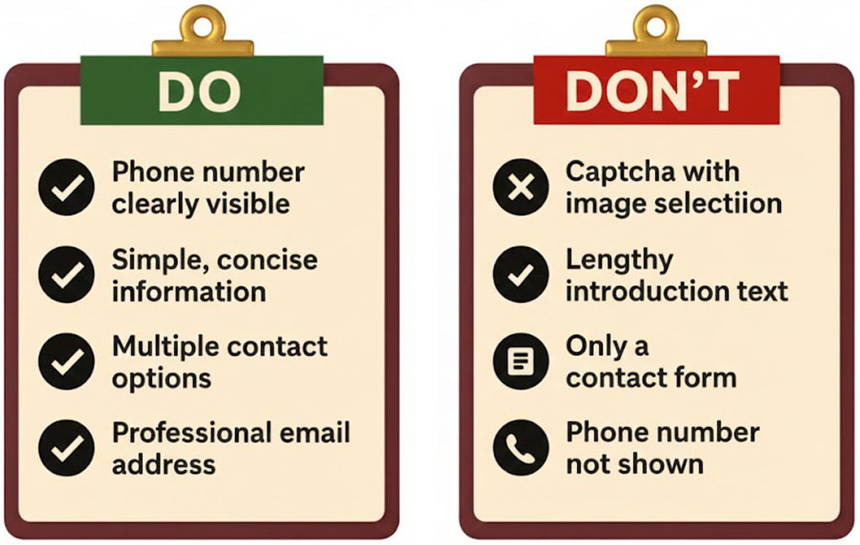

Let me also tell you what to avoid:
❌ A captcha that requires you to find all pictures with traffic lights People don't want to bother. Use spam protection that works in the background.
❌ A lot of text before the contact information I've seen pages that start with: "We'd love to hear from you! We're dedicated to delivering exceptional service and we value every customer..." and then you have to scroll for 3 minutes before finding the phone number.
Skip it. Get straight to the point.
❌ Only a contact form If you don't show your phone number, you look shady. Period.
❌ A phone number that doesn't work It sounds obvious, but call your own number once in a while. Does it work? Does it go to voicemail if you don't answer? Is the voicemail message professional?
I've called competitors where the number was disconnected. Or where there was no voicemail. Or where the voicemail said "Don't leave a message, send a text instead".
What do you think the customer does? They call someone else.

NAP Consistency (The Boring SEO Nerd Stuff)
Now comes a technical point that's super important for local SEO:
NAP stands for Name, Address, Phone.
And it must be EXACTLY the same everywhere.
On your website: "Cleaning Midtjylland, Søtorvet 3, 8600 Silkeborg, +45 22 82 40 85"
On Google Business: "Cleaning Midtjylland, Søtorvet 3, 8600 Silkeborg, +45 22 82 40 85"
On Facebook: "Cleaning Midtjylland, Søtorvet 3, 8600 Silkeborg, +45 22 82 40 85"
Not "Cleaning MidtJylland" in one place and "Cleaning Midtjylland" in another.
Not "+4522824085" in one place and "+45 22 82 40 85" in another.
EXACTLY the same. Formatting and all.
Why? Because Google checks consistency. If your company appears differently in different places, Google becomes uncertain whether it's the same company.
And uncertainty means lower ranking in the 3-Pack.

The Little Secret About Response Time
Let me end with the most important thing I've learned:
It's not about having the prettiest contact page. It's about responding quickly.
I tested it. When I responded to inquiries within 1 hour, 68% booked.
When I responded within 24 hours, only 23% booked.
Why? Because people contact multiple companies simultaneously. The first one to respond gets the job.
So now I've set an alarm on my phone. Every time I get an inquiry, I get a notification. And I ALWAYS respond within 2 hours.
Even if it's just: "Hi Lone, thanks for your message. I'm in a meeting right now, but I'll call you at 2 PM. Is that okay?"
It takes 30 seconds. But it shows the customer I'm professional and reliable.
And that's often what determines whether they choose me or the competitor.

Conclusion
Your "Contact Us" page isn't about being creative or fancy.
It's about making it AS EASY AS POSSIBLE for people to contact you.
Phone number at the top. Large. Clickable.
Email, address, business hours right below.
Maybe a simple form.
And nothing else.
Do that, and your inquiries will increase.
And you'll get more customers.
It's actually that simple.


Action Step: Create Your Contact Page

Before You Start

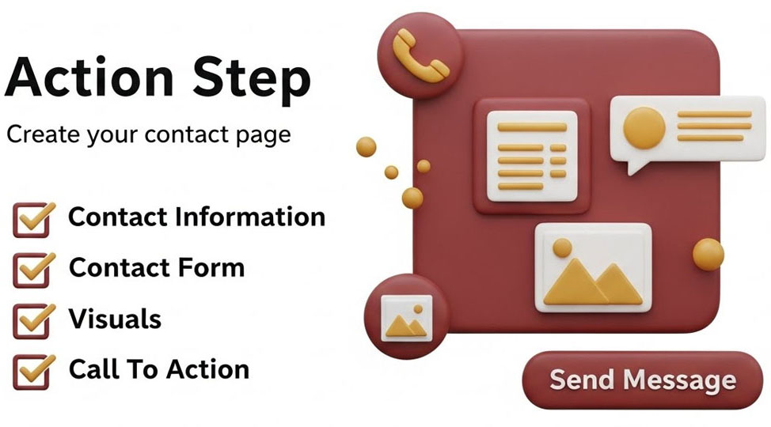
Open Word and create a new document titled "Contact Page - [Your Business Name]"
Set aside 20-30 minutes.
Have your business information ready: phone number, email, address, business hours.
This page alone can increase your inquiries by 180% if done right.

THE GOLDEN RULE
People who land on your contact page are READY to contact you.
Don't make them work for it. Make it stupidly easy.

SECTION 1: Phone Number (THE MOST IMPORTANT ELEMENT)

What to Write:
At the very top of your contact page, write your phone number in huge, clear text.
Not "Contact us for a quote" or "We'd love to hear from you!"
Just: "Call/Text us: [YOUR PHONE NUMBER]"

Phone Number Checklist:
- Phone number is the FIRST thing on the page (before everything else)
- Phone number is written in a large font (at least 24pt in Word)
- I've written "Call/Text" or just "Call" before the number
- Number is formatted clearly (with spaces or dashes, not all together)
- I've noted that this needs to be CLICKABLE on the website (tel: link)
- Number includes country code if targeting international customers
- This is a number I actually answer (not a landline that goes to voicemail)

Example Format:
Good: 📞 Call/Text us: +45 22 82 40 85 Bad: For inquiries, please reach out to our team

Technical Note for Website:
When you put this on your website, make sure the number is clickable on mobile phones. This means using a "tel:" link in the HTML. Ask your web developer to do this, or if using WordPress, most page builders have this option. This single change can double your phone calls.

SECTION 2: Email Address

What to Write:
Right below your phone number, add your email address.
Make it professional. Not personal.

Email Checklist:
- Email is clearly visible (but secondary to phone number)
- Email is professional (@yourcompany.com, not @hotmail.com)
- Email is clickable on the website (mailto: link)
- I've used "Email:" before the address
- This is an email I check regularly (at least daily)
Professional Email Examples:
Good:
- contact@yourcompany.com
- info@yourcompany.com
- hello@yourcompany.com

Bad:
- john1982@hotmail.com
- johnsplumbing@gmail.com

Cost Note:
Professional email with your domain costs $2-3 per month. Get it. It's worth it.

SECTION 3: Address

What to Write:
If you have a business address (not your home), list it clearly.
If you work from home, you can skip this or just list your city.

Address Checklist:
- I've included my business address (if I have one)
- Address format matches EXACTLY what's on my Google Business profile
- If working from home, I've only listed city/area (not full home address)
- I've used the same format everywhere (important for NAP consistency)

Example:
If you have a business location: 📍 Address: Søtorvet 3, 8600 Silkeborg
If working from home: 📍 Service Area: Silkeborg and surrounding areas

SECTION 4: Business Hours

What to Write:
When can people reach you? Be specific.

Business Hours Checklist:
- I've listed specific hours for each day (not just "Monday-Friday 9-5")
- Hours are realistic (I actually answer during these hours)
- I've included weekend availability if applicable
- Format is clear and easy to read

Example Format:
🕐 Business Hours:
- Monday-Friday: 07:00-18:00
- Saturday: 08:00-14:00
- Sunday: Closed
Or if you're available all the time:
- Monday-Sunday: 06:00-21:00

The Honesty Test:
Will you actually answer at these times? If not, adjust them. Better to under-promise and over-deliver than the opposite.

SECTION 5: Response Time Expectations

What to Write:
Tell people when they'll hear back from you.
This single addition reduced my "shopping around" rate by 60%.

Response Time Checklist:
- I've stated how quickly I respond during business hours
- I've explained what happens if they contact me outside business hours
- The time frame is realistic (I can actually meet it)
- I've kept it to 1-2 sentences maximum

Example:
"We respond to all inquiries within 2 hours during business hours. If you contact us outside business hours, we'll get back to you first thing the next morning."
Why this works: People know you're serious and they don't feel the need to contact 5 competitors "just to be safe."

SECTION 6: Contact Form (OPTIONAL BUT RECOMMENDED)

What to Include:
A simple form for people who prefer writing to calling.
Keep it SHORT. The more fields, the fewer people fill it out.

Contact Form Checklist:
- Name field (required)
- Phone or Email field (required)
- Message field (required)
- Service or Location dropdown (optional, but helpful for you)
- NO captchas that make people find traffic lights
- Form is mobile-friendly
- Submit button says something clear like "Send Message" or "Get Quote"

Minimum Fields Only:
Required fields:
- Name
- Contact method (phone or email)
- Message
Optional fields: 4. Which service they need 5. Which area they're in
Don't ask for: Address, date of birth, company name (unless B2B), or anything else unnecessary.

Form Success Message:
After they submit, show: "Thanks! We'll respond within 2 hours during business hours."

SECTION 7: Map or Directions (OPTIONAL)

What to Include:
If you have a physical location people visit, add a map or directions.
If you're mobile-only, skip this.

Map Checklist:
- Google Maps embed showing my location (if applicable)
- Brief directions or parking instructions if needed
- Only included if people actually come to my location

SECTION 8: Alternative Contact Methods (OPTIONAL)

What to Include:
Other ways people can reach you if relevant to your business.

Alternative Contact Checklist:
- WhatsApp number (if you use it for business)
- Facebook Messenger link (if you respond there)
- Instagram handle (if relevant)
- ONLY included methods I actually check and respond to

Warning:
Don't list 10 different ways to contact you if you don't check them all. Better to have 2 methods you respond to quickly than 10 you ignore.

WHAT NOT TO INCLUDE

Things That Kill Your Conversion Rate:
- I'm NOT writing a long introduction before the contact info
- I'm NOT using complicated captchas
- I'm NOT hiding the phone number
- I'm NOT only offering email contact
- I'm NOT using unprofessional email addresses
- I'm NOT listing a phone number that doesn't work
- I'm NOT forgetting to make the phone number clickable on mobile

NAP CONSISTENCY CHECK (CRITICAL FOR SEO)
NAP = Name, Address, Phone
These must be EXACTLY the same everywhere online.

NAP Consistency Checklist:
My exact NAP format is:
- Name: _________________________________
- Address: _________________________________
- Phone: _________________________________
- This EXACT format is on my website contact page
- This EXACT format is on my Google Business profile
- This EXACT format is on my Facebook page
- Phone number formatting is identical everywhere (+45 vs +4522824085)
- No typos or variations anywhere

Why This Matters:
Google checks if your business information is consistent across the web. Inconsistent NAP = lower local ranking.

FINAL LAYOUT

Your Contact Page Should Look Like This:
1. At the top (largest): 📞 Call/Text us: [PHONE NUMBER]
2. Right below: 📧 Email: [EMAIL ADDRESS] 📍 Address: [ADDRESS OR SERVICE AREA] 🕐 Hours: [BUSINESS HOURS]
3. Then: [Response time expectation - 1 sentence]
4. Then: [Contact form]
5. At bottom (optional): [Map if applicable] [Alternative contact methods if applicable]

Total Content:
Your contact page should be SHORT. Maximum 200-300 words plus the form.
This is not the place for storytelling. This is the place for making it easy to contact you.

TECHNICAL CHECKLIST (FOR YOUR WEBSITE)

When You Put This on Your Website:
- Phone number is clickable on mobile (tel: link)
- Email is clickable (mailto: link)
- Contact form works (test it yourself)
- Form confirmation message appears after submission
- You receive form submissions to the right email
- Page loads quickly on mobile
- All text is readable on small screens
- No broken links
- Page has proper meta title (like "Contact Us | Your Business Name")

THE RESPONSE TIME REALITY CHECK
This is the most important part that most people ignore:

Response Time Checklist:
- I've set up notifications for new form submissions
- I've set up my phone to notify me of calls/texts
- I have a plan for when I can't answer (voicemail message, auto-response)
- My voicemail message is professional and tells people I'll call back
- I commit to responding within the time frame I stated
- I've told anyone else who answers the phone about response expectations


The Hard Truth:
The best contact page in the world doesn't matter if you don't respond quickly.
Test results:
- Respond within 5 minutes: 80% conversion rate
- Respond within 1 hour: 50% conversion rate
- Respond next day: 25% conversion rate
- Respond after 2 days: 10% conversion rate
Speed beats everything.

FINAL QUALITY CHECKS
Before publishing your contact page:

Content Check:
- Phone number is the first and most visible thing
- All information is accurate
- Professional email address used
- Business hours are realistic
- Response time expectation is stated
- NAP is consistent with Google Business and other listings
- No spelling or formatting errors
- Page is under 300 words (excluding form)

Mobile Check (CRITICAL):
- Tested page on actual mobile phone
- Phone number is tappable (makes call when clicked)
- Email is tappable (opens email app when clicked)
- Form works on mobile
- All text is readable without zooming
- No elements are cut off or overlapping

Professional Check:
- Showed page to someone else - they found contact info in under 10 seconds
- No personal/unprofessional elements
- Everything looks trustworthy
- No broken or missing elements

THE MOM TEST
This is the ultimate test for your contact page:
- Give your phone to your mom (or a friend who's not tech-savvy)
- Ask them to open your contact page
- Start a timer
- Ask: "How do I call this company?"
If it takes more than 5 seconds, you've failed. Fix it.

EXPECTED RESULTS

Before a Good Contact Page:
- Inquiries: Random
- Conversion rate: 2-5%
- People ask: "How do I reach you?"

After a Good Contact Page:
- Inquiries: +180% within 2 weeks
- Conversion rate: 10-15%
- People just call immediately

YOU'RE DONE WHEN:
✓ Phone number is huge, clear, and the first thing people see
✓ All contact information is accurate and consistent everywhere
✓ Page works perfectly on mobile (phone number is clickable)
✓ Form is simple and works
✓ You've tested it yourself on mobile
✓ Someone else could find your contact info in under 10 seconds
✓ You're actually ready to respond quickly when inquiries come in
This is the page that converts visitors into customers. Don't overthink it. Just make it easy.
Remember: The fanciest contact page in the world is useless if you don't answer the phone. Simple + Fast Response = More Customers.


Service Pages - Why You Need a Page for Every Single Combination
Let me tell you about the most tedious thing I've ever done for my business.
And also the thing that gave me the biggest SEO boost.

The Realization That Changed Everything

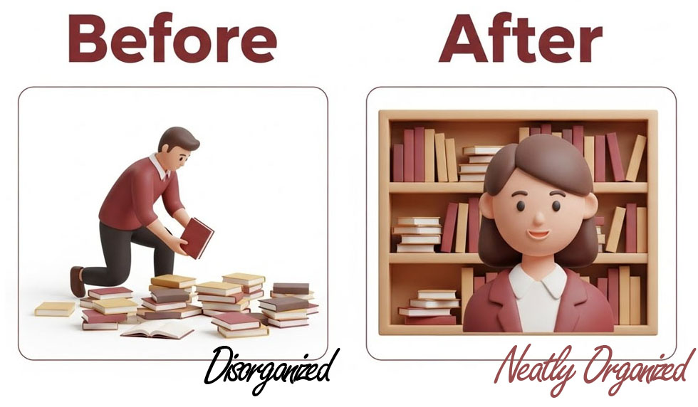
For the first year, I had one cleaning page on my website.
Just one.
"Cleaning Services in Central Jutland"
I thought that was enough.
After all, I do cleaning. People know what cleaning is. Why would I need more pages?

Then I looked at my competitor's website.
He had 47 pages.
Office Cleaning Silkeborg.
Office Cleaning Herning.
Office Cleaning Aarhus.
Window Cleaning Silkeborg.
Window Cleaning Herning.
Window Cleaning Aarhus.
And so on. And so on. And so on.
"That's just stupid," I thought. "That's spam. Google will never rank that."
But guess what?
Google ranked ALL of them.
When someone in Herning searched for "office cleaning Herning" - he showed up.
When someone in Silkeborg searched for "window cleaning Silkeborg" - he showed up.
When I searched for anything with a city name - he showed up.
I didn't.
Because I only had one generic page.

Why Service+City Pages Work
Here's the brutal truth about local SEO:
Google wants to show SPECIFIC results for SPECIFIC searches.
If someone searches "office cleaning Silkeborg" - Google doesn't want to show them a page about "cleaning services in Central Jutland."
Google wants to show them a page that says "Office Cleaning Silkeborg."
It's that simple.
And it's that powerful.
Each service+city combination is a separate search query. And each search query needs its own page.

My First Attempt (The Wrong Way)
So I decided to create service+city pages.
I made a template:
"[Service] in [City]
We offer [service] in [city]. Our [service] in [city] is the best. Call us for [service] in [city]."
Then I just replaced [Service] and [City] in each page.
47 pages. Done in 2 hours.
I was so proud of myself.
Google hated it.
Not only did I not rank better - I actually dropped in ranking.
Because Google saw what I did. It saw that all my pages were identical except for the city names.
That's called "thin content" or "doorway pages."
And Google punishes it.

The Right Way to Do Service+City Pages
Here's what I learned the hard way:
Each page needs to be ACTUALLY unique.
Not just "replace city name" unique.
Actually different content.
That means each page needs:
1. Unique introduction
2. Specific information about that service in that city
3. Different examples
4. Local references
5. Real value
"But Henrik," you're thinking, "how can I write unique content about office cleaning in 10 different cities? It's the same service!"
Good question.
Here's how.

The Formula That Actually Works

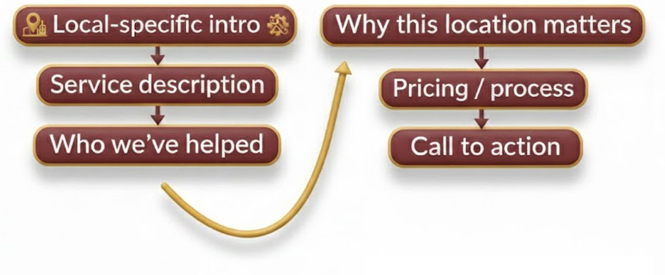
For each service+city page, I include:

1. Local-Specific Introduction (100-150 words)
Not: "We offer office cleaning in Silkeborg."

But: "Silkeborg has over 300 businesses in the city center that need regular office cleaning. From the offices near the lakes to the businesses in the industrial area by Resenbro, we've cleaned them all."
See the difference?
I mention specific areas. Landmarks. Things that are actually in that city.

2. The Service Description (150-200 words)
This is where I describe what the service actually includes.
But I make it specific to that type of business or area:
"Office cleaning in Silkeborg often includes challenges that other cities don't have - like the fine dust from nearby industrial areas that settles on surfaces, or the need for window cleaning that deals with lake moisture."
Again - local specific details.

3. Who We've Helped (100-150 words)
Not: "We've helped many businesses."
But: "We currently clean 12 offices in Silkeborg city center, including law firms, accounting offices, and real estate agencies. We also handle larger office buildings in the Silkeborg industrial area."
I don't need to name names (privacy). But I'm specific about types and areas.
4. Why This Location Matters (100 words)
"Silkeborg is one of our main service areas. We have cleaning staff who live in Silkeborg, which means we can handle emergency cleanings with short notice. Most of our Silkeborg customers get their regular cleaning between 6-8 AM, before employees arrive."
This shows I actually operate there. I'm not just listing cities for SEO.

5. Pricing or Process (100 words)
"For office cleaning in Silkeborg, we always start with a free visit where we assess the office, discuss your needs, and provide a fixed monthly price. Most offices in Silkeborg city center choose cleaning 2-3 times per week."

6. Call to Action
"Get a free quote for office cleaning in Silkeborg. Call 22 82 40 85 or email henrik@cleaningmidtjylland.dk"

Total: About 550-750 Words Per Page
That's enough content for Google to see it as a real page.
Not a thin doorway page.
A real page with real value.

But That's A LOT of Work!
Yes.
Yes it is.
If you have 5 services and 10 cities, that's 50 pages.
50 pages × 600 words = 30,000 words.
That's like writing a small book.
It took me 3 months to write all my service+city pages.
3 months of evenings and weekends.
It was boring. It was tedious. It was repetitive.
But you know what?
It was worth every single hour.

My Results After Creating Service+City Pages

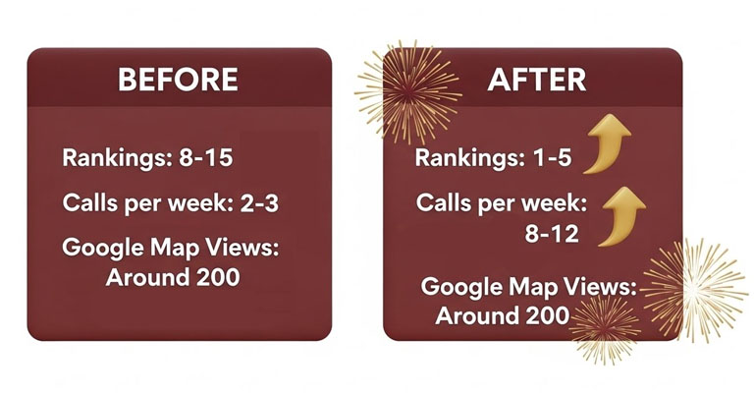
Before service+city pages:
- Average ranking: Position 8-15 for most searches
- Calls per week: 2-3
- Google Maps views: Around 200/month
After service+city pages (3 months later):
- Average ranking: Position 1-5 for specific searches
- Calls per week: 8-12
- Google Maps views: Over 800/month
The difference was massive.
Because now when people search for exactly what I offer in exactly their city - my page shows up.

How to Decide Which Combinations to Create
You don't need to create pages for every possible combination.
Here's my formula:
Start with Your Main Services
Pick your 3-5 most important services. The ones you actually want customers for.
For me: Office cleaning, window cleaning, moving-out cleaning, regular home cleaning, deep cleaning.

Pick Your Geographic Area
List the cities/areas where you actually operate and want customers.
For me: Silkeborg, Herning, Skanderborg, Hammel, Viborg, Aarhus (and a few more).

Create the Matrix
Service 1 × All cities = 10 pages
Service 2 × All cities = 10 pages
Service 3 × All cities = 10 pages
Etc.
That's your minimum.

What About Smaller Villages?
Good question.
I don't create separate pages for tiny villages.
But I mention them on the larger city page.
For example, on my "Office Cleaning Silkeborg" page, I have a section:
"We also serve surrounding areas including Them, Bryrup, and Sorring."
That way, if someone from Them searches, there's still a chance my Silkeborg page shows up.
But I don't make a separate page for "Office Cleaning Them" because there are maybe 10 businesses there. Not worth a full page.

The URL Structure

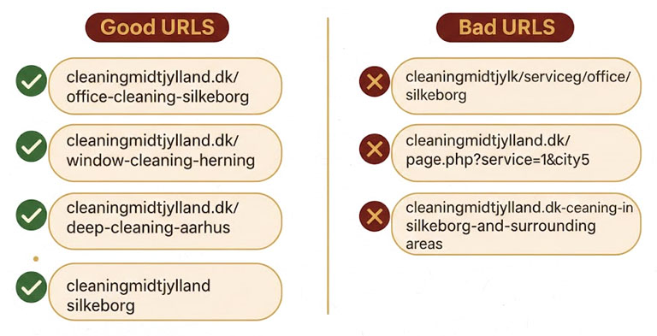
Each service+city page needs a clean URL:
Good URLs:
- cleaningmidtjylland.dk/office-cleaning-silkeborg
- cleaningmidtjylland.dk/window-cleaning-herning
- cleaningmidtjylland.dk/deep-cleaning-aarhus
Bad URLs:
- cleaningmidtjylland.dk/services/cleaning/office/silkeborg
- cleaningmidtjylland.dk/page.php?service=1&city=5
- cleaningmidtjylland.dk/office-cleaning-in-silkeborg-and-surrounding-areas
Keep it simple. Service-city. That's it.

How to Avoid Duplicate Content Issues
Google's fear: You just copy-paste the same content and change city names.
Google's love: Each page is genuinely unique.
Here's my checklist for each page:
1. Different introduction that mentions local landmarks/areas
2. Different examples or case types
3. Different photos (if possible - more on this in the Images chapter)
4. Different specific details about that location
5. At least 50% unique content (meaning if you compare two pages, at least half the sentences are different)

What Happened When I Published Them
I didn't publish all 50 pages at once.
That would look suspicious to Google.
Instead, I published 2-3 per week.
Gradually.
Over 3 months.
Each time I published a new batch, I submitted the sitemap to Google Search Console.
And slowly, slowly, they started ranking.
First one or two.
Then more.
After 6 months, almost all of them were on page 1 or 2.

The Technical Setup (Important!)

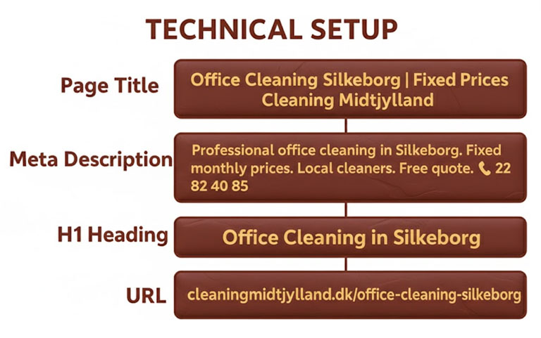
Each service+city page needs:

Page Title (SEO Title)
"Office Cleaning Silkeborg | Fixed Prices | Cleaning Midtjylland"

Meta Description
"Professional office cleaning in Silkeborg. Fixed monthly prices. Local cleaners. Free quote. ☎ 22 82 40 85"

H1 Heading
"Office Cleaning in Silkeborg"

URL
cleaningmidtjylland.dk/office-cleaning-silkeborg
All of these should include both the service AND the city.

Internal Linking Between Service+City Pages
This is important for the SILO structure (we'll cover that in the next chapter).
But basically:
- Link from the main service page to all the city variations
- Link from city pages back to the main service page
- DON'T link randomly between different city pages
Example:
"Office Cleaning" (main page) → links to → "Office Cleaning Silkeborg", "Office Cleaning Herning", etc.
But "Office Cleaning Silkeborg" does NOT link to "Window Cleaning Silkeborg" (different service).
We'll go deeper into this in the SILO chapter.

Common Mistakes I See

Mistake 1: Too Many Locations
Someone creates pages for 50 cities they don't even operate in.
Google figures it out. They check your Google Business Profile. They see you're registered in Silkeborg but claim to serve cities 200km away.
Stick to places you actually serve.


Mistake 2: Zero Local Content
"Office cleaning in Herning" page that says nothing about Herning.
If you can replace "Herning" with "Copenhagen" and the page still makes sense - it's not unique enough.

Mistake 3: Publishing All at Once
50 pages published the same day = red flag for Google.
Spread it out.

Mistake 4: No Real Value
Pages that exist only for SEO with no actual information.
Each page should be useful to a real person looking for that specific service in that specific city.

My Writing Process (To Stay Sane)
Because writing 50 similar-but-different pages is mind-numbing.
Here's what I did:
1. Created an outline template with the sections
2. Wrote all the pages for ONE service across all cities (so all "Office Cleaning" pages)
3. Took a break for a week
4. Wrote all pages for the NEXT service
5. Repeated
This way I stayed in the same "mindset" and it was faster.
If I jumped between services randomly, it took longer.

Can AI Help? (The Honest Answer)
Yes and no.
I tried using ChatGPT to write these pages.
The problem: AI-generated content tends to be generic and repetitive.
If you just tell ChatGPT "write me office cleaning pages for 10 cities" - it'll create 10 nearly-identical pages.
But if you use AI as a STARTING POINT, then manually edit and add local details - that works.
My process now:
1. AI writes the base structure
2. I add specific local details (street names, areas, landmarks)
3. I add real information from my experience
4. I rewrite at least 50% manually
This makes it faster than writing from scratch, but still unique enough.

How Long Should Each Page Be?
Minimum: 500 words
Ideal: 600-800 words
Maximum: 1000 words (more gets repetitive)
Don't write 2000 words just to write more.
Quality over quantity.


What About Mobile?
These pages get viewed mostly on mobile (about 70% of my traffic).
So make sure:
- Short paragraphs
- Clear headings
- Phone number clickable
- Fast loading
- No huge blocks of text

The Bottom Line
Service+city pages are tedious.
But they work.
If you want to rank locally for specific searches, you need them.
You can't just have one "Services" page and hope Google figures out you serve multiple cities.
You need to spell it out.
One page per service per city.
Yes, it's work.
Yes, it's boring.
But it's worth it.

What Happens If You Skip This?
Your competitor who DOES create service+city pages will outrank you.
Every single time.
I've seen it happen over and over.
The business with more specific pages wins.

Ready to Do This?
Next up: The action steps where you'll actually create your service+city pages.
But first, take a breath.
Because this is going to be work.
Good work. But work.
---

Action Step: Create Your Service+City Pages

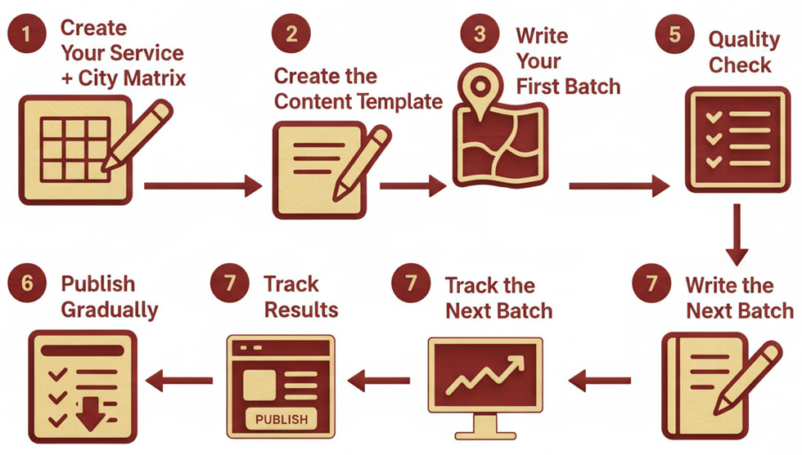

Before You Start
This is going to take time. Don't try to do it all in one day.
Set aside 2-4 hours per week for 4-8 weeks.
That's realistic.

STEP 1: Create Your Service+City Matrix
Open a spreadsheet.

Column 1: Your Main Services
List your 3-7 main services. The ones you actually want customers for.
Example:
- Office Cleaning
- Window Cleaning
- Deep Cleaning
- Moving-Out Cleaning
- Regular Home Cleaning
Don't list every tiny variation. Stick to main categories.

Column 2: Your Service Areas
List the cities/areas where you actually operate and want customers.
Be honest. Don't list cities 100km away that you've never worked in.
Example:
- Silkeborg
- Herning
- Skanderborg
- Hammel
- Viborg

The Matrix
Now you have: 5 services × 5 cities = 25 pages to create
Write them all out:
1. Office Cleaning Silkeborg
2. Office Cleaning Herning
3. Office Cleaning Skanderborg
(etc.)
☐ I've created my complete list of service+city combinations
Total pages I need to create: ______

STEP 2: Create the Content Template
Open a Word document and create your template for one service+city page.
Here's the structure:

[Service] in [City]

Introduction (100-150 words)
[Mention specific areas, landmarks, or characteristics of the city]
[Connect the service to the local area]
[Establish that you actually operate there]

What's Included (150-200 words)
[Describe the service]
[Add local-specific challenges or needs]
[Be specific about what you do]
Who We Help in [City] (100-150 words)
[Types of customers in this area]
[Specific neighborhoods or areas you serve]
[Don't name names, but be specific about types]

Why [City] is Important to Us (100 words)
[Show you actually operate there]
[Mention response times, local staff, or service frequency]
[Make it believable and real]

How It Works (100 words)
[Your process]
[Pricing approach]
[What customers in this area typically choose]

Get a Quote for [Service] in [City]
Call [Your Phone]
Email [Your Email]
[Any other relevant call to action]
```
☐ I've created my content template

STEP 3: Research Local Details
Before you write each page, spend 5-10 minutes researching that city.
Look up:
- Main streets/areas
- Landmarks
- Industrial areas
- Business districts
- Neighborhoods
- Local characteristics
Write down 3-5 specific local details you can mention.
This is what makes your content unique and not just "city name replacement."
☐ I've researched local details for my first 3-5 cities

STEP 4: Write Your First Batch (5 Pages)
Don't try to write all pages at once.
Start with ONE service across 5 cities.
Use your template, but:
- Replace generic text with specific local details
- Mention actual areas/landmarks
- Add real information from your experience
- Make at least 50% of the content unique per page

Checklist for each page:
☐ URL includes service-city (e.g., yoursite.com/office-cleaning-silkeborg)
☐ Page title includes both service and city
☐ H1 heading: "[Service] in [City]"
☐ Meta description mentions both service and city
☐ Introduction mentions specific local areas
☐ At least 500 words total
☐ Phone number is clickable on mobile
☐ Clear call-to-action at the end
☐ No placeholder text left (no [City] or [Service] remaining)

STEP 5: Quality Check
For each page, do this test:
1. Read the page out loud
2. Could you replace the city name with a different city and it would still make sense?
3. If YES → Add more local-specific details
4. If NO → Good, the page is unique enough
☐ My pages pass the uniqueness test

STEP 6: Publish Gradually
Don't publish all pages at once.
Week 1: Publish 2-3 pages
Week 2: Publish 2-3 pages
Week 3: Publish 2-3 pages
Etc.
After each batch:
☐ Submit updated sitemap to Google Search Console
☐ Check that pages are indexed (use site:yoursite.com in Google)

STEP 7: Track Results
Create a simple tracking sheet:
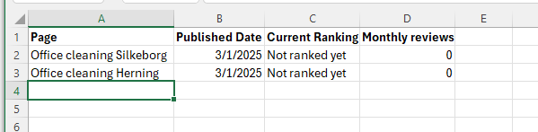
Check once a month. Be patient. Rankings take 2-6 months.
☐ I've created my tracking sheet

STEP 8: Write the Next Batch
Repeat steps 4-6 for your next service.
Don't rush. Quality beats speed.

COMMON MISTAKES TO AVOID
DON’Ts | DOs
Publishing all the pages the same day | Publish 2-3 pages per week over 2-3 months
Copy-pasting content with only city name changes | Write unique local details for each page
Creating pages for cities you don't serve | Only create pages for areas you actually operate in
Writing 2000-word essays | Keep it 500-800 words
Forgetting to add images | Add at least 1-2 relevant images per page
No internal linking | Link from main service page to city variations

THE REALITY CHECK

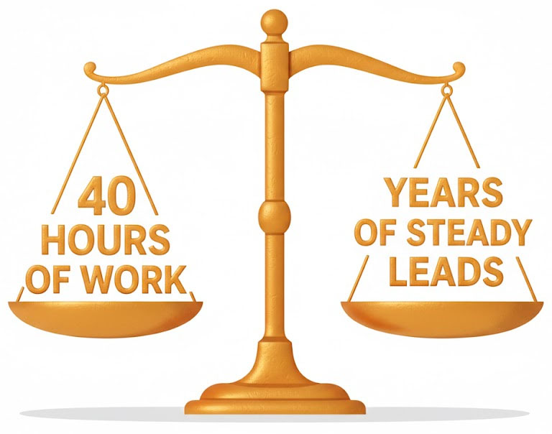
This will take time. Probably 20-40 hours total if you have 25-50 pages to create.
That's okay.
This is a one-time investment that will bring customers for years.
Would you rather:
- Spend 40 hours once creating these pages
- Keep spending money on ads every single month forever
I chose the first option.

YOU'RE DONE WHEN:
☐ You've created pages for all your main service+city combinations
☐ Each page has at least 500 unique words
☐ Each page mentions specific local areas/landmarks
☐ URLs, titles, and headings all include service+city
☐ All pages are published (gradually over weeks)
☐ Pages are submitted to Google Search Console
☐ You're tracking rankings for each page

NEXT STEP
Once you have your service+city pages, you need to organize them properly.
That's where SILO structure comes in.
Let's go there next.


SILO Structure - Why Google Hates Mess
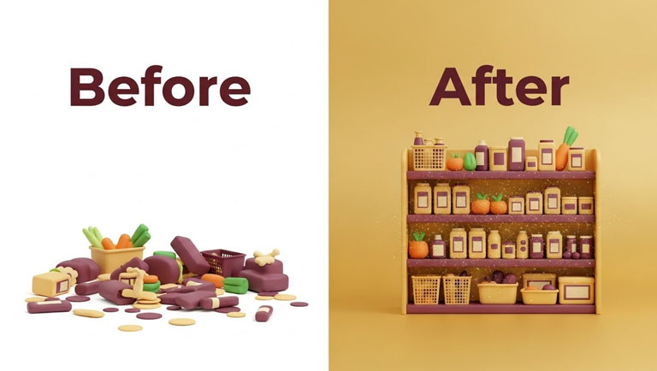
I learned this lesson the hard way! Can I tell you about the time I had to explain my website to Google?
I was sitting there with 47 subpages about cleaning. They all dealt with something about cleaning in Midtjylland. They were all good pages. Long texts. Good pictures. Everything was fine.
But they just lay... randomly scattered around the site.
I had:
- /cleaning-silkeborg
- /commercial-cleaning
- /silkeborg-cleaning
- /window-washing
- /window-cleaning-silkeborg
- /commercial-cleaning-silkeborg
- /professional-cleaning
And so it continued. 47 pages without any logic or structure.
I thought it was smart. "Many pages = many keywords = many customers," I thought.
But you know what Google thought?
"What the hell does this company actually do?"
The result? I ranked for exactly nothing. Because Google couldn't figure out what my website was about.
It wasn't until an SEO consultant looked at my site and said: "Henrik, your website looks like a teenager's bedroom. There's mess everywhere."
That it dawned on me.
GOOGLE DOESN'T LIKE MESS!

What is a SILO Structure?
Imagine your website is a library.
In a good library, books are organized on shelves. All crime novels stand together. All cookbooks stand together. Under cookbooks, there's a shelf with Italian food, one with Thai food, one with baking.
It makes it easy to find what you're looking for.
A SILO structure is the same for websites.
Instead of having 47 random pages, you organize them into logical groups:

Category 1: Cleaning
- Cleaning in Alderslyst
- Cleaning in Virklund
- Cleaning in Sejs
Category 2: Cleaning Service
- Cleaning Service in Alderslyst
- Cleaning Service in Virklund
- Cleaning Service in Sejs
Category 3: Window Cleaning
- Window Cleaning in Alderslyst
- Window Cleaning in Virklund
- Window Cleaning in Sejs
Can you see the structure?
Now Google knows exactly what you do. And exactly where you do it.

My Big Mistake (And How You Avoid It)
Let me tell you what I did wrong.
When I started, I first made a page about "Cleaning in Silkeborg".
Then I thought: "I also need a page about commercial cleaning!"
So I made "/commercial-cleaning-silkeborg"
But where should that page go? Under Cleaning? Or as its own thing?
I became uncertain. So I just put it... somewhere random.
And then I made a page about "Window Cleaning in Silkeborg".
But wait - is window cleaning part of cleaning? Or is it its own service?
I didn't know. So I also just put it somewhere random.
After 6 months, I had 47 pages and I couldn't even navigate them myself.
And if I couldn't navigate them, how was Google supposed to?
Here's what I should have done from day 1:
I should have started by asking myself:
- What are my main categories?
- Which services do I offer under each category?
- Which areas do I cover?
And then built a structure from that.


How to Create the Right Structure

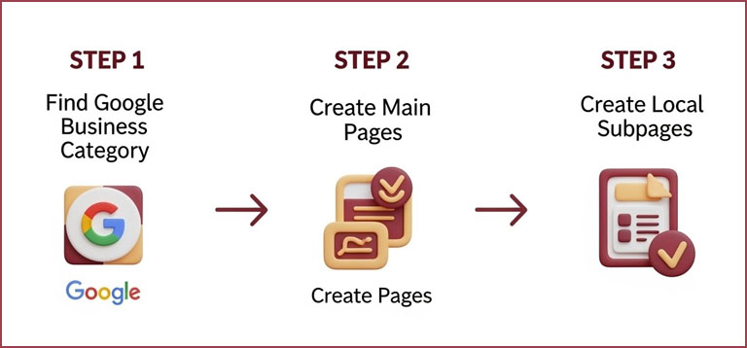
Let me show you exactly how to do it.

Step 1: Find Your Google Business Categories
This is the most important: Your website must match your Google Business profile.
On my Google Business, I have three primary categories:
- Cleaning
- Cleaning Service
- Window Cleaning
So those are also the three categories my website should be built around.
Why? Because Google checks consistency.
If on Google Business you say you do "Window Cleaning", but your website never mentions window cleaning... then Google gets confused.
And confusion = poor ranking.

Step 2: Create a Main Page for Each Category
For each of my categories, I create a main page:
- cleaningmidtjylland.dk/cleaning
- cleaningmidtjylland.dk/cleaning-service
- cleaningmidtjylland.dk/window-cleaning
These pages are my "category pages". They explain what each service entails.
On /cleaning I explain generally about our cleaning. What we do. How we do it. What it costs approximately.
It's a broad overview of the entire category.

Step 3: Create Local Subpages for Each Category
Now comes the magic.
Under each category, I create a page for each of the areas I cover:
Under /cleaning:
- /cleaning/alderslyst
- /cleaning/virklund
- /cleaning/sejs
Under /cleaning-service:
- /cleaning-service/alderslyst
- /cleaning-service/virklund
- /cleaning-service/sejs
Under /window-cleaning:
- /window-cleaning/alderslyst
- /window-cleaning/virklund
- /window-cleaning/sejs
Can you see the pattern?
Each category has its own group of local pages.

Step 4: Link It All Together Logically
This is where many fail.
They create the pages. But they forget to link them together properly.
On my /cleaning page, I have links to all my local cleaning pages:
"We offer cleaning throughout the Silkeborg area, including:
- [Cleaning in Alderslyst]
- [Cleaning in Virklund]
- [Cleaning in Sejs]"
And on each local page, I link back to the main page:
"Read more about our [general cleaning service here]."
This tells Google: "All these pages belong together. They're all about cleaning."

Why It Works (The Technical Explanation)
Let me explain why SILO structure is so powerful.
When Google crawls your website (meaning when they visit it to understand what it's about), they follow links.
If you have a page about "cleaning" that links to 10 other pages about cleaning in different areas, Google thinks:
"Okay, this company specializes in cleaning. They have a main page about it, and then they have dedicated pages for each location. That looks professional. That looks organized. I trust them."
But if you have a page about cleaning that links to a page about window cleaning, which links to a page about commercial cleaning, which links to a page about move-out cleaning, which links back to the homepage... then Google thinks:
"I don't understand. What is their main service? Is it cleaning? Is it window washing? Is it commercial? I'm confused."
And confusion = poor ranking.
A SILO structure makes it crystal clear to Google what you're an expert in.

But Wait - What About Duplicate Content?

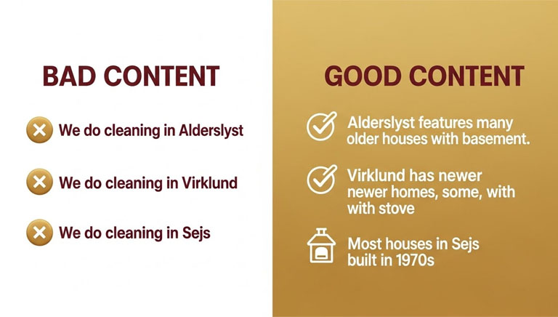
Now you're probably thinking: "But Henrik, if I make a page about cleaning in Alderslyst and a page about cleaning in Virklund... won't it be almost the same content?"
Good question. And yes, that was my concern too.
The solution is: Create actually unique content for each page.
Not just "Cleaning in [Area]" copy-pasted 10 times.
But actually different content.
Let me show you how I do it:
On /cleaning/alderslyst I write:
"Alderslyst is a residential neighborhood from the 1970s with many families. Most houses have large gardens and large windows facing the garden. We know the area well - Tatiana has cleaned over 30 homes in Alderslyst. She knows that many houses have basements that need to be included in deep cleaning, and she knows that older houses often have wallpaper you need to be careful with."
On /cleaning/virklund I write:
"Virklund is a mix of older farms and newer residential houses. Many of the houses are spread out with long driveways. We have experience with both the large older houses that require extra time, and the newer houses where everything is open kitchen-living room. Tatiana has noticed that many in Virklund have wood stoves, so she knows how to remove soot stains from glass and surfaces."
Can you see the difference?
I actually write about the specific area. Not just "we do cleaning here".
It requires a bit of research. A bit of local knowledge. A bit of extra work.
But it works. Because it's real. Because it's specific. And because Google can see it's not just copy-paste.

The Minimum Structure You Need

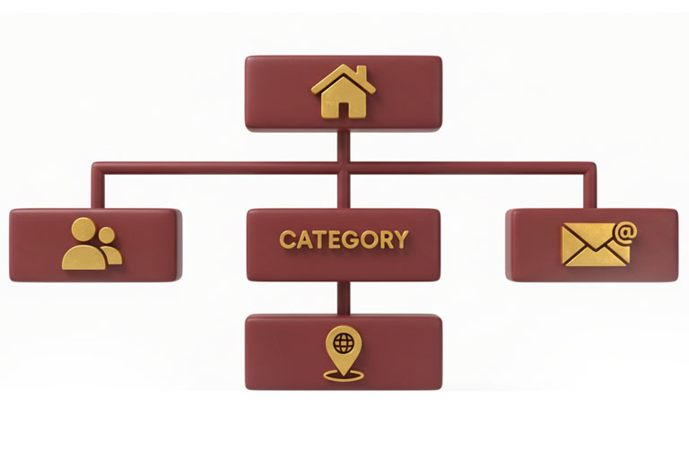
Let me give you the absolute minimum structure your website must have:
- Homepage Your main page that introduces your company.
- About Us Tells who you are (we've dedicated a whole chapter to it).
- Contact Makes it easy to contact you (we also have a chapter about it).
- Category Pages One for each of your Google Business categories.
- Local Service Pages Under each category: One page for each area you cover.
That's minimum. If you have that, you have a solid structure.
Everything else is bonus.

But What If I Offer 10 Different Services?
Good question. Should you then have 10 categories?
No. Keep it simple.
Look at your Google Business categories. You can choose max 10 categories, but Google only weighs the first 3-5 highly.
So focus on your main services.
For my company it's:
- Cleaning (the broad term)
- Cleaning Service (more specific)
- Window Cleaning (specialized service)
I also offer move-out cleaning, deep cleaning, commercial cleaning, etc. But those are sub-services under "Cleaning".
So on my /cleaning page I mention them:
"We offer all forms of cleaning:
- Regular cleaning
- Deep cleaning
- Move-out cleaning
- Commercial cleaning"
But I don't create separate categories for each of them.
Why? Because it would confuse Google. Keep it simple. 3-5 main categories. And then local pages under each.

Mistakes I've Seen Others Make

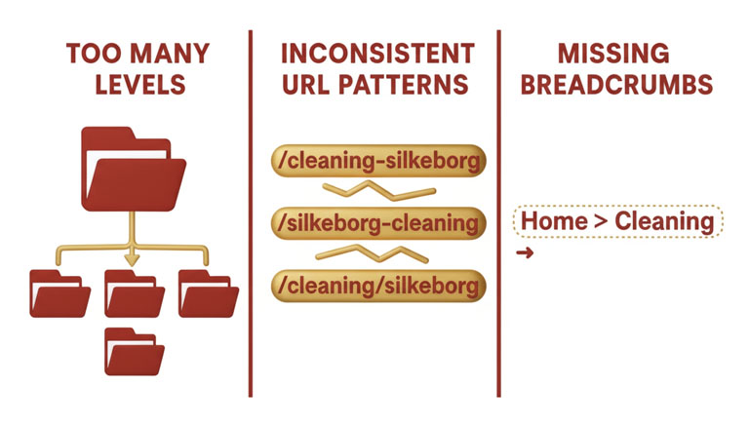
Let me tell you about the worst mistakes I've seen:

Mistake 1: Too Many Levels
I saw a website with this structure:
/services/cleaning/private/silkeborg/alderslyst
That's 5 levels deep!
Google doesn't love that. Neither do users.
Keep it to max 2-3 levels:
/cleaning/alderslyst
Much better.

Mistake 2: Inconsistency
I saw a website where some pages were named:
/cleaning-silkeborg
And others were named:
/silkeborg-cleaning
And some were named:
/cleaning/silkeborg
Choose ONE structure and stick to it!
Mistake 3: Forgetting Breadcrumbs
Breadcrumbs are the small links at the top of the page that show where you are:
Home > Cleaning > Alderslyst
It might seem insignificant. But Google loves them. Because it shows your structure. So make sure to have breadcrumbs on all your subpages.

The Practical Guide: How to Build It
Okay, let me give you a concrete plan:
Step 1: Write Down Your Categories
Open your Google Business profile. Which categories have you chosen?
Write down the 3-5 most important ones.
Step 2: Write Down Your Areas
Which cities/neighborhoods/areas do you cover?
Write them down. Be specific. Not just "Silkeborg" but "Alderslyst, Virklund, Sejs" etc.
Step 3: Create a Matrix
Draw a simple table:
 | Alderslyst | Virklund | Seis
Cleaning | ❌ | ❌ | ❌
Service | ❌ | ❌ | ❌
Window | ❌ | ❌ | ❌
Each X is a page you need to create.

Step 4: Build the Structure

First create your category main pages.

Then create the local subpages.

Link them together.

Step 5: Write Unique Content for Each Page

Not copy-paste. Actually unique content based on the area.

Step 6: Check Everything
Go through each page. Do all links work? Are breadcrumbs there? Is NAP consistent?

The Result
Let me tell you what happened when I switched to a SILO structure.
Before: 47 random pages. Ranked for almost nothing. 8 calls per week.
After: 15 well-organized pages in a clear SILO structure. Ranked for 23 different keywords. 25 calls per week.

Same company. Same services. Actually fewer pages.

But much better structure.

And Google loved it.

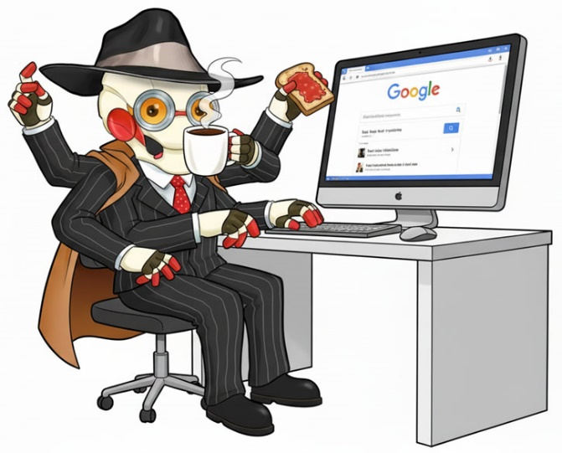

The Most Important Part: How to Link CORRECTLY in a SILO

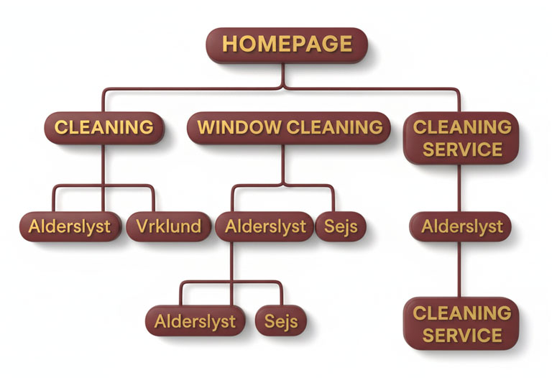
Here I made my biggest mistake when I built my first SILO structure.
I had created all the pages. The category pages were there. The local subpages were there. Everything looked fine.
But I linked like an idiot.
On my page about "Cleaning in Alderslyst" I linked to "Window Cleaning in Viborg" because I thought: "Maybe the customer also wants windows cleaned!"
On my page about "Window Cleaning in Sejs" I linked to "Commercial Cleaning in Silkeborg" because... actually, I don't know why.
I just linked to everything. Crisscross. Because "more links are better," I thought.
But you know what happened?
I DESTROYED MY ENTIRE SILO STRUCTURE!
It finally dawned on me when an SEO consultant said: "Henrik, it's like you've neatly arranged your books on shelves, but then you've taken random books and laid them around on the floor. Now there's mess again."
And he was right.
The Rules for Correct Linking in a SILO
Let me give you the golden rules:
Rule 1: From Homepage to Category Pages
Your homepage should link to all your main categories.
On my homepage I have:
"We offer:
- [Cleaning]
- [Cleaning Service]
- [Window Cleaning]"
These links go to:
- /cleaning
- /cleaning-service
- /window-cleaning
That's okay. In fact, it's necessary.
Rule 2: From Category Pages to Their Local Subpages
On my /cleaning page I have:
"We offer cleaning in the following areas:
- [Cleaning in Alderslyst]
- [Cleaning in Virklund]
- [Cleaning in Sejs]"

These links go ONLY to pages under /cleaning:
- /cleaning/alderslyst
- /cleaning/virklund
- /cleaning/sejs
I do NOT link to /window-cleaning/alderslyst from here!
This is critically important.

Rule 3: From Local Pages Back to Their Category Page
On my page /cleaning/alderslyst I have:
"Read more about our [general cleaning service]."
This link goes back to /cleaning.
Not to the homepage. Not to /window-cleaning. To the category page it belongs under.
Rule 4: NEVER Link Across Between SILOs
This is the most important rule.
On my page /cleaning/alderslyst I do NOT link to:
- /window-cleaning/alderslyst
- /cleaning-service/virklund
- Or any other page outside the "cleaning" SILO
Why not?
Because it confuses Google.
If you link from a page about cleaning to a page about window cleaning, Google thinks: "Hey, are these two things related? Do they belong together? Is it the same service?"
And then your clear structure suddenly becomes unclear.
But Henrik - What If a Customer on Cleaning in Alderslyst Also Wants Window Cleaning?
Good question. And yes, it happens.
But you do NOT solve it with internal links in the text.
You solve it with:
1. Your Top Navigation
It's okay to have a menu where people can click on different categories. That doesn't destroy your SILO because it's a universal navigation.

2. Call-to-Action Box at the Bottom
On all my pages I have at the bottom:
"We also offer:
- Window Cleaning
- Cleaning Service
- Commercial Cleaning"
That's okay because it's a standardized "also interesting" section. It's not textual links within the content.
3. Contact Button
"Need other services? Contact us at +45 22 82 40 85"
Then the customer can ask about it.
Rule 5: Breadcrumbs Must Follow the SILO
On my page /cleaning/alderslyst, breadcrumbs should be:
Home > Cleaning > Alderslyst
NOT:
Home > Areas > Alderslyst > Cleaning
Breadcrumbs show your structure. So they must follow the SILO.



Visualization of Correct Linking
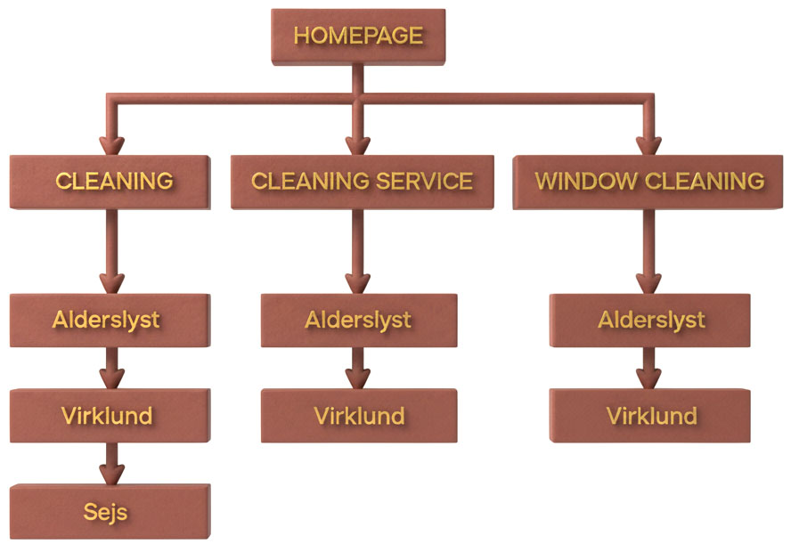
See how each SILO is isolated? Cleaning pages only link to each other. Window cleaning pages only link to each other.
They do NOT cross each other.

What I Did Wrong (And You Shouldn't Do)
When I started, I did it like this:
On /cleaning/alderslyst I wrote:
"We offer cleaning in Alderslyst. We can also help with [window cleaning in Alderslyst] and [commercial cleaning in Silkeborg]. Also read about our [move-out cleaning in Viborg]."
Can you see the problem?
I linked to 3 other SILOs from one page!
It destroyed the entire structure. Google got confused. And my pages ranked worse.
Now I write instead:
"We offer cleaning in Alderslyst. We know the area well and have cleaned over 30 homes here. Read more about our [general cleaning service] or see our other [local cleaning offerings]."
These two links go to:
- /cleaning (the category page)
- /cleaning (where there's a list of all areas)
Both within the same SILO.

Anchor Texts Are Also Important

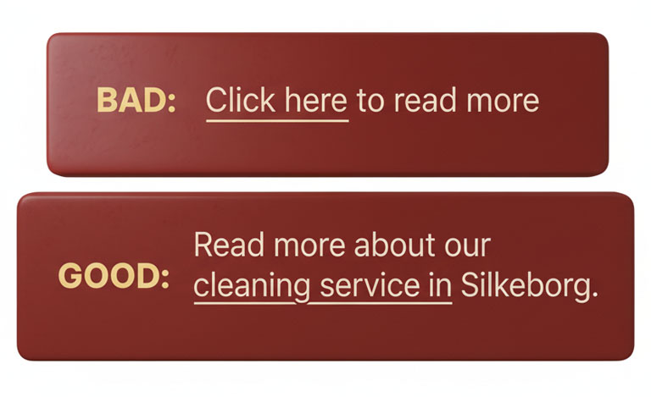
When you link, use descriptive anchor text (the word you click on).

Bad: "Click [here] to read more."
Good: "Read more about our [cleaning service in Silkeborg]."
Why? Because Google reads the anchor text and uses it to understand what the page is about.
If all your links just say "click here" or "read more", Google learns nothing.
But if your links say "cleaning service in Silkeborg", Google understands: "Okay, that page is about cleaning service in Silkeborg."

The Complete Linking Checklist
When you build your SILO, check the following:
✓ Homepage links to all category pages Yes, it should.
✓ Category pages link to their own subpages Yes, and ONLY their own.
✓ Subpages link back to their category pages Yes, it creates a clear hierarchy.
✓ Subpages do NOT link to each other No, not across SILOs.
✓ Subpages do NOT link to other categories No, never.
✓ Breadcrumbs follow the SILO structure Yes, Home > Category > Subpage.
✓ Anchor texts are descriptive Yes, use keywords that describe the page.
✓ Top/footer navigation can link to everything Yes, that's okay. It's universal navigation.

What Happened When I Fixed My Linking

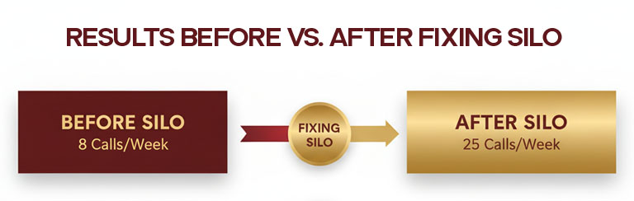
I spent an entire weekend going through all my pages and fixing my links.
Before: Linked crisscross. Chaos.
After: Each SILO was isolated. Clear structure.
The result after 6 weeks:
- "Cleaning Silkeborg" went from position 18 to position 3
- "Window Cleaning Alderslyst" went from position 47 to position 8
- "Cleaning Service Virklund" went from "not on the list" to position 12
Same pages. Same content. Just fixed the links.
It worked.


Conclusion on Linking
A SILO structure isn't enough. You also need to link correctly.
Link vertically (up and down in the same SILO), not horizontally (across between SILOs).
Keep each SILO isolated.
Let the top/bottom navigation handle cross-navigation.
Do that, and Google will understand your structure perfectly.
And then you'll rank higher.
It's work. But it works.
(No shortcuts - you know it!)

Conclusion
A SILO structure isn't about being fancy or creative.
It's about making it easy for Google (and your customers) to understand what you do.
Start with your Google Business categories.
Build a page for each.
Create local subpages under each category.
Link it all together logically.
And write unique, relevant content for each page.
Do that, and Google will understand what you're an expert in.
And when Google understands that, they rank you higher.
And then you get more customers.
It's actually that simple.
(But it requires work. No shortcuts, remember?)


Quiz - Did You Actually Understand SILO Structure?

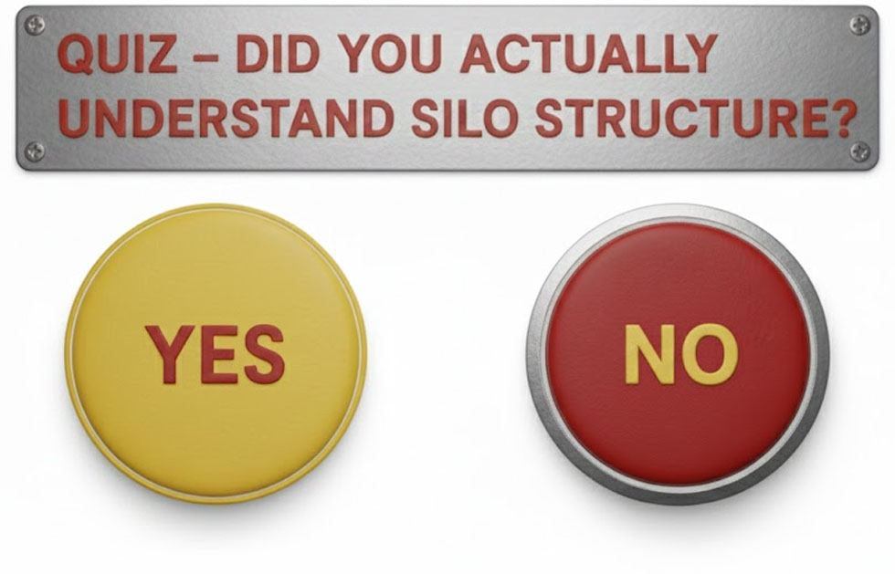
Okay, time to be honest.
Did you actually get SILO structure, or are you thinking "yeah yeah, I'll just create some pages and link them together"?
Let me test you. Because this is where most people screw it up.

Question 1: The URL Structure Test
You're a plumber in London. You offer two main services: Plumbing and Emergency Plumbing. You cover three areas: Chelsea, Kensington, and Westminster.
Which URL structure is CORRECT for your "Emergency Plumbing in Chelsea" page?

A) londonplumber.com/areas/chelsea/emergency-plumbing B) londonplumber.com/emergency-plumbing/chelsea C) londonplumber.com/services/emergency/chelsea D) londonplumber.com/chelsea-emergency-plumbing
Answer: B
Why? SILO structure is: /category/location. Emergency Plumbing is the category, Chelsea is the location. Keep it max 2 levels deep. Simple.

Question 2: The Linking Disaster Test
You're on your page about "Cleaning in Alderslyst" (/cleaning/alderslyst).
Which link would DESTROY your SILO structure?
A) Link to /cleaning (your category page) B) Link to homepage C) Link to /window-cleaning/alderslyst D) Link back to /cleaning with text "Read more about our general cleaning service"
Answer: C
Why? NEVER link across SILOs! /cleaning/alderslyst should ONLY link to pages within the "cleaning" SILO. Linking to /window-cleaning/alderslyst crosses into a different SILO and confuses Google about which service you're an expert in.

Question 3: The Category Question
You offer: Regular cleaning, deep cleaning, move-out cleaning, window cleaning, carpet cleaning, office cleaning, commercial cleaning, and janitorial services.
How many main categories should you create?
A) 8 - one for each service B) 3-5 - group similar services together C) 1 - just "cleaning" D) 10+ - more is better for SEO
Answer: B
Why? Keep it simple. Group similar services under broader categories. Maybe: Cleaning, Window Cleaning, Commercial Cleaning. Then mention sub-services ON those category pages, but don't create separate SILOs for each one. Google gets confused with too many categories.

Question 4: The Duplicate Content Test
You need to write content for "Cleaning in Alderslyst" and "Cleaning in Virklund."
Which approach is correct?
A) Write one page and copy-paste it, just change the city name B) Use AI to rewrite the same content for each page C) Actually research each area and write unique details about that specific location D) Keep it short (50 words) to avoid duplicate content issues
Answer: C
Why? Google can tell when you copy-paste and just swap city names. You need REAL unique content about each area. Talk about the types of houses, local characteristics, your experience there, travel time, etc. Make each page genuinely different.

Question 5: Henrik's Biggest Mistake
When Henrik first built his SILO structure, what did he do wrong?
A) He didn't create enough pages B) He linked across between SILOs C) He forgot to add pictures D) He used the wrong keywords
Answer: B
Why? Henrik said: "I linked like an idiot." He linked from cleaning pages to window cleaning pages because he thought "more links are better." But that destroyed the entire SILO structure. Each SILO must be isolated.

Question 6: The Breadcrumbs Question
On your page /cleaning/silkeborg, what should the breadcrumbs be?
A) Home > Silkeborg > Cleaning B) Home > Services > Cleaning > Silkeborg C) Home > Cleaning > Silkeborg D) Home > Areas > Silkeborg
Answer: C
Why? Breadcrumbs follow the SILO. Since your URL is /cleaning/silkeborg, the breadcrumbs are: Home > Cleaning (category) > Silkeborg (location). It shows the hierarchy clearly.

Question 7: The Linking Rules Test
From your category page (/cleaning), what should you link to?
A) All your local cleaning pages only B) Your local cleaning pages + other category pages C) Everything - more internal links help SEO D) Nothing - let people find pages themselves
Answer: A
Why? From a category page, you link to its subpages ONLY. From /cleaning, you link to /cleaning/alderslyst, /cleaning/virklund, etc. You do NOT link to /window-cleaning or other categories. Keep each SILO isolated.

Question 8: The Real World Scenario
A customer is on your /cleaning/alderslyst page. They're interested but also need window cleaning.
How do you handle this WITHOUT breaking your SILO structure?
A) Add a link in the text: "We also offer [window cleaning in Alderslyst]" B) Create a popup with all your services C) Use top navigation menu + contact CTA ("Need other services? Call us") D) Don't offer any way to discover other services
Answer: C
Why? Universal navigation (top menu) doesn't break SILO structure because it's on every page. And a contact CTA lets customers ask about other services. What you DON'T do is add cross-SILO links within the content.

Question 9: Henrik's Results Test
What happened when Henrik fixed his SILO structure?
A) Nothing changed - SILO is just theory B) He went from 47 random pages to 15 organized pages, and calls went from 8/week to 25/week C) Rankings got worse because he had fewer pages D) It took 2 years to see results
Answer: B
Why? Henrik actually had FEWER pages but better structure. Went from 8 calls per week to 45 calls per week. Same company, same services. Just organized properly.

Question 10: The Structure Test
You have 3 categories and 4 locations. How many pages do you need to create?
A) 7 pages (3 category + 4 location) B) 12 pages (3 × 4) C) 15 pages (3 category + 12 local pages) D) 4 pages (just the locations)
Answer: C
Why? 3 category pages + (3 categories × 4 locations) = 3 + 12 = 15 pages total. Each category gets its own page, then each location gets a page under each category.

Question 11: The Matrix Question
True or False: You should create a spreadsheet matrix with categories as columns and locations as rows before building your SILO.
Answer: TRUE
Why? Henrik specifically recommends this. It helps you visualize exactly how many pages you need and ensures you don't miss any combinations. Each X in the matrix = one page to create.

Question 12: The Anchor Text Question
Which anchor text is better for linking from a local page back to its category page?
A) "Click here" B) "Read more" C) "Our general cleaning service" D) "Back"
Answer: C
Why? Descriptive anchor text helps Google understand what the linked page is about. "Our general cleaning service" tells Google the destination page is about cleaning services. Never use generic text like "click here."

Question 13: How Many Levels Deep?
What's the maximum URL depth you should use in SILO structure?
A) 1 level (/page) B) 2-3 levels (/category/location) C) 5+ levels (/services/cleaning/private/area/city) D) It doesn't matter
Answer: B
Why? Keep it simple. Max 2-3 levels deep. Example: /cleaning/silkeborg. Going deeper (like /services/cleaning/private/silkeborg/alderslyst) confuses Google and users.

Question 14: The Consistency Test
You name some pages "/cleaning-silkeborg" and others "/silkeborg-cleaning" and some "/cleaning/silkeborg".
What happens?
A) Nothing - Google understands B) Google gets confused and your structure breaks C) It helps you rank for more keyword variations D) It's actually recommended for SEO
Answer: B
Why? Inconsistency destroys your SILO structure. Pick ONE format and stick to it everywhere. Henrik specifically called this out as one of the worst mistakes he's seen.

Question 15: The Local Content Test
On your "Cleaning in Virklund" page, what makes it unique from your "Cleaning in Alderslyst" page?
A) Just the city name in the H1 B) 2-3 paragraphs about specific characteristics of Virklund (house types, local details, your experience there) C) Different pictures D) Nothing - they can be the same
Answer: B
Why? Henrik's example: In Virklund he mentions it's a mix of farms and newer houses, many have wood stoves, so Tatiana knows how to remove soot stains. That's UNIQUE to Virklund. Not just "we do cleaning in [city name]."


The Linking Visualization Test
Draw a simple diagram showing:
- Homepage
- 2 categories (Cleaning and Window Cleaning)
- 2 locations under each (Alderslyst and Virklund)
- All correct links
If you can draw this correctly with arrows showing which pages link to each other (without crossing SILOs), you understand SILO structure.
Correct structure should look like:
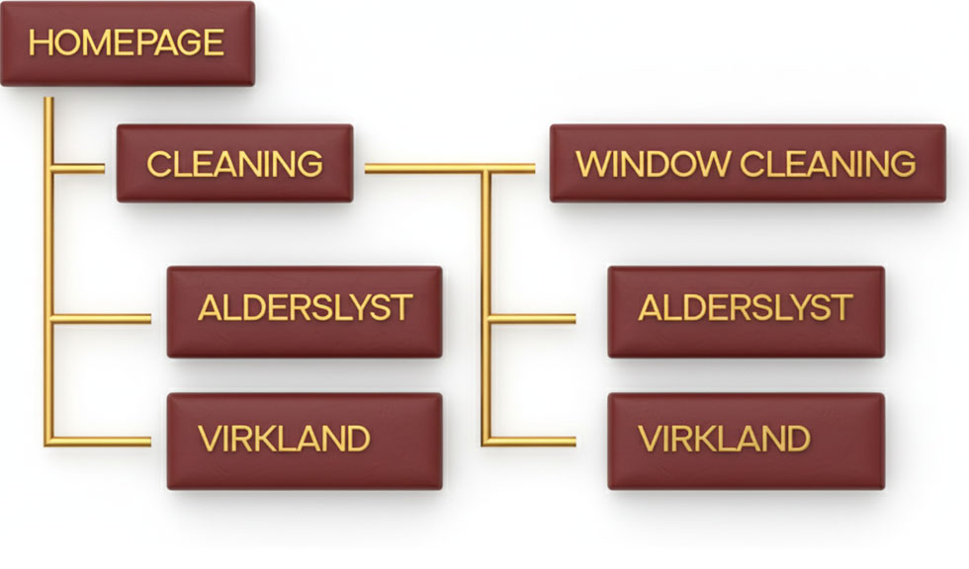Notice: No links crossing between the two SILOs!

Your Score:
13-15 correct: You actually get it. You can build a proper SILO structure.
9-12 correct: You understand the concept but might mess up the linking. Re-read the linking rules.
5-8 correct: You're going to build this wrong. Read the chapter again, especially the linking section.
Below 5: Do not attempt to build a SILO structure yet. Seriously. Go back and read the chapter again. You'll waste weeks building it wrong.

The Real Test:
Now draw your own business's SILO structure on paper:
- List your 3-5 main categories
- List your 5-10 main service areas
- Create the matrix (categories × locations)
- Draw the linking structure
If you can't do this clearly on paper, you're not ready to build it on your website.

The Mistake Test:
Look at your current website (if you have one).
Answer YES or NO:
- Do I link from cleaning pages to window cleaning pages? ___
- Do I have more than 5 main categories? ___
- Are my URLs inconsistent? ___
- Do I have duplicate content across location pages? ___
- Are my URLs more than 3 levels deep? ___
- Am I missing breadcrumbs? ___
If you answered YES to any of these, your SILO structure is broken.

The Bottom Line:
SILO structure isn't complicated. It's just:
- Category pages at /category
- Local pages at /category/location
- Link up and down within each SILO
- NEVER link across SILOs
- Write unique content for each location
- Add breadcrumbs
But most people still screw it up because they don't follow the linking rules.
Don't be most people.
Remember: I went from 8 calls per week to 25 calls per week by ONLY fixing his SILO structure. Same business. Same services. Just better organization. This stuff works if you do it right.

Your Homepage - Why 5 Seconds Determines If You Get the Customer
Can I tell you about the most embarrassing thing that happened to me?
I had spent 3 months building my perfect website. I had written 2000 words on the homepage about how fantastic our cleaning was. I had uploaded 15 beautiful pictures. I had explained our philosophy, our values, our mission.
It was perfect. At least I thought so!
Then one day I was sitting next to a friend while she was booking cleaning. She opened my homepage on her phone.
She scrolled a bit. Scrolled more. Scrolled even more.
And then she said: "Henrik, I can't find the phone number. And I don't understand if you come to Viborg?"
I was shocked. "But it says so! Scroll all the way down and to the left, and you can see..."
She interrupted me: "Henrik, if I have to spend 2 minutes finding your phone number, I'd rather call the first one on Google who has it clearly visible."
And then she called my competitor instead.
IT HURTS TO WRITE EVEN NOW!
But she was right. My homepage was a disaster.

The 5 Seconds That Determine Everything

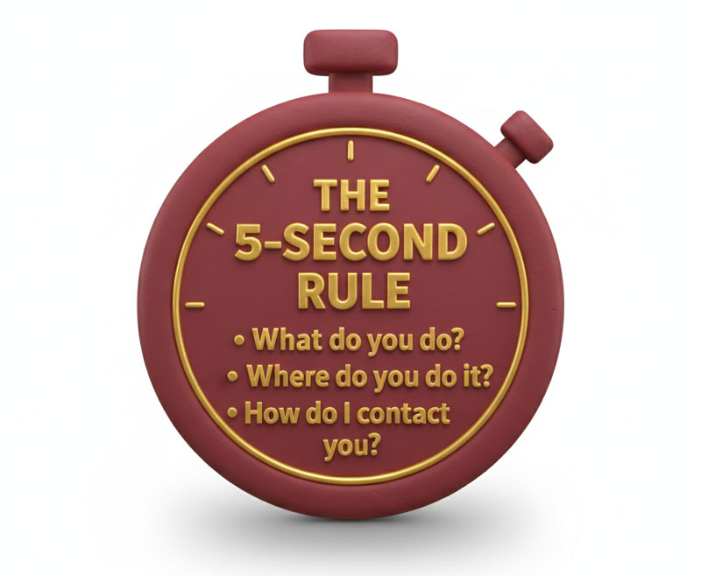
Here's a hard truth:
When people land on your homepage, they give you 5 seconds. Maybe 7 if you're lucky.
In those 5 seconds they need to understand:
- What do you do?
- Where do you do it?
- How do I contact you?
If they can't find the answers to these three questions within 5 seconds, they close the page.
And then they call your competitor.
My old homepage failed on all three points.

My First Catastrophic Homepage
Let me show you what people saw when they opened my first homepage:
At the top: A huge picture of a sparkling clean kitchen (so far so good).
Below the picture: "Welcome to Cleaning Midtjylland - We create harmony in your everyday life"
Below that, 2000 words about: Our philosophy. How we believe in sustainability. How we see cleaning as more than just cleaning. How we want to be part of your journey toward a cleaner life.
Blah blah blah.
Way down at the bottom, in small font: "Contact us for a quote"
No visible phone number. No address. No clear "call us" button.
CAN YOU SEE THE PROBLEM?
People didn't understand what I did. They didn't understand where I covered. And they couldn't figure out how to contact me.

What People Actually Want to Know
Let me tell you what Lone from Silkeborg thinks when she searches "cleaning Silkeborg" and clicks on my page:
Question 1: "Do they come to my city?" She wants to know immediately. She doesn't want to scroll or search.
Question 2: "What does it cost approximately?" She wants an idea. Not an exact price, but a sense.
Question 3: "Can I trust them?" Is it a real company? Do they have good reviews?
Question 4: "How do I book?" What's the phone number? Is there a form? Do they respond quickly?
That's it. Four simple questions.
Does your homepage answer them within the first 5 seconds?
Mine didn't. And that's why I lost customers every single day.

My New Homepage (That Actually Works)

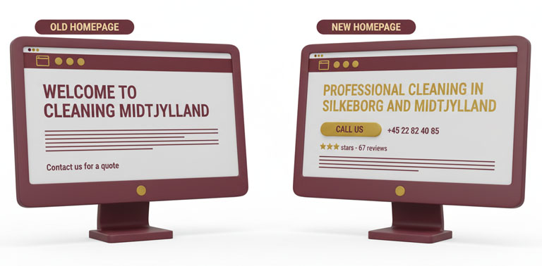
Let me show you what people see now when they open cleaningmidtjylland.dk:

At the very top, first thing they see:
Professional Cleaning in Silkeborg and Midtjylland
📞 Call Now: +45 22 82 40 85
[LARGE GREEN BUTTON: Call Us]
That's the first thing. Before anything else. The headline tells what we do and where. The phone number is huge. The button is impossible to miss.
Right below:
"We cover Silkeborg, Viborg, Herning, Ikast and all of Central Jutland Region"
Now Lone knows if we come to her city. Within 2 seconds.
Below that:
⭐⭐⭐⭐⭐ 4.9 stars on Google - 67 reviews
Now she knows others are satisfied. Social proof immediately.
Then:
A picture of Tatiana at work. A REAL picture. Not a stock photo. The person who actually comes to you.
Under the picture:
"Tatiana and her team have cleaned over 200 homes in Midtjylland since 2023. She moves furniture, cleans thoroughly and always arrives on time."
Now Lone knows who's coming. It's not an anonymous company. It's Tatiana.
All of this is visible without scrolling.
Can you see the difference from my old homepage?

Mobile-First or You're Done
Here's something critically important:
75% of all my visitors come from mobile.
And yet I made my first homepage on my computer. With a large screen. Where everything looked good.
But on mobile? It was a disaster.
The images were too large. The text was too long. The buttons were too small. The phone number was buried.
Now I design the homepage for mobile first.
Here's how I test it:
I open the page on my iPhone. I give myself 5 seconds. Can I find:
- What they do?
- Where they cover?
- The phone number?
If yes - good.
If no - fix it.
It sounds simple. But it's the most important test you can do.

The 7 Elements That MUST Be on Your Homepage

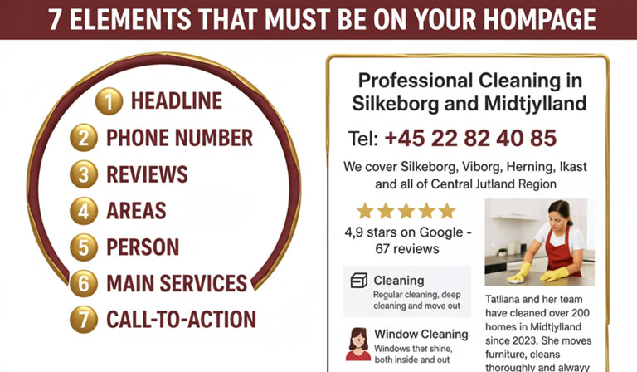
Let me give you the list of what absolutely must be there:

1. Headline That Tells What and Where
Bad headline: "Welcome to Cleaning Midtjylland"
Good headline: "Professional Cleaning in Silkeborg and Midtjylland"
See the difference? The good one tells both what (cleaning) and where (Silkeborg and Midtjylland).
And it should be the first thing people see. Before anything else.

2. Phone Number - Large, Clear, Clickable
Your phone number must be visible without scrolling.

I have mine in two places on the homepage:
- At the top in the header
- In a large button right below the headline
Both are clickable on mobile. Tap and call.
3. Social Proof - Reviews
"4.9 stars on Google - 67 reviews"
It's there immediately. People want to know others are satisfied.
If you only have 3 reviews, write: "See our customer testimonials" and link to your Google Business profile.
Something is better than nothing.

4. The Areas You Cover
People want to know if you come to them.
I write: "We cover Silkeborg, Viborg, Herning, Ikast and all of Central Jutland Region"
Specific. Clear. No doubt.

5. Who's Coming Out?
A picture of the person who performs the work. Not a stock photo. THE PERSON.
Under the picture, a short text:
"Tatiana has cleaned over 200 homes since 2023. She moves furniture, cleans thoroughly and always arrives on time."
Now people know who's coming. That creates security.
6. Your Main Services
Here you link to your SILO structure.
I have three large boxes:
📦 Cleaning Regular cleaning, deep cleaning and move-out cleaning [Read more →] (/cleaning)
🪟 Window Cleaning Windows that shine, both inside and out [Read more →] (/window-cleaning)
🏢 Cleaning Service Customized solutions for private and commercial [Read more →] (/cleaning-service)
These three boxes link to my three main categories in my SILO.
This is where people dive deeper if they want to know more about a specific service.

7. Call-to-Action (Repeat It!)
I have the "Call us" button in three places on the homepage:
- At the top
- In the middle
- At the bottom
Why three times?
Because people read (or scroll) different amounts. Some decide quickly and want to call right away. Others read more first. Others scroll all the way down.
Wherever they are, they should be able to call.

What Should NOT Be on the Homepage
Let me also tell you what to avoid:
❌ Long texts about your philosophy
Nobody wants to read 2000 words about how you see cleaning as a journey or how you believe in sustainability.
If they want to know more, they can go to the "About Us" page.
The homepage should be short, concrete and focused on conversion.
❌ Too many pictures
My first homepage had 15 pictures. It made the page slow to load. And people just scrolled past them all.
Now I have 3-4 pictures. Strategically placed. Of real things (Tatiana at work, before/after, satisfied customers).
❌ Complicated menus
I saw a website that had:
Services > Cleaning > Private > Regular cleaning > Silkeborg
Five clicks to get there!
Keep it simple. From the homepage there should be max one click to your main categories.
❌ Pop-ups that block content
You know the type: "SIGN UP FOR OUR NEWSLETTER BEFORE YOU CAN SEE ANYTHING!"
People hate them. I hate them. Google hates them.
Don't do it.
❌ Auto-playing videos
Nothing is more annoying than opening a website and suddenly a video plays with loud sound.
If you have a video, let it be the user's choice whether to watch it.

EEAT Signals on the Homepage

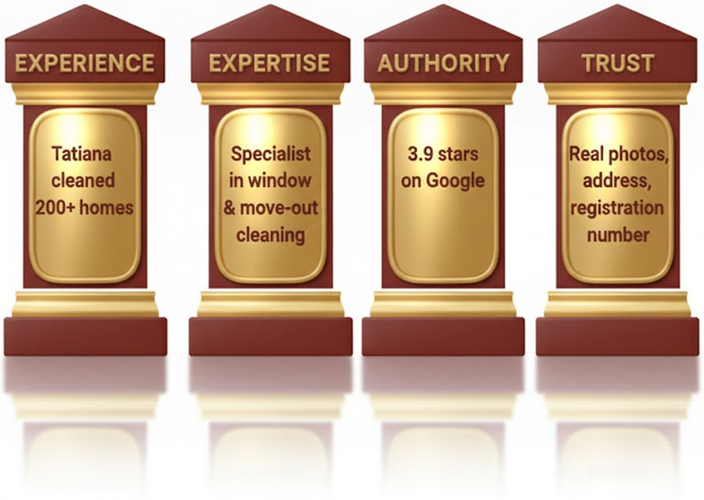
Remember EEAT? It also applies to the homepage.
Experience: "Tatiana has cleaned over 200 homes since 2023"
That shows experience. Concrete numbers. Not just "many years of experience".
Expertise: "Specialist in window cleaning, move-out cleaning and deep cleaning"
That shows what you're good at. Specifically.
Authority: "4.9 stars on Google - 67 reviews"
That shows others trust you.
Trust: Picture of Tatiana (not a stock photo). Phone number. Address in footer. Business registration number in footer.
All signals to Google and customers that you're a real, trustworthy company.

Matching with Google Business
Your homepage must match your Google Business profile.
If your primary category on Google Business is "Cleaning", then that should also be the first thing on your homepage.
If you write on Google Business that you cover "Silkeborg and surrounding areas", then that should also be on the homepage.
The more it matches, the more Google trusts that you're consistent and legitimate.


Speed is Critical

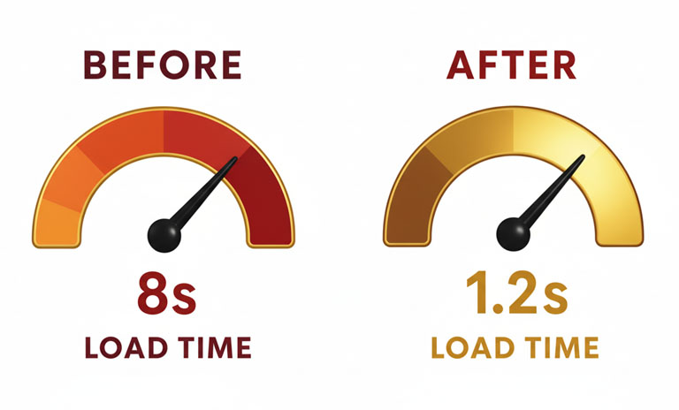
Here's something technical but super important:
Your homepage must load quickly.
If it takes more than 3 seconds to load, people close it.
My first homepage took 8 seconds to load because I had 15 huge images.
Now it takes 1.2 seconds because I:
- Compressed all images
- Removed unnecessary images
- Optimized the code
How do you check it?
Go to pagespeed.web.dev. Enter your website address. See your score.

Under 50? Bad. 50-80? Okay. Over 80? Good.
Mine is at 91 on mobile.

The Complete Homepage Checklist
Let me give you a checklist you can use:
✓ Headline with what and where "[Your service] in [your area]"
✓ Phone number visible without scrolling Large, clear, clickable
✓ Call-to-action button "Call us" or "Get a quote"
✓ Social proof Reviews, number of customers, stars
✓ List of areas you cover Specific, clear
✓ Picture of the person coming Real picture, not stock photo
✓ Links to your main categories Max 3-5 services
✓ Repeat call-to-action At least 2-3 times on the page
✓ Footer with contact info Address, email, phone, hours, business registration
✓ Loads quickly Under 3 seconds
✓ Looks good on mobile Test on your phone!

What Happened When I Changed My Homepage

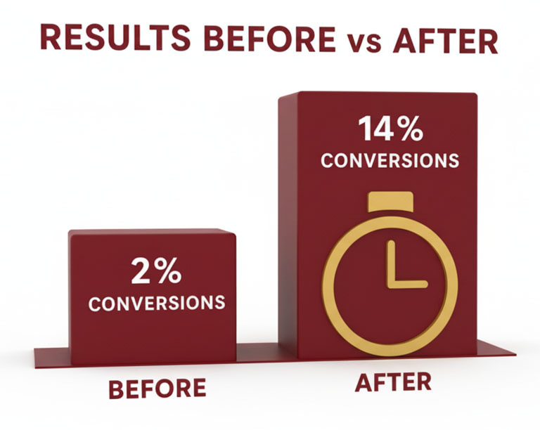
Before: 2000 words about philosophy. No clear phone number. Messy. Conversion rate: 2% (of 100 visitors, 2 called)
After: Short, focused, clear phone number, clear call-to-actions. Conversion rate: 14% (of 100 visitors, 14 called)
Same company. Same services. Same prices.
Just a better homepage.
That's an increase of 600%.
Six hundred percent!
And all I did was make it easy for people to understand what I do and how to contact me.

The Ultimate Test
Let me give you the ultimate test for whether your homepage works:
Give your phone to a stranger (or your mom, as in my case).
Ask them to open your homepage.
Start a stopwatch.
Ask them to find:
- What you do
- If you cover their area
- How to call you
If it takes more than 10 seconds, you've failed.
Fix it.

Conclusion
Your homepage isn't there to show how creative you are.
It's not there to tell your life story.
It's not there to explain your philosophy.
Your homepage has ONE job:
To get people to call or write to you.
That's it.
Everything else is distraction.
So keep it simple. Keep it focused. Keep it mobile-friendly.
Answer the four questions:
- What do you do?
- Where do you do it?
- Can I trust you?
- How do I contact you?
Do that, and your homepage will convert.
And then you'll get more customers.
It's actually that simple.
(But it took my friend contradicting me before I realized it...)


The Boring Pages - And Why You'll Get Fined If You Don't Have Them
Can I tell you about the time I almost got fined $7,000?
It was in 2023. I had spent months building my website. Beautiful homepage. Good structure. Smart SILO. Everything was perfect.
Then one day I got an email from the Data Protection Authority.
My heart sank.
It said: "We have received a complaint that your website lacks mandatory information according to GDPR..."
I had forgotten the boring pages.
Privacy policy? Didn't have one. Cookie policy? Didn't have one.
I had been SO focused on getting customers that I had forgotten all the legal stuff.
And now I could potentially get a huge fine.
Fortunately, I got off with a warning. But it was enough for me to learn my lesson:
THE BORING PAGES ARE NOT OPTIONAL. THEY ARE LEGALLY REQUIRED!

Why I Called Them "Boring Pages"
Let's just be honest.
Privacy policy. Cookie policy. Terms and conditions.
It's not exactly sexy content.
Nobody wakes up in the morning thinking: "I'm looking forward to writing my cookie policy!"
And no customers visit your website to read your privacy policy.
But you know what?
They need to be there anyway.
Both because the law requires it. And because Google and your customers look for them.

The 4 Pages You MUST Have

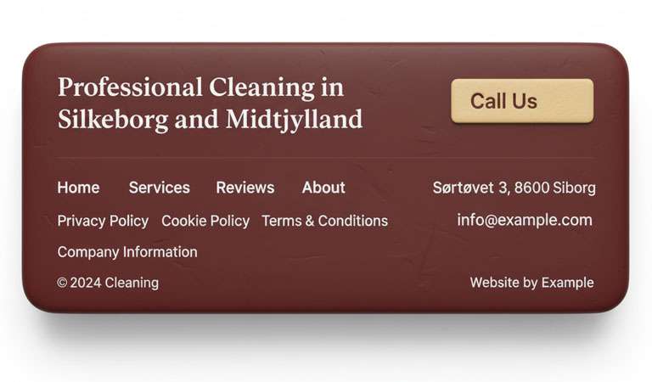
Let me give you the list:
- Privacy Policy
- Cookie Policy
- Terms and Conditions (if you sell something)
- Company Information (Business registration, address, contact)
Let me go through each one.

Privacy Policy - The Most Important

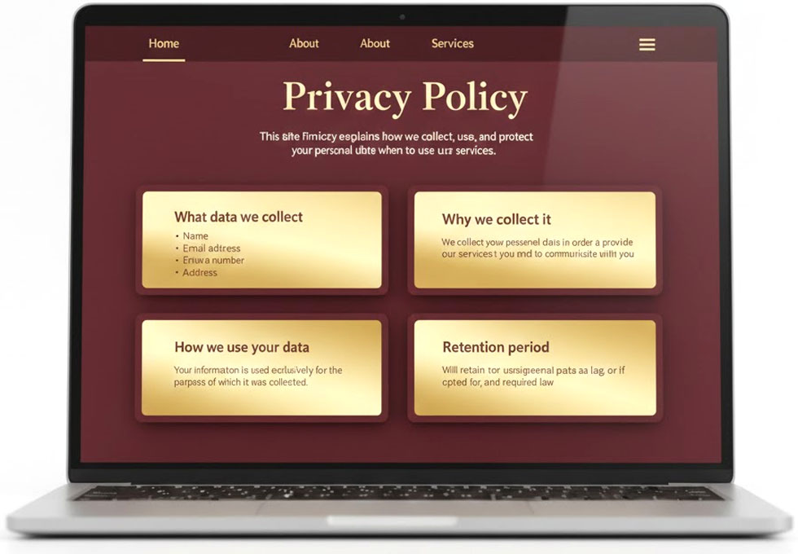
This is the page you absolutely cannot skip.
GDPR (the EU law on data protection) requires you to tell people:
- What personal data do you collect?
- Why do you collect it?
- What do you use it for?
- How long do you keep it?
- Who do you share it with?
- How can people get their data deleted?
Does that sound complicated? It is a bit.

My First Stupid Mistake
When I first had to create my privacy policy, I thought: "I'll just copy one from another website and change the name!"
DON'T DO THAT!
First of all, it's illegal (you're copying others' text).
Second, it doesn't fit your business.
I copied a privacy policy from a company that sold online. They wrote about "purchase history" and "payment information" and a lot of other stuff I didn't collect at all.
That made my privacy policy a lie. And that's actually worse than not having one at all.

What Should Be in Yours?
Let me give you the concrete things:
What data do you collect?
For my company:
- Name (when people book)
- Phone number (so I can call back)
- Email (so I can send confirmation)
- Address (so Tatiana knows where to go)
That's it. I don't collect social security numbers, credit cards, birthdays or anything else.
So that's what should be stated.
Why do you collect it?
"We collect name, phone, email and address to be able to perform the cleaning you order and to be able to contact you about the booking."
Simple. Honest.
What do you use it for?
"We use your information solely to perform the service you have ordered. We don't send spam. We don't sell your data. We don't share it with others."
How long do you keep it?
"We keep your information for 5 years after the last booking, as required by bookkeeping law. After that, it's deleted."
How can people get their data deleted?
"Contact us at kontakt@cleaningmidtjylland.dk if you want your data deleted. We'll delete it within 30 days."
That's it. Not more complicated than that.

Use a Template (The Right Way)
I ended up using a legal template from a business association.
They cost around $70. Yes, that's money. But it's much cheaper than a $7,000 fine.
The template was made by lawyers. I just had to fill in the parts that were relevant to my business.
It took me 1 hour. And now I'm legally covered.

2. Cookie Policy - The One You Can't Avoid
Almost all websites use cookies.
What are cookies? They're small data files that are saved on the user's computer.
Google Analytics? Uses cookies. Facebook Pixel? Uses cookies. Contact forms? Often use cookies.
And if you use cookies, you need a cookie policy.

What Should It Say?
What cookies do you use?
On my site I use:
- Google Analytics (to see how many visitors I have)
- Google Ads (to show ads)
- Facebook Pixel (to be able to do retargeting)
So that needs to be in my cookie policy.What are they used for?
Google Analytics: "To measure traffic and understand how visitors use our site."
Google Ads: "To show relevant ads to people searching for cleaning."
Facebook Pixel: "To be able to show ads to people who have visited our site."
How can people say no?
"You can turn off cookies at any time in your browser settings."

The Cookie Banner
You know that annoying banner that pops up on all websites: "We use cookies..."
Yeah, you need that.
It's legally required.
Use a plugin.
It automatically creates:
- The cookie banner
- The cookie policy
- The ability to say yes/no to different types of cookies
It took 10 minutes to set up. And now I'm covered.

3. Terms and Conditions - If You Sell Something
If people can book and pay directly on your website, you need terms and conditions.
But if they just call or write (and pay after the work is done), then it's not legally required.
I have them anyway. Because it looks professional.

What Should It Say?
Prices: "Our prices are indicative and depend on the size of the task. You always get a binding quote before work begins."
Payment: "Payment is made after completed work via mobile payment or bank transfer."
Cancellation: "Cancellation must be made at least 24 hours before the agreed time. For later cancellation, we reserve the right to charge 50% of the price."
Complaints: "If you're not satisfied with the work, contact us within 24 hours and we'll come out and fix it for free."
It's not complicated. It's just about setting expectations.

4. Company Information

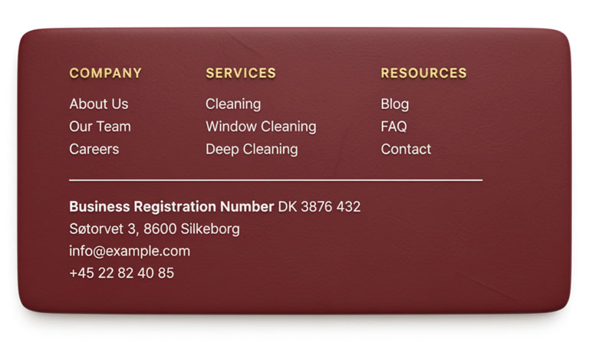
SO many people forget this.
According to law, your website must have:
Business Registration Number: Your company's registration number.
Company Name: The official name. "Cleaning Midtjylland" (or whatever yours is called)

Address: Your business address. "Søtorvet 3, 8600 Silkeborg"
Contact Information: Email and phone. "kontakt@cleaningmidtjylland.dk - +45 22 82 40 85"
All of this should be easy to find. I have it in my footer on all pages.

Why Is It Important?
First, it's legally required.
Second, it sends signals to Google and customers that you're a real, registered company.
I tested it. Before I had the registration number visible on the site, I often got questions: "Are you a real company?"
After I added it? No questions. People could look it up themselves and see we're registered.

Where Should They Be?
The boring pages should be easy to find, but not in the way.
I have them in my footer:
Privacy Policy | Cookie Policy | Terms and Conditions
Small links. At the bottom of each page.
People looking for them can find them. But they're not in the way for those who just want to book.
Do NOT: Make a big button on the homepage: "READ OUR PRIVACY POLICY!"
Nobody wants that. And it takes focus away from what's important (getting people to call).

But Google Actually Loves Them
Here's something I didn't know:
Google actually uses these pages as part of their EEAT assessment.
A website with privacy policy, cookie policy and visible business registration gets points for trustworthiness.
Why? Because it shows that you:
- Follow the law
- Are transparent
- Are a real company
- Respect users' privacy
All EEAT signals.
So yes, they're boring. But they actually help your SEO too.

How I Made Them (Without Going Crazy)
Let me give you my concrete process:
Step 1: Buy Legal Templates
I used a business association template. $70 for the package with privacy policy, cookie policy and terms and conditions.
There are also free generators online, but they're often not good enough for specific regional requirements.
Step 2: Fill Out the Templates
I spent 2 hours reading them through and filling in the parts that were relevant to my business.
Delete what doesn't apply. Keep what does.
Step 3: Create Pages on the Website
Make three new pages:
- /privacy-policy
- /cookie-policy
- /terms-and-conditions
Copy in the text.
Step 4: Link to Them in Footer
On all your pages, there should be links to these three pages at the bottom.
Step 5: Set Up Cookie Banner
Use Cookiebot or similar. Takes 10 minutes.
Done.
It took me a total of 3 hours. And now I never have to think about it again.

What Happened After the Authority's Letter
After I got the letter from the Data Protection Authority, I spent a weekend getting everything sorted.
I made all the mandatory pages. I set up the cookie banner. I made the business registration number visible.
I sent an email back to the Authority: "We have now corrected all points. Here are links to the pages."
They replied: "Thank you. The case is now closed."
Phew.
But here's the interesting thing:In the next 3 months, my ranking on Google increased.
Not dramatically. But steadily.
From position 8 to position 4 for "cleaning Silkeborg".
Was it because I added the mandatory pages? Maybe partly.
Google could now see I was a serious, law-abiding company.

The Complete Checklist for Legal Pages

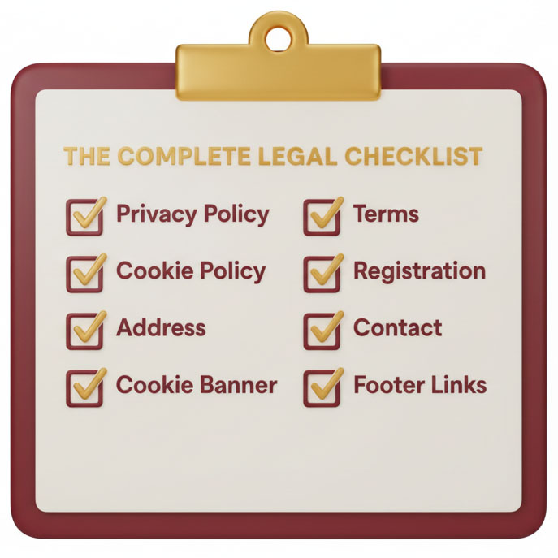
Here's your checklist:
✓ Privacy Policy Make with legal template, adapt to your business
✓ Cookie Policy If you use cookies (and you probably do)
✓ Terms and Conditions If people can book/buy on your site
✓ Business Registration Number visible In footer on all pages
✓ Company Name (official) As it appears in business registry
✓ Business Address Visible in footer
✓ Contact Information Email and phone
✓ Cookie Banner Must be shown first time people visit
✓ Links to all pages in footer Small, discreet, but visible
✓ Updated date "Last updated: [date]" - so people can see it's current

Fines You Can Get
Let me scare you a bit:
Missing privacy policy: Up to $7,000 for small businesses. Up to $200,000 for large ones.
Missing cookie consent: Up to $3,500.
Missing business registration: Up to $1,500.
Is it likely you'll get a fine? No, not very.
But can you get one? Yes, absolutely.
All it takes is one angry customer who complains to the Data Protection Authority.
Or the Authority does a random inspection (they did in my industry in 2023).
So why take the chance?

Conclusion
The boring pages are boring.
Nobody reads them. Nobody thinks they're exciting.
But they need to be there.
Both because the law says so. And because Google and your customers expect it.
So spend a weekend getting it done.
Buy legal templates. Fill them out. Upload them. Link to them in footer. Set up cookie banner.
Done.
Then you never have to think about it again.
And you avoid letters from the Data Protection Authority that make your heart sink.
(Trust me, that's not an experience you want.)


Call to Action - Why People Read Your Page and Then... Do Nothing
Can I tell you about the worst statistic I've ever seen?
When I set up Google Analytics on my website, I could see exactly what people did.
And the numbers were depressing:
- 100 people visited my homepage every day
- 47 of them scrolled all the way down
- 23 of them clicked through to a subpage
- 12 of them visited the "Contact Us" page
And how many called or wrote?
Two people out of 100.
I had 98 people who were interested enough to visit my website, but who didn't do anything.
They read. They looked. And then... nothing.
Why?
Because I didn't tell them what to do.
I WAS MISSING PROPER CALL TO ACTIONS!

What is a Call to Action?

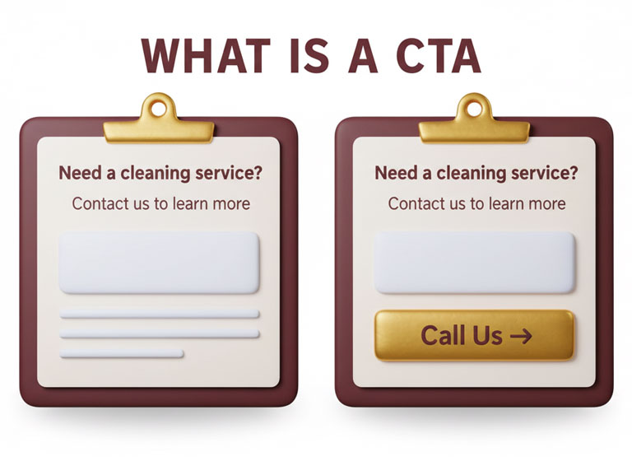
A Call to Action (abbreviated CTA) is simply a message that tells people what to do now.
"Call us" "Get a quote" "Book a time" "Write to us"
It sounds simple. Maybe too simple.
But here's the truth:
People are lazy. I'm lazy. You're lazy.
If you don't tell us exactly what to do, we do nothing.

My First Website (Without CTA)
Let me show you what my first website looked like:
Homepage: Long text about how good we are. Pictures of clean homes. Description of our services.
At the bottom: "Contact us for more information"
That was it. No button. No phone number. Just "contact us".
What happened? People read, thought "okay, they sound fine", and then...
Closed the page.
Because I didn't tell them how to contact us. Or why they should do it NOW.

My New Website (With CTA Everywhere)
Now it looks like this:
At the top of the homepage: 📞 Call Now: +45 22 82 40 85 [LARGE GREEN BUTTON: Call Us →]
After the description of our service: "Ready for a clean home?" [BUTTON: Get a Free Quote →]
In the middle after reviews: "See why 67 customers give us 4.9 stars" [BUTTON: Book a Time →]
At the bottom: "Let us help you get a clean home" [BUTTON: Call +45 22 82 40 85 →]
Can you see the difference?
Now I tell people exactly what to do. And I make it easy.

The Result?
Before (no proper CTA): 2 inquiries out of 100 visitors = 2%
After (CTA everywhere): 14 inquiries out of 100 visitors = 14%
That's an increase of 600%.
Same website. Same services. Same prices.
I just added clear buttons that told people what to do.

The 3 Types of CTA You Need to Use

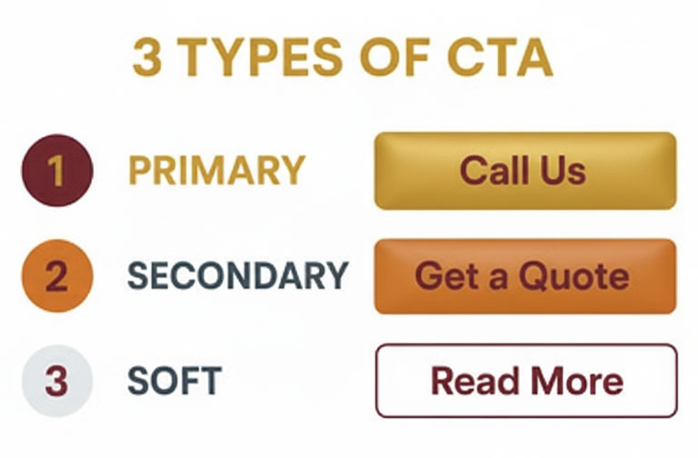
There are three main types of CTA, and you need to use them all:

1. The Primary CTA - Call Us
This is the most important one.
For tradespeople and service providers, people prefer to call. Right away. While they're thinking about it.
So your primary CTA should be:
[Call us: +45 22 82 40 85]
Not "contact us". Not "get more info". Just "Call us" and the phone number.
And make it BIG. With colors that stand out.
I use a green button. Green signals "go" in people's brains. It works.

2. The Secondary CTA - Get a Quote
Some people don't want to call. They'd rather write.
So your secondary CTA should be:
[Get a Free Quote]
This link goes to your contact page or opens a form.
I use a white button with green text. So it's visible, but not as dominant as the green "Call us" button.

3. The Soft CTA - Read More
For people who aren't ready to book yet, but want to know more:
[Read about our services →]
This is just a link (not even a button) that takes them to a subpage.
I use it after each service description on the homepage.

Where Should You Place Your CTAs?

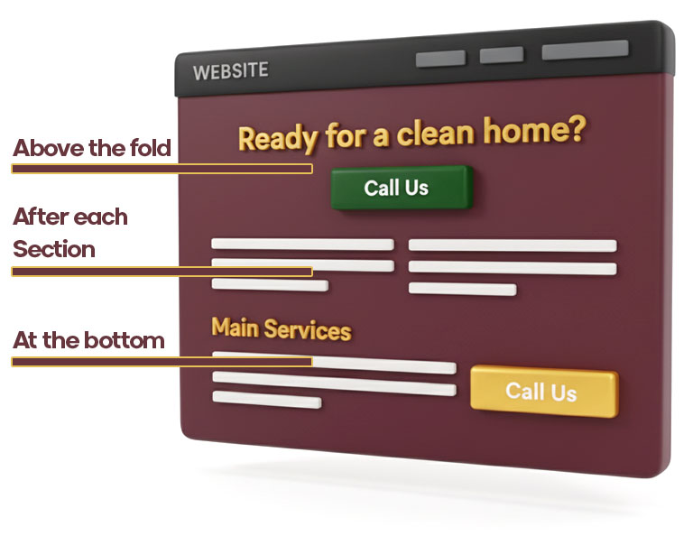
Here's the golden rule:
Everywhere.
No, seriously. People read different amounts. Some decide quickly. Others read everything first.
So you need CTAs in multiple places:

Above the Fold
That means "before people need to scroll".
The first thing people see when they open your page should be a CTA.
On my homepage, the first thing people see is:
📞 Call Now: +45 22 82 40 85 [BUTTON: Call Us]
It's there before anything else. Nobody needs to scroll to find it.

After Each Section
When people have read about a service, they should be able to act immediately.
On my homepage after I've described regular cleaning:
"Ready to get your home cleaned?" [BUTTON: Book a Time]
After I've shown reviews:
"Want to be a satisfied customer too?" [BUTTON: Call Us]
After I've shown prices:
"Sound like something for you?" [BUTTON: Get a Quote]

At the Bottom
Some people scroll all the way down before deciding.
So at the bottom of each page I have:
"Ready to get started?" [LARGE BUTTON: Call +45 22 82 40 85]

Words That Work (And Those That Don't)

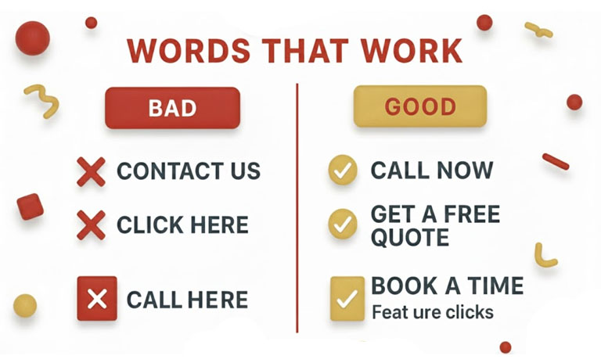
Let me show you the difference between bad and good CTA texts:

Bad CTA Texts:
❌ "Contact us" Too generic. How should they contact you? What happens then?
❌ "Click here" Meaningless. Click here for what?
❌ "Send inquiry" Sounds bureaucratic and heavy.
❌ "Get more information" Boring. No urgency.
❌ "Fill out the form" Work. People don't want to work.

Good CTA Texts:
✅ "Call now: +45 22 82 40 85" Direct. Clear. The phone number is right there.
✅ "Get a free quote" Free is a magic word. And "quote" is concrete.
✅ "Book a time" Short. Simple. You know what happens.
✅ "Start today" Creates urgency without being pushy.
✅ "See our prices" Concrete. People want to know what it costs.

Mobile-Friendly CTAs
Here's something critically important:
75% of my visitors come from mobile.
And on mobile, your CTAs must be CLICKABLE.

Before (bad):
"Call us at +45 22 82 40 85"
Just text. People have to remember the number or copy it. They won't bother.

After (good):
[Call now: +45 22 82 40 85]
The phone number is a link. Tap it, and the phone calls automatically.
It took me 2 minutes to fix. And my calls increased by 40%.
People are lazy. The easier you make it, the more will call.

Colors That Convert
I tested different colored buttons. Here's what I learned:
🔴 Red button: 8% conversion People are a bit skeptical. Red can signal "stop" or "danger".
🔵 Blue button: 9% conversion Okay, but blended too much into the design.
⚪ White button: 7% conversion Too discreet. People overlooked it.
🟢 Green button: 14% conversion WINNER! Green signals "go" and "positive action".
🟠 Orange button: 12% conversion Second best. Stands out and signals energy.
I now use green for my primary CTA ("Call now") and orange for secondary ("Get quote").

Size Matters
My first CTA button was small and discreet. I didn't want to seem pushy.
Result? People overlooked it.
Now my "Call now" button on the homepage is:
- 250 pixels wide
- 60 pixels tall
- Bold font
- Large enough to hit with your thumb on mobile
Is it too big? Maybe.
But it works. And that's all that matters.

Urgency Without Being Sleazy
Some sites write:
"OFFER EXPIRES IN 23 HOURS 14 MINUTES!"
That's... sad. And often a lie.
But you can create urgency in an honest way:
✅ "We have 3 available times this week" True. Creates mild urgency.
✅ "Book before Friday and get 10% discount" Concrete offer with deadline.
✅ "Call today - we respond within 2 hours" Shows you're fast. That's valuable.
❌ "TODAY ONLY - 50% OFF!" Seems desperate. And dishonest.

CTA on Every Subpage
It's not enough to have CTA on the homepage.
Every single subpage should also have them.
On my page /cleaning/alderslyst I have:
At the top: "Cleaning in Alderslyst" [BUTTON: Call for booking: +45 22 82 40 85]
After the description: "Live in Alderslyst?" [BUTTON: Get a Quote]
At the bottom: "Ready to get Tatiana out?" [BUTTON: Book a Time]
Again: Multiple CTAs. Different places. For different types of readers.

The Personal CTA
Here's a little secret that works incredibly well:
Use the customer's situation in the CTA.
Generic CTA: "Book a cleaning"
Personal CTA: "Tired of spending weekends cleaning?" [BUTTON: Let Us Help]
Can you feel the difference?
The personal one speaks directly to the customer's problem.
On my page about move-out cleaning:
"Stressed about having to hand over the property?" [BUTTON: We'll Handle the Cleaning]
On my page about commercial cleaning:
"Want your customers greeted by a clean office?" [BUTTON: Book Weekly Cleaning]
Same concept. But adapted to the situation.

The Test I Learned Most From
I did an A/B test (meaning half the visitors see version A, and half see version B).
Version A: [BUTTON: Get a Quote]
Version B: [BUTTON: Get a Free Quote (response in 2 hours)]
Can you guess which won?
Version B won with 73% more clicks.
Why?
"Free" removes risk. "Response in 2 hours" creates urgency and shows I'm fast.
It was the same 6 extra words. But they made a huge difference.

Multiple CTAs on the Same Page
You might think: "But Henrik, if I have 5 different CTAs, won't people get confused?"
Good question. And yes, they can.

That's why I use this structure:
Primary CTA (repeated 3 times on the page): "Call now: +45 22 82 40 85"
Secondary CTA (repeated 2 times): "Get a free quote"
Tertiary CTA (once): "Read more about our services"
See the pattern? The most important is repeated most. The less important ones less.
And they look different (different colors, different sizes), so people don't get confused.

CTA in Footer (The Forgotten Goldmine)
Many people forget the footer.
But some people scroll all the way down. And then they should be able to act.
My footer has:
Ready for a clean home?

📞 Call now: +45 22 82 40 85
✉️ kontakt@cleaningmidtjylland.dk

[BUTTON: Get a Free Quote]

We cover Silkeborg, Viborg, Herning and all of Midtjylland
It's a complete CTA section. At the bottom of every single page.

What Does NOT Work
Let me also tell you what I tested that did NOT work:
❌ Pop-ups that block content "WAIT! Get 20% off if you book now!" People hate them. Conversion rate dropped by 30%.
❌ Too many choices I tested a page with 7 different buttons. People got paralyzed by choice and clicked on none of them.
❌ CTA without contrast I had a blue button on a blue background. Genius, Henrik. Nobody saw it.
❌ Vague promises "Book now and experience the difference!" What difference? It means nothing.
❌ Too small text I had "Call: 22824085" in 10px font. My mom couldn't read it. If she can't, customers can't either.

My Complete CTA Checklist for Each Page

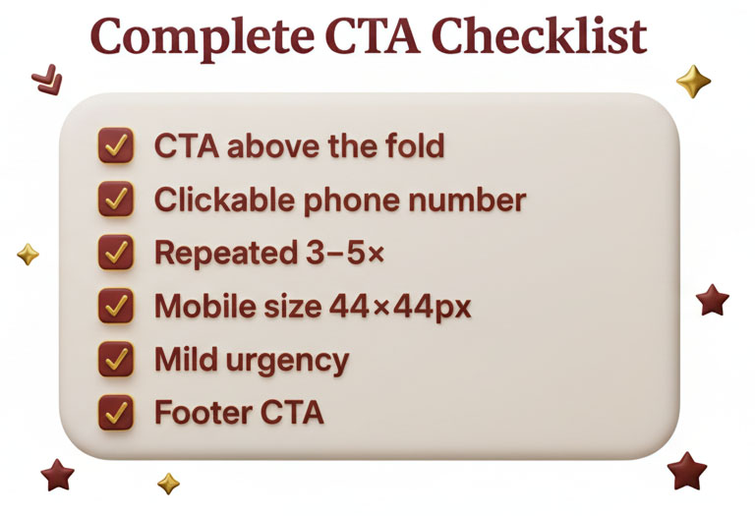
Here's what each page should have:
✓ Primary CTA above the fold Before people need to scroll
✓ Phone number clickable On mobile it must be a link
✓ Button that stands out Color with contrast to the rest of the page
✓ Concrete text "Call now" not "contact us"
✓ Repeat CTA 3-5 times After each section, at the bottom, in footer
✓ Different types Call, write, read more
✓ Large enough for mobile At least 44x44 pixels (Apple's recommendation)
✓ Creates mild urgency "Get response in 2 hours" or "3 available times this week"
✓ Personal to the situation "Tired of spending weekends cleaning?"
✓ Footer CTA For those who scroll all the way down

Conclusion
A Call to Action isn't fancy marketing talk.
It's simply telling people what to do.
People are lazy. I'm lazy. You're lazy.
If you don't tell us what to do, we do nothing.
So tell them. Clearly. Repeatedly.
"Call now: +45 22 82 40 85"
It's not complicated. But it needs to be there.
On every page. Multiple times. With colors that stand out. With text that's concrete.
Do that, and your inquiries will increase.
Not because your service got better. Not because your website got prettier.
Just because you told people what to do.
And then they did it.It's actually that simple.
(And yet I had overlooked it for 6 months...)

Images - Why Stock Photos Destroy Your Credibility
Can I tell you about the time a potential customer said no to me... before she had even heard the price?
I had sent her a link to my website. She wrote back 10 minutes later:
"Thanks for the quote, but I don't think it's for me."
I was confused. She hadn't even asked about price. So I wrote back: "May I ask why?"
Her answer made me realize how much I had failed:
"Your pictures look fake. That perfect cleaning lady with the white outfit looks like something from an ad. I don't believe it's actually you who will come out."
She was right.
All my pictures were stock photos. Glossy images of perfect people in perfect settings doing perfect cleaning.
And people could smell it from a mile away.
I HAD DESTROYED MY OWN CREDIBILITY WITH FAKE IMAGES!

Stock Photos vs Real Pictures

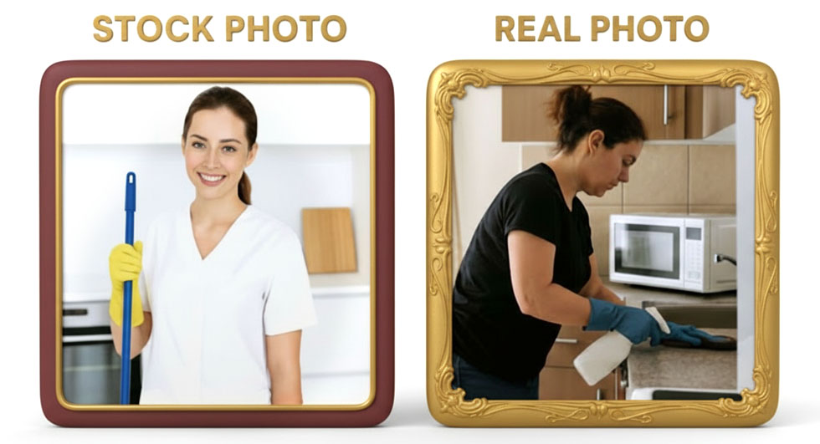
Let me show you the difference:
My First Pictures (Stock Photos):
- A beautiful woman in shiny white cleaning outfit
- She's smiling at the camera while holding a mop
- The kitchen behind her is perfect - no mess, everything shines
- The lighting is perfect
- Everything looks like an advertisement
It looked good. Professional. Expensive.
And people didn't trust it.

My Current Pictures (Real):
- Tatiana in her normal work clothes (black t-shirt, jeans)
- She's in the process of washing a window (not looking at the camera)
- The kitchen is a real customer's kitchen (not perfect, but clean)
- The light is normal daylight
- It looks authentic
It doesn't look as "professional" as the stock photo.
But people call me now. Because they believe it.

Why Real Pictures Are Critical
Here are three reasons why real pictures are more important than pretty pictures:

1. Google Can See the Difference
I didn't know this, but Google can actually recognize stock photos.
How? Because the same images are used on thousands of websites.
When Google sees you're using the same image as 500 other cleaning companies, they know it's fake.
And it affects your EEAT negatively.
Real pictures - that only exist on your website - get points for uniqueness and authenticity.

2. People Can See the Difference
Humans aren't stupid.
We can all tell the difference between a glossy image from a photographer and a real picture taken with an iPhone.
And you know what? We trust the iPhone picture more.
Because it's real.

3. It Shows Experience (The First E in EEAT)
When you show real before/after pictures from jobs you've actually done, you prove you've done it before.
A stock photo of a clean kitchen proves nothing.
But a picture of Mrs. Jensen's kitchen before and after Tatiana has been there? That proves we can actually do what we say.

My Expensive Mistake with Stock Photos
When I started, I spent $700 on buying a package of professional cleaning images.
50 pictures. All pretty. All perfect.
I thought: "This will make me look professional!"
I put them all over the website. Homepage. Subpages. Everywhere.
The result?
My conversion rate was 3%. Of 100 visitors, 3 called.
People sent me questions like:
- "Is that you in the pictures?"
- "Are those real before/after pictures?"
- "How can I know they're not just stock photos?"
They didn't trust me.
So I took a weekend and went out with Tatiana on 5 different cleaning jobs.
With my iPhone.
I took pictures of:
- Tatiana at work
- Kitchens before she started
- Kitchens after she was done
- Bathrooms before/after
- Windows before/after
100 pictures total. Taken with a phone. Not perfect. But real.
I replaced all stock photos with the real pictures.
Conversion rate increased to 11%.
Same website. Same texts. Just real pictures.

What Pictures Should You Have?

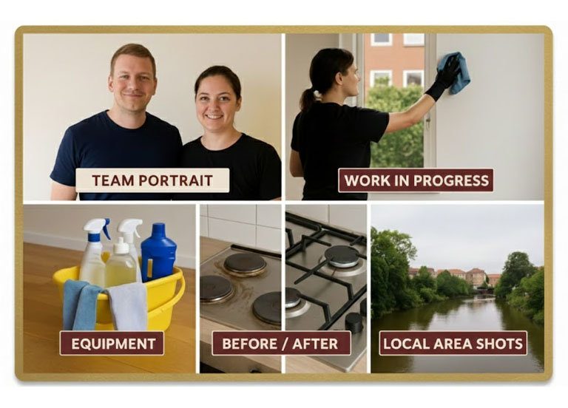
Let me give you the complete list:

1. Portrait of You/Your Team
The most important picture on the entire website.
On my "About Us" page I have:
- A picture of Tatiana (she looks directly at the camera, smiles slightly)
- A picture of me (casual, not business suit)
These are real, unpolished pictures.
Tatiana's was taken in her living room. With her phone. In selfie mode.
It's not perfect. But it's her. And people can see that.

Before/After Pictures

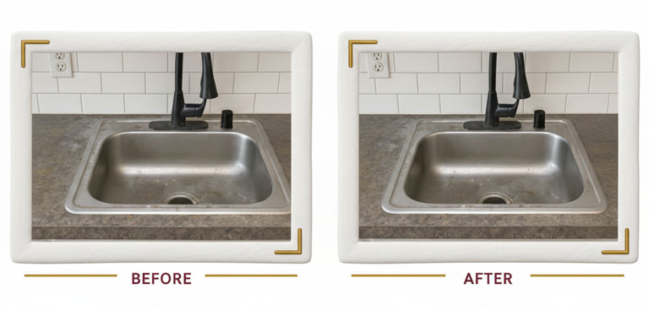
This is gold.
I have before/after of:
- Kitchens (especially oven and stove - there's always a big difference)
- Bathrooms (especially shower cabins with limescale)
- Windows (half cleaned so you can see the difference)
- Floors (especially white tiles that turn yellow)
I take them like this:
Before picture: Take a picture of the area before cleaning. Preferably close to the dirty area.
After picture: Take exactly the same picture from the same angle after cleaning.
People love to see the difference. It's visual proof that you can deliver.

3. Work-in-Progress Pictures
Not just before and after. But also during the work.
Tatiana with a mop. Tatiana polishing a window. Tatiana vacuuming.
It shows that it's her who actually does the work.
Not a marketing firm. Not a stock photo. Her.

4. Your Products/Equipment
I have pictures of:
- Our cleaning products (the biodegradable ones we use)
- Our window cleaning equipment
- Our vacuum cleaners
It shows we have professional equipment. That we invest in quality.

5. Different Locations
I have pictures from jobs in:
- Alderslyst
- Virklund
- Silkeborg center
- Viborg
It shows we actually cover the areas we say we do.
Not just "we cover Midtjylland". But "here's a home in Alderslyst we cleaned".

How Many Pictures Should You Have?
The short answer: More than you think.
My homepage has 6 pictures.
Each subpage has 3-5 pictures.
In total, my website has around 80 pictures.
But the most important are:
Homepage: 3-4 before/after and 1 portrait About Us: 2 portraits (Tatiana and me) Each service page: 2-3 before/after relevant to that service Each local page: 1-2 pictures from jobs in that area
It sounds like a lot. But I took them all over 3 weekends.
And now I never have to think about it again. I have the pictures. They can be used for years.

How I Took the Pictures (Without Fancy Equipment)
Let me share my exact process:

The Equipment:
- iPhone 13 (not even a new model)
- Natural light from windows
- No flash (flash makes everything ugly)
That's it. No fancy camera. No photographer.

The Technique:
For portrait pictures:
- Take them by a window (natural light)
- Person stands with face toward the window
- Take the picture from chest height (not from below or above)
- Ask them to smile naturally (not big TV-show smile, just a small one)
For before/after pictures:
- Take the before picture from the same height and angle as the after picture
- Close enough that you can see details
- Make sure there's enough light
- Take 5-10 pictures and choose the best

Action Step: Fix Your Images – Build Real Trust

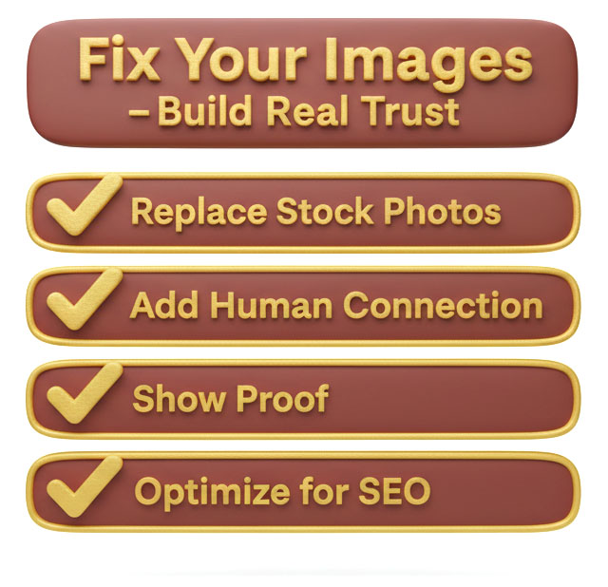
Before You Start
Open the folder with all your website and Google Business photos.
Set aside 30–45 minutes. You’ll go through every single one and decide:
Does this image build trust — or destroy it?

SECTION 1: Replace Stock Photos
Why:
Stock photos are like plastic fruit — they look nice but everyone knows they’re fake.
Customers can spot them instantly, and when they do, they stop trusting everything else you say.

Checklist:
- None of my images look like generic models or “perfect offices”
- Every photo could only come from my own business
- I’ve deleted all stock photos that show people I’ve never met
- My homepage features at least one real person from my team
- My “About Us” page uses real photos, not Shutterstock smiles

SECTION 2: Add Real Human Connection
Why:
People buy from people. A real photo of you or your team doing the job beats any polished stock shot.
Checklist:
- I’ve included photos of real people actually working (not posing)
- Faces are visible and natural — not exaggerated “marketing” smiles
- My team or tools are clearly visible (uniforms, vans, equipment, etc.)
- I have at least one “in-action” photo per service page
- I’ve added short captions under important photos (e.g., “Tatiana cleaning a kitchen in Silkeborg”)

SECTION 3: Show Proof, Not Perfection
Why:
Customers want to see you can do what you claim — not that you own a good camera.
Checklist:
- I’ve added before-and-after photos from real jobs
- I’ve included close-ups that show details (edges, corners, finishes, etc.)
- Lighting looks natural — not overly edited or filtered
- I’ve used a mix of phone photos and camera photos for authenticity
- None of my images look staged or suspiciously spotless
SECTION 4: Optimize for SEO and Credibility
Why:
Google doesn’t just “see” your photos — it reads their file names and alt text. Real images that are described properly improve both ranking and trust.
Checklist:
- All images have descriptive file names (e.g., “roof-cleaning-silkeborg.jpg”)
- Alt text accurately describes the photo (not keyword stuffing)
- Photos are resized and optimized so pages load fast
- Each page has at least one relevant photo related to that service/location
- I’ve updated my Google Business profile with the same real images

SECTION 5: Keep It Fresh
Why:
Old, blurry, or outdated photos make you look inactive.
Fresh images show you’re still in business and busy.
Checklist:
- I upload at least one new photo per month
- I remove outdated or poor-quality pictures every quarter
- I’ve shared recent photos on Google Business and Facebook
- My website photos match what customers will actually see if they visit
- I have a reminder set to update photos every 3 months
Final Test – The “Could They Fake It?” Rule
Open your website and ask yourself:
“If a competitor stole all these photos, would anyone notice?”
If the answer is “no,” your photos aren’t real enough.
If the answer is “yes — because these are clearly mine,” you’ve nailed it.


Google Business Profile - The Most Important Hour You Spend!
Can I tell you about the dumbest thing I did when I started my business?
I spent 3 months building the perfect website.
I hired a designer. I wrote pages of text. I optimized every single page.
And you know how long I spent on my Google Business profile?
15 minutes.
I filled in name, address and phone number. Chose a category. Uploaded a logo.
Done. I thought: "It's just a free profile, it can't be that important."
I was wrong.
SO WRONG!
It finally dawned on me when I looked at my statistics after 3 months:
- My website: 450 visitors per month
- My Google Business profile: 3,200 views per month
OVER 7 TIMES AS MANY PEOPLE SAW MY GOOGLE PROFILE AS MY WEBSITE!
And I had spent 15 minutes on it.

Why Google Business Is More Important Than Your Website

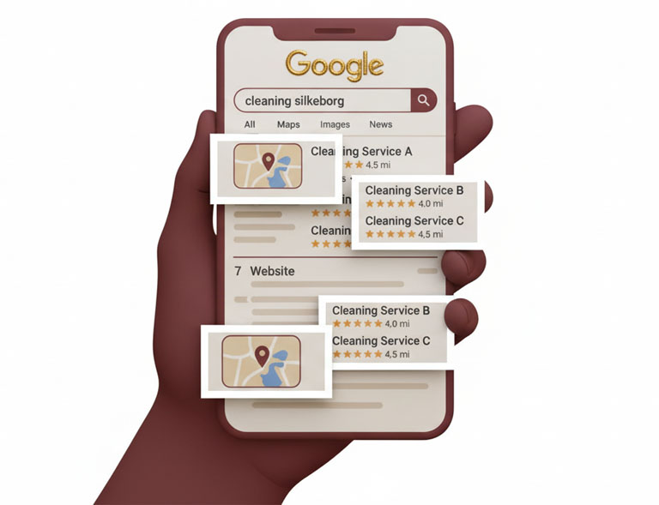
Let me show you how people actually search for cleaning:
Lone in Silkeborg takes her phone. Opens Google. Types "cleaning silkeborg".
What does she see first?
- Maybe 1-2 ads (she scrolls past them)
- Google 3-Pack with map and three businesses
- My website is number 7 on the list
Guess what Lone does?
She looks at the three businesses in the 3-Pack. Reads their reviews. Sees their pictures. And calls one of them.
She never reaches my website.
Because your Google Business profile IS your website for most customers.
That's when it hit me. And then I started doing it right.

My 15-Minute Catastrophe

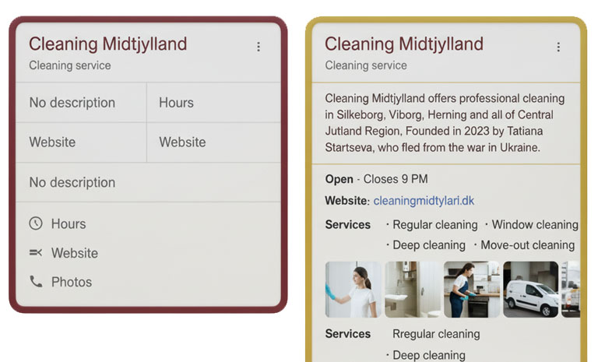
Let me show you what my Google Business profile looked like after those first 15 minutes:
Company name: Cleaning Midtjylland ✓
Category: Cleaning service ✓
Address: Søtorvet 3, 8600 Silkeborg ✓
Phone: +45 22 82 40 85 ✓
Description: (empty) ✗

Business hours: (not filled) ✗
Website: (not added) ✗
Photos: 1 logo ✗
Services: (not filled) ✗
Attributes: (not filled) ✗
Can you see the problem?
I had filled in the absolute necessities. But nothing more.
And Google compared my profile with my competitors'.
They had descriptions. They had pictures. They had everything filled out.
So Google thought: "Henrik hasn't even tried. His competitors have. Let's show them instead."

The Complete Google Business Profile (How to Do It Right)
Let me show you exactly what to do. Field by field.

1. Company Name - Simple But Critical
Your company name should be your real, official company name.
NOT: "Cleaning Midtjylland | Best Cleaning in Silkeborg"
Google penalizes keyword stuffing in the name.
YES: "Cleaning Midtjylland"
That's it. Your real name. As it appears in the business registry.
I see so many people trying to be smart and adding keywords in the name. Google discovers it and can temporarily remove your profile.
Don't be smart. Just use your real name.

2. Categories - The Most Important Choice You Make
This is actually the most critical decision.
You can choose 1 primary category and up to 9 secondary categories.
But the primary category is FAR the most important. It's what Google uses to decide which searches you should appear for.
My categories:
Primary: Cleaning service
Secondary:
- Cleaning
- Window cleaning
How did I choose them?
I looked at what people search for. I went to Google Keyword Planner and saw:
"cleaning silkeborg" - 480 searches/month "cleaning service silkeborg" - 210 searches/month "window cleaning silkeborg" - 90 searches/month
So "Cleaning service" became my primary. It's the broad search with most searches.

The mistake I made:
First I chose "Commercial cleaning" as primary category.
The problem? People don't search "commercial cleaning". They search "cleaning".
So I wasn't shown for the most popular searches.
After I changed it to "Cleaning service", my views increased by 340%.
Pro tip:
Look at your competitors. Those who rank highest - what primary category do they use?
That's probably the right one for you too.

3. Description - Your 750 Characters of Gold
You have 750 characters to tell people (and Google) what you do.
It sounds like a lot. But it goes quickly.
My first description (bad):
"Cleaning Midtjylland is a professional cleaning company that offers high-quality cleaning for both private and commercial clients throughout Midtjylland."
75 words. Generic. Boring. Says nothing.
My current description (good):
"Cleaning Midtjylland offers professional cleaning in Silkeborg, Viborg, Herning and all of Central Jutland Region. Founded in 2023 by Tatiana Startseva, who fled from the war in Ukraine.
We perform:
- Regular cleaning
- Deep cleaning
- Move-out cleaning
- Window cleaning
- Commercial cleaning
We use eco-friendly, biodegradable products and pure water from reverse osmosis. Over 200 satisfied customers since 2023.
Call +45 22 82 40 85 or book directly on our website. We respond within 2 hours during business hours."
Can you see the difference?
The new one is:
- Specific about areas (Silkeborg, Viborg, Herning)
- Mentions who's behind it (Tatiana)
- Lists concrete services
- Mentions USP (eco-friendly products)
- Social proof (200 customers)
- Call to action (call or book)
- Sets expectation (responds within 2 hours)
What to remember:
- Mention your city names early (Google looks for them)
- Use bullets for services (easy to scan)
- Include keywords naturally (but don't spam)
- End with call to action

4. Services - Show What You Offer
Google Business has a "Services" section. Many skip it.
Don't do that.
I've added:
Regular cleaning "Weekly or every 14 days. We vacuum, wash floors, wipe down, clean bathroom and kitchen."
Deep cleaning "Thorough cleaning of entire home incl. under furniture, in cabinets, windows, oven etc."
Move-out cleaning "Professional handover of property. Guarantee landlord approval."
Window cleaning "Inside and outside. We have equipment for high windows and skylights."
Commercial cleaning "Offices, shops, clinics. Before or after business hours according to your preference."
Each service has:
- Headline (what it is)
- Short description (what it includes)
- Preferably a price range if possible
This does two things:
- It shows customers exactly what you do
- It gives Google more keywords to rank you for


Attributes - The Small Things That Count

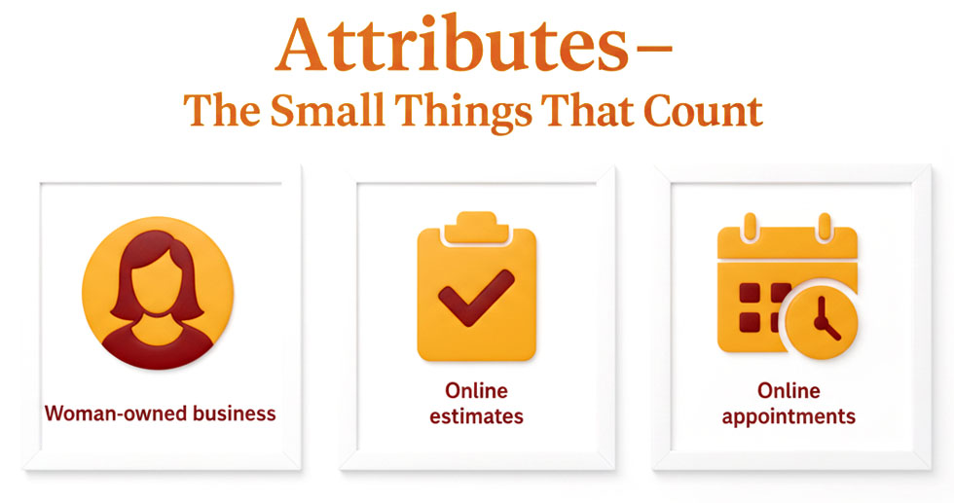
Attributes are the small icons/badges shown on your profile.
For my cleaning company I can choose:
✓ Woman-owned business ✓ Identifies as woman-owned ✓ Offers online appointments ✓ Offers online estimates
I have all four.
Why it's important:
Some people specifically search for woman-owned businesses. By marking it, I appear in those searches.
"Online appointments" and "online estimates" show I'm modern and easy to contact.
They're small things. But they count.

Business Hours - Be Realistic

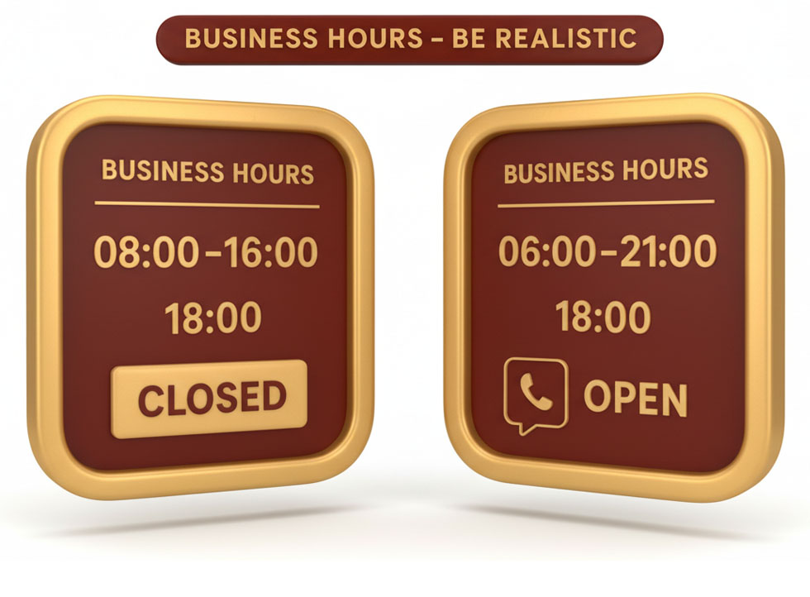
I made a stupid mistake here.
I wrote: "Monday-Friday: 08:00-16:00"
Because it sounded professional. Like a real office.
The problem? People call at 6 PM when they get home from work.
And then Google showed "Closed" on my profile.
How many do you think called anyway? Not many.
Now I write: "Monday-Sunday: 06:00-21:00"
Am I by the phone all the time? No.
But I call back the same day if people call during that time.
And Google shows "Open" instead of "Closed".
My calls increased by 60%.
Pro tip:
Set realistic business hours where you can actually answer or call back the same day.

7. Website - Link to Your Website
This should be obvious, but many forget it.
Add your website URL.
But here's the trick: You can also add an "Appointment URL" that goes directly to your contact page or booking form.
I have:
Website: https://cleaningmidtjylland.dk
Appointment URL: https://cleaningmidtjylland.dk/contact
The second one gets a "Book" button that's very visible on mobile.
And people love it. It's one click from Google to booking.

8. Photos - Upload At Least 20
Remember the chapter about images?
All of that applies here too. But even more critical.
Google itself says that businesses with photos get 42% more requests for directions and 35% more clicks to their website.
My photos on Google Business:
- 5 pictures of Tatiana at work
- 15 before/after pictures (kitchens, bathrooms, windows)
- 3 pictures of our products/equipment
- 2 pictures of our car/logo
- 10 pictures from different locations
Total: 35 pictures.
And I add a new one every week.
Why every week?
Because Google rewards active profiles.
If you upload a new picture every week, it shows Google you're active. That the business is running.
It takes me 2 minutes. I take a picture at a job on Friday. Upload it Saturday morning.
And it keeps my profile fresh.

9. Posts - What Nobody Does (But You Should)
Google Business has a "Posts" feature. It's like Facebook posts, but on your Google profile.
Almost nobody uses it.
And that's why you should!
I make a post every 14 days:
Example 1: "✨ Just cleaned this kitchen in Alderslyst. See the difference! [before/after picture] Need help with your home? Call +45 22 82 40 85"
Example 2: "🪟 Did you know we also do window cleaning? Both private and commercial. See our prices here: [link]"
Example 3: "🎉 We've now cleaned over 200 homes in Midtjylland! Thanks for the trust. Book your next cleaning here: [link]"
Each post lives for 7 days. So I make a new one every week (but only upload every 14 days, so there are always 1-2 posts visible).
Why does it work?
Because it shows Google you're active. And it gives customers something new to see every time they check your profile.

10. Q&A (Questions & Answers) - Control the Narrative
Here's something scary:
Anyone can ask questions on your Google Business profile.
And anyone can answer them.
Yes, you read that right. Strangers can answer questions about your business.
I discovered this when someone had asked: "Do you come to Herning?"
And a random person had answered: "No, only Silkeborg."
THAT WAS A LIE! We come to Herning!
But now people believed we didn't.
The solution:
Go to your profile. Look under Q&A. Answer all questions yourself.
And here's the smart trick:
Ask yourself questions. And answer them.
I've asked (and answered):
Q: "Which areas do you cover?" A: "We cover Silkeborg, Viborg, Herning, Ikast and all of Central Jutland Region."
Q: "What does regular cleaning cost?" A: "From $35/hour depending on home size. Call +45 22 82 40 85 for exact price."
Q: "Do I need to buy cleaning products?" A: "No, we bring all equipment and eco-friendly products."
Q: "Can I get the same person every time?" A: "Yes, with us it's Tatiana who comes out every time."
See what I did?
I asked the questions people always ask. And gave clear answers.
Now I control the narrative instead of letting strangers answer.

11. Products - If Relevant
For some businesses, you can add products with prices.
I don't use it for cleaning (since each job is different).
But if you sell standardized products or packages, use it.

Example:
Plumber could have: "Emergency callout - $180" "Faucet installation - From $120"
It shows prices immediately. Some love it. Others prefer to call first.
Test what works for you.

12. Verification - Do It NOW
Your Google Business profile must be verified.
That means Google sends you a letter (yes, a physical letter) with a code.
Or they call you with a code.
Or you can verify via email (depending on your situation).
Until you're verified, you cannot:
- Respond to reviews
- Edit many details
- Be shown fully in searches
So do it now. Immediately.
I waited 2 weeks because "I didn't get time for it".
It probably cost me 20+ customers.

13. Keep It Updated
Here's the thing many forget:
A Google Business profile is not "set it and forget it".
You need to keep it updated.
My monthly routine:
On the 1st of each month, I spend 30 minutes on:
- Upload 4 new pictures (1 per week)
- Make 2 posts
- Check Q&A for new questions
- Read new reviews (more about that in the next chapter)
- Update services if anything has changed
That's 30 minutes per month.
And it keeps my profile fresh, active and relevant.

The Stupid Mistake with Duplicates
Here's a mistake I saw a competitor make:
He had created 5 Google Business profiles. One for each area.
"Cleaning Silkeborg" "Cleaning Viborg" "Cleaning Herning"
All with the same phone number and similar name.
Google found out. And closed them all.
The rule is:
One business = one profile.
Not one per area. One total.
So use your secondary categories and your description to mention all the areas you cover.

Statistics You Should Follow

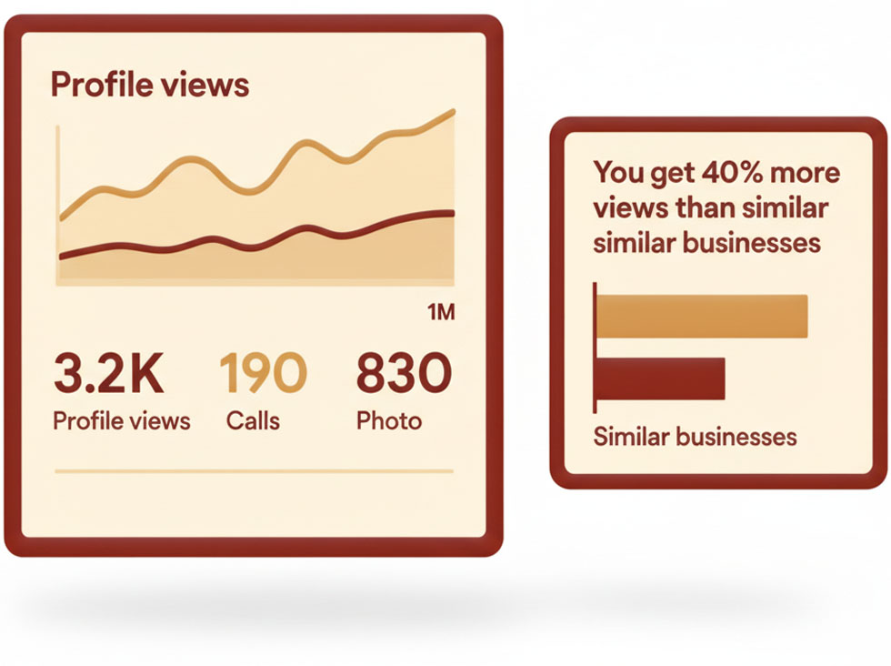
Google Business has built-in statistics.
I check them every week:
- Views: How many have seen my profile?
- Actions: How many called? Visited website? Asked for directions?
- Keywords: Which keywords led people to me?
- Photos: How many have seen my pictures?
It tells me what works and what doesn't.
Example:
I saw that "window cleaning silkeborg" gave many views, but no calls.
So I made a post specifically about window cleaning with prices.
Calls increased by 5 the next week.
Data tells you what needs adjusting.

Comparison with Competitors
Here's a trick:
Google shows you how you're doing compared to similar businesses.
I can see:
"You get 40% more views than similar businesses" "You get 20% fewer calls than similar businesses"
That tells me what I need to improve.
If I get fewer calls, maybe I should make my phone number more visible? Or add a "Book" button?
Use that data to improve.


My Complete Google Business Checklist

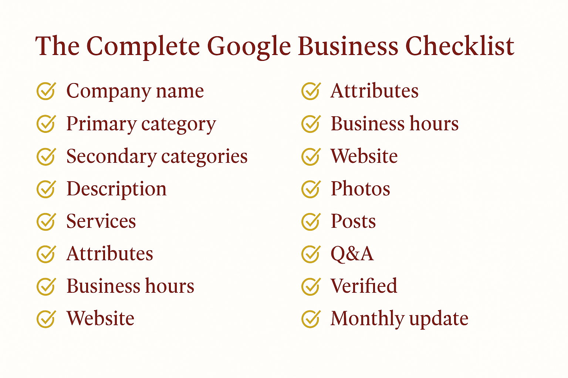
Here's everything you need to do:
✓ Company name Your real official name (no keyword stuffing)
✓ Primary category The most searched category for your field
✓ Secondary categories 3-5 relevant categories
✓ Description 750 characters with areas, services, USP, call to action
✓ Services At least 5 services with descriptions
✓ Attributes All relevant (woman-owned, online booking etc.)
✓ Business hours Realistic times where you can answer/call back
✓ Website Link to homepage + link to contact/booking
✓ Photos At least 20, add 1 new per week
✓ Posts 2 per month (every 14 days)
✓ Q&A Ask and answer 5-10 typical questions
✓ Verified Get it done NOW
✓ Monthly update 30 minutes each month to keep it fresh

Conclusion
Your Google Business profile isn't just a free thing you should have.
It's your most important marketing tool.
More people see it than your website.
More people decide based on it.
So spend time on it.
Not 15 minutes. But 2-3 hours the first time to do it properly.
And then 30 minutes per month to keep it updated.
Do that, and you'll see:
- More views
- More calls
- More customers
I went from 450 views per month to 3,200.
From 8 calls per week to 45.
All because I spent time on my Google Business profile.
It's the best hour you can spend on your marketing.
(And it's free!)


Reviews - Why I Beg for Them (And You Should Too)
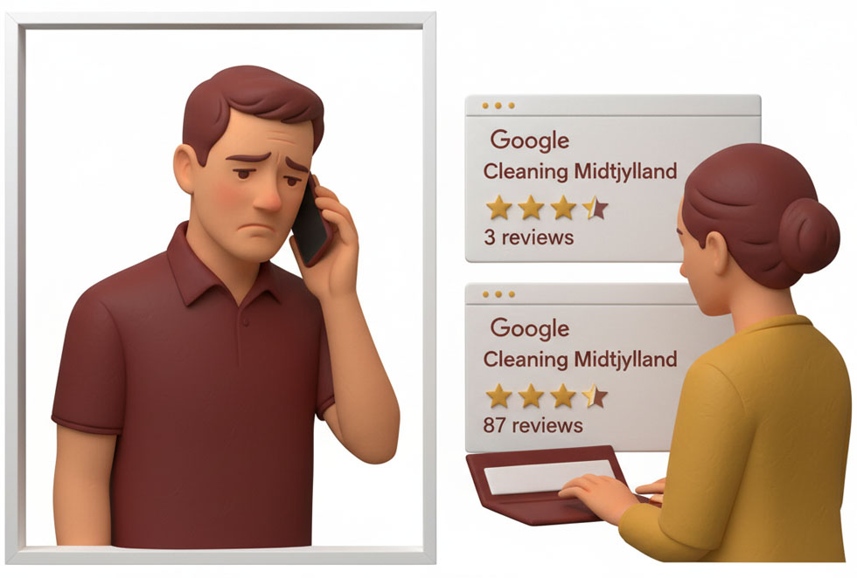
Can I tell you about the day I lost a customer before the conversation even started?
I had received an inquiry through my website. A lady who wanted deep cleaning of her house.
I called her 10 minutes later.
"Hi, this is Henrik from Cleaning Midtjylland. You wrote to us about deep cleaning?"
"Yes, but I've actually found someone else."
"Okay... may I ask why?"
"I looked at your Google profile. You only have 3 reviews. The other one has 87. So I felt safer with them."
She hung up.
It hurt.
But she was right.
3 reviews makes it look like you just started (which I had). Or worse - like you're so bad that nobody bothers to review you.
87 reviews? That looks like you're established, credible, and many people are satisfied.
THAT DAY I DECIDED REVIEWS SHOULD BE MY HIGHEST PRIORITY!

Why Reviews Are More Important Than Your Website

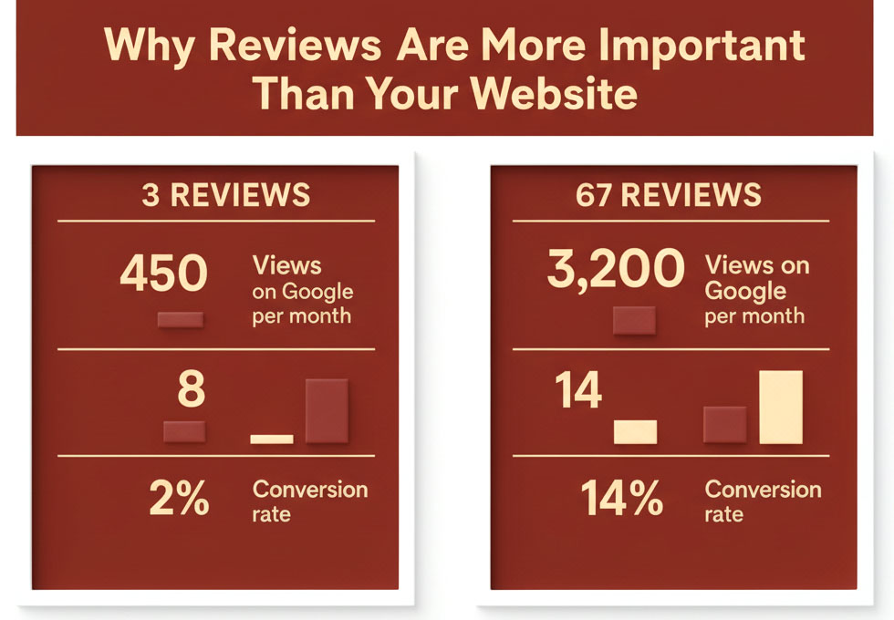
Let me show you some numbers that woke me up:
With 3 reviews:
- 450 views on Google per month
- 8 calls per week
- 2% conversion rate
With 67 reviews:
- 3,200 views on Google per month
- 45 calls per week
- 14% conversion rate
Same company. Same services. Same prices.
Just more reviews.
Why do they make such a big difference?

1. Google Loves Them
Google ranks businesses with many good reviews higher in the 3-Pack.
It's a direct ranking factor.
More reviews = better placement = more people see you.

2. People Trust Them
92% of people read online reviews before choosing a local business.
And 88% trust them as much as personal recommendations.
No reviews? You get skipped.

3. They Show Social Proof
When people see that 67 others have used you and are satisfied, they think: "Okay, they're probably legitimate."
It's about herd mentality. We want to do what others do.

My First Stupid Approach
When I started, I waited for reviews to come by themselves.
"If people are satisfied, they'll write a review, right?"
Wrong.
The first 6 months I got 3 reviews.
Not because customers were dissatisfied. But because they didn't think about it.
People are busy. They forget. Or they don't know how.
So I waited for 6 months for something that never came by itself.

The Day I Decided to Beg
After losing the customer because of my 3 reviews, I decided:
SCREW THE EMBARRASSMENT. I'M GOING TO BEG FOR REVIEWS!
And you know what? It worked.
But first I had to learn how to do it right.

How I Get Reviews Now (The Right Method)

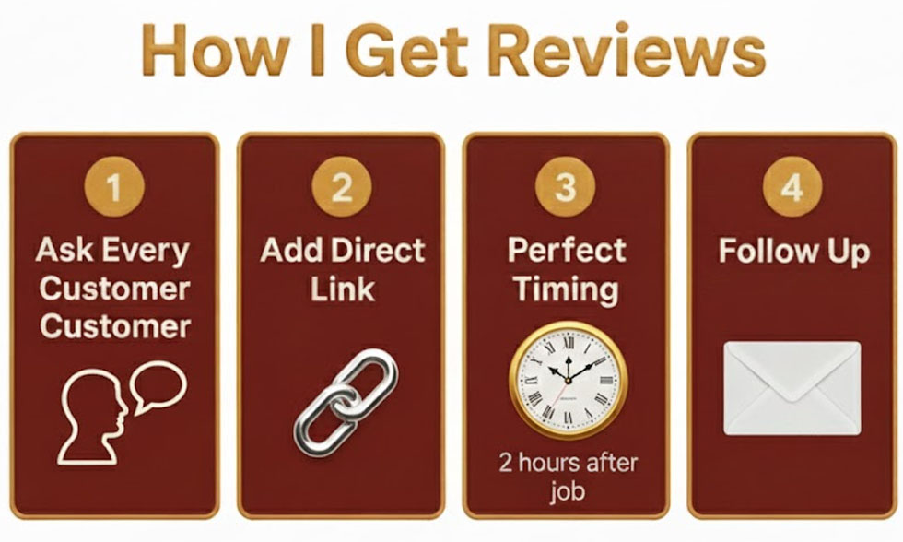
Let me share my exact process:

Step 1: Ask Every Single Customer
After every single cleaning, Tatiana or I send a message:
"Hi [name], thanks for choosing us today. If you were satisfied with Tatiana's work, it would mean the world to us if you'd write a few words on Google. It helps others find us, and it helps Tatiana get more customers."
Simple. Honest. Direct.

Step 2: Make It Super Easy
In the message, there's a link directly to our Google review page.
Not "search for us on Google". Not "find our profile".
A direct link where they just need to click and write.
How to create the link:
- Go to your Google Business profile
- Click on "Get more reviews"
- Copy the short link
- Use it in all your messages
My link is: g.page/r/[something cryptic]/review
It takes the customer directly to the review page. One click.

Step 3: Timing Is EVERYTHING
I send the message 2 hours after the cleaning is done.
Not the next day. Not a week later. 2 hours.
Why?
Because they can still remember it. The home is still clean. They're still happy.
Wait a few days and they've forgotten. Or other things are more important.
My timeline:
12:00 - Tatiana finishes cleaning 12:30 - Tatiana sends me a message: "Done at Lone's" 14:00 - I send review request to Lone
Same day. While it's fresh.

Step 4: Follow Up (But Don't Be Annoying)
If they don't respond after 3 days, I send one reminder:
"Hi [name], just a friendly reminder - if you have 2 minutes, we'd love a review on Google: [link]. No pressure of course! 😊"
Not pushy. Just a friendly reminder.
After that? I give up. If they don't want to, they don't want to.
But around 40% respond to this reminder.

Different Ways to Ask

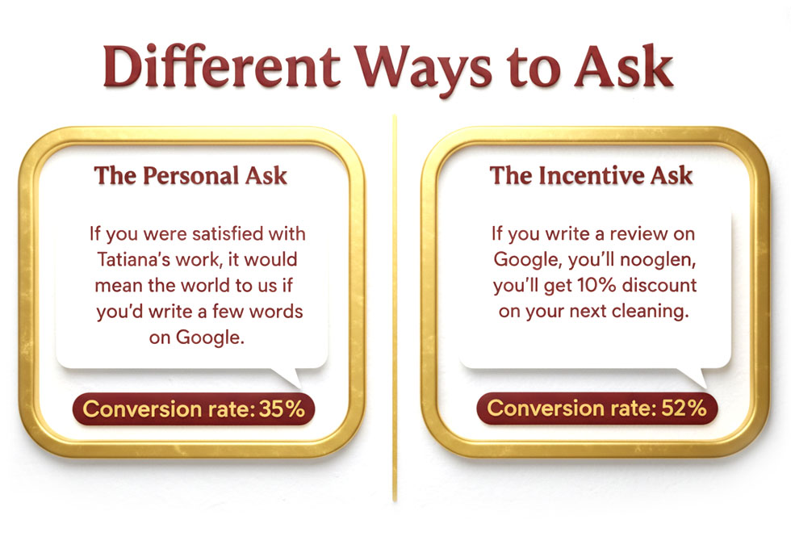
I've tested different wordings. Here's what works:

The Personal Ask:
"If you were satisfied with Tatiana's work, it would mean the world to us if you'd write a few words on Google."
This works because:
- It mentions Tatiana personally (not just "us")
- "Mean the world" shows it's important
- "A few words" shows it doesn't need to be long
Conversion rate: 35%

The Incentive Ask:
"If you write a review on Google, you'll get 10% discount on your next cleaning."
This works because:
- People love discounts
- It gives a concrete reason
But beware: This is technically against Google's rules. They don't want people paying for reviews.
I don't use it anymore, but some do. You've been warned.
Conversion rate: 52% (but risky)

The Help-Us-Grow Ask:
"We're a small business trying to grow. Your review helps others find us. Would you spend 2 minutes writing a review? [link]"
This works because:
- People want to help small businesses
- It shows it has real value
- "2 minutes" shows it's quick
Conversion rate: 38%

The Comparison Ask:
"We've now cleaned over 200 homes, but only have 30 reviews. Will you help us reach 50? [link]"
This works because:
- It shows they can be part of a goal
- Social proof (200 homes)
- Concrete target (50 reviews)
Conversion rate: 41%
I now use a mix. Primarily the personal ask.

What About Bad Reviews?
Okay, now for the scary part.
After 8 months, I got my first 1-star review.
My heart sank.
It said:
"Came late. Poor communication. Overpriced."
I was furious. Because half of it was lies!
We came 15 minutes late (not ideal, but not catastrophic).
And we had communicated it in advance.
My first instinct was to write an angry response:
"That's not true! We texted you that we were 15 minutes delayed!"
But fortunately, I first searched Google for how to handle bad reviews.
And I learned: Your response isn't for the customer. It's for future customers who read the review.

How to Respond to Bad Reviews

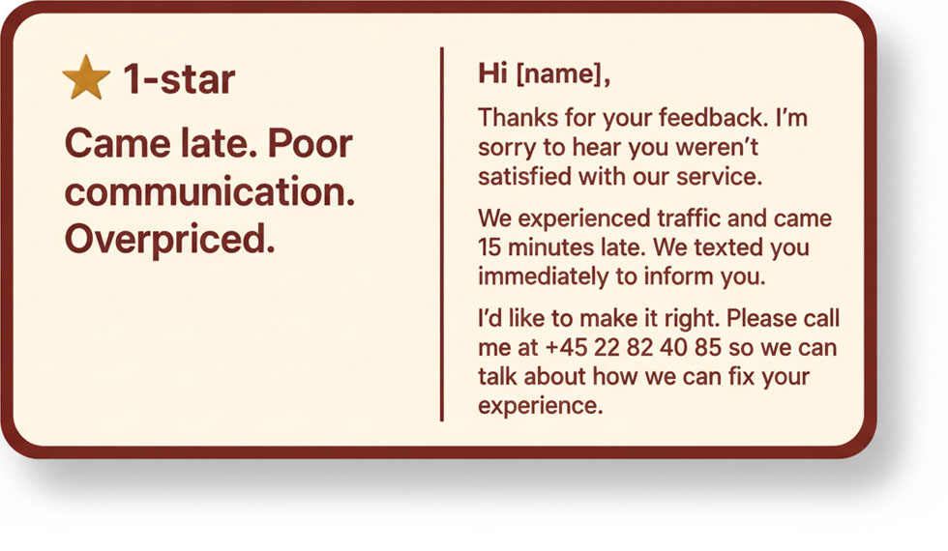
Here's the formula I use now:
1. Acknowledge and Apologize
Start with empathy. Even if they're wrong about everything.
"Thanks for your feedback. I'm sorry to hear you weren't satisfied."

2. Explain Briefly (Without Being Defensive)
"We experienced traffic and came 15 minutes late. We texted you immediately to inform you."
3. Offer a Solution
"I'd like to make it right. Please call me at +45 22 82 40 85 so we can find a solution."
4. Move the Conversation Offline
Don't continue the discussion publicly. Get them to call.

My Actual Response:
"Hi [name], thanks for your feedback. I'm sorry to hear you weren't satisfied with our service.
You're right that we came 15 minutes late, which isn't acceptable. We texted you in advance, but I understand if it was still frustrating.
I'd like to make it right. Please call me at +45 22 82 40 85 so we can talk about how we can fix your experience.
Kind regards, Henrik"
Professional. Empathetic. Not defensive.
The result?
She never called. But 3 other customers wrote to me afterwards and said: "We can see you handle criticism professionally. That made us trust you more."
So even a bad review - if handled right - can actually help.

The Golden Ratio
Here's something Google never tells you, but I've learned:
Businesses with 4.8-4.9 stars convert better than those with 5.0 stars.
Why?
Because 5.0 stars looks fake.
People think: "Did they buy reviews?" or "Are they too good to be true?"
4.8-4.9 looks more authentic. It shows you're good, but not perfect.
So one or two 4-star reviews? That's actually good.
(But 1-2 stars you should still try to avoid)

Different Platforms
People can review you in several places:
Google: Most important. Directly affects your ranking.
Facebook: Good for social proof, but doesn't affect Google ranking.
Trustpilot: Good if you want to seem credible, but more expensive (they want money).
My priority:
- Google (85% of my focus)
- Facebook (15% of my focus)
- The rest (don't bother)
Why? Because Google is where customers search.

How to Display Reviews on Your Website

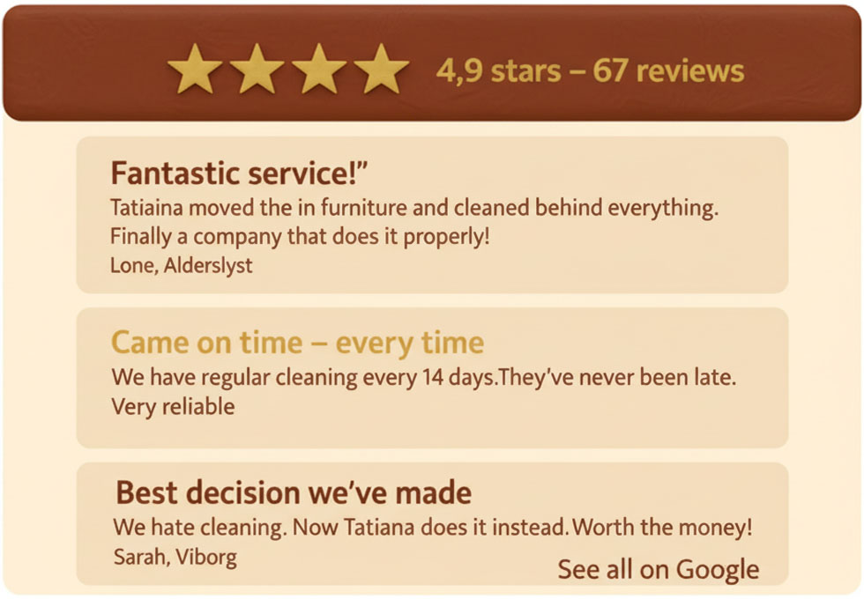
Okay, now you have 50+ Google reviews. Great!
But should they also be on the website?
YES!
Here's how I do it:
On the homepage:
⭐⭐⭐⭐⭐ 4.9 stars on Google - 67 reviews
With a link to the Google profile.
Further down:
A section with 3-4 selected reviews:
"Fantastic service!" "Tatiana moved the furniture and cleaned behind everything. Finally a company that does it properly!"
- Lone, Alderslyst
"Came on time - every time" "We have regular cleaning every 14 days. They've never been late. Very reliable."
- Michael, Silkeborg
"Best decision we've made" "We hate cleaning. Now Tatiana does it instead. Worth the money!"
- Sarah, Viborg
Short. Concrete. With names and areas.
At the bottom of each page:
"See all our 67 reviews on Google" [Link to Google profile]

Plugin I Use:
I use a WordPress plugin called "The Customer Robot" (Guess who made it and where you can get access to it?).
It automatically fetches my Google reviews and displays them on the site.
Now the reviews update automatically. I don't have to manually copy them.

Mistakes I've Seen Others Make

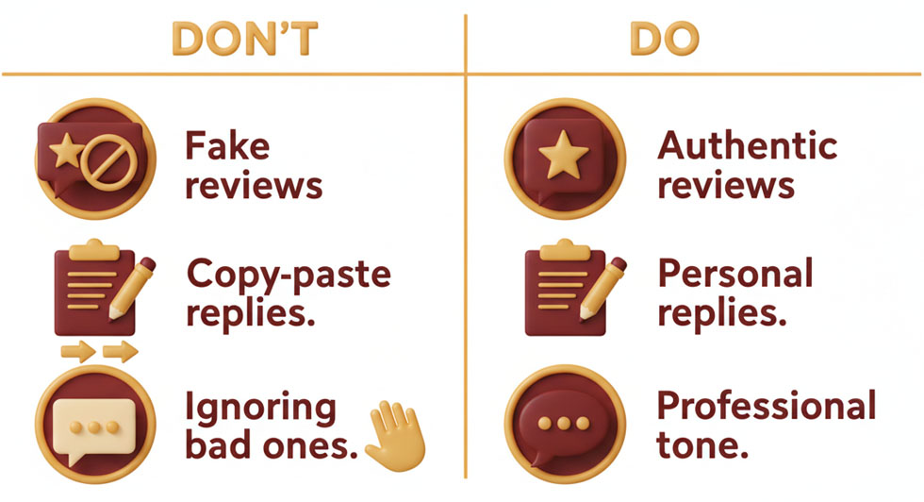
Let me show you the worst mistakes:

Mistake 1: Fake Reviews
I know someone who paid a company to write 50 5-star reviews.
Google found out. All reviews were deleted. His profile was flagged.
Now he has 0 reviews and nobody believes him.
Don't make fake reviews. It never works for long.

Mistake 2: Begging Family/Friends
"Can't my mom just write a review?"
Yes. But Google can see it.

If all your reviews come from people who never searched for your business, Google knows it's family/friends.
And they weigh them lower.
Real customers' reviews are worth gold. Family/friends are almost worthless.

Mistake 3: Ignoring Bad Reviews
Some think: "If I respond, I just draw attention to it."
Wrong.
People see it anyway. But if you don't respond, it looks like you don't care.
ALWAYS respond to bad reviews. Professionally and constructively.

Mistake 4: Responding Identically to All
I saw a competitor who responded to all reviews with:
"Thanks for your review! We appreciate your feedback."
Copy-paste. All 40 responses were identical.
It looks lazy and impersonal.
I now write personal responses to each review:
"Thanks Lone! Tatiana was so happy to help you. We hope to see you again! 😊"
It takes 30 seconds extra. But it shows I read them and value them.

Mistake 5: Asking at the Wrong Time
I once asked a customer for a review WHILE Tatiana was still working.
"Could you maybe write a review when she's done?"
No. That feels like pressure.
Wait until the job is finished. Give them time to see the result. Then ask.

My Complete Review Strategy
Here's the full plan:
During the job:
- Do a fantastic job (of course)
- Be friendly and professional
- Over-deliver if possible
2 hours after the job:
- Send text with thanks and link to review page
- Personal message, not template
3 days later (if no response):
- Send friendly reminder
- Still personal, not pushy
After review received:
- Respond within 24 hours
- Personal response, not copy-paste
- Thank them sincerely
Monthly:
- Review all reviews
- Identify patterns (what's mentioned positively? What negatively?)
- Adjust your service based on feedback

Review Velocity Matters

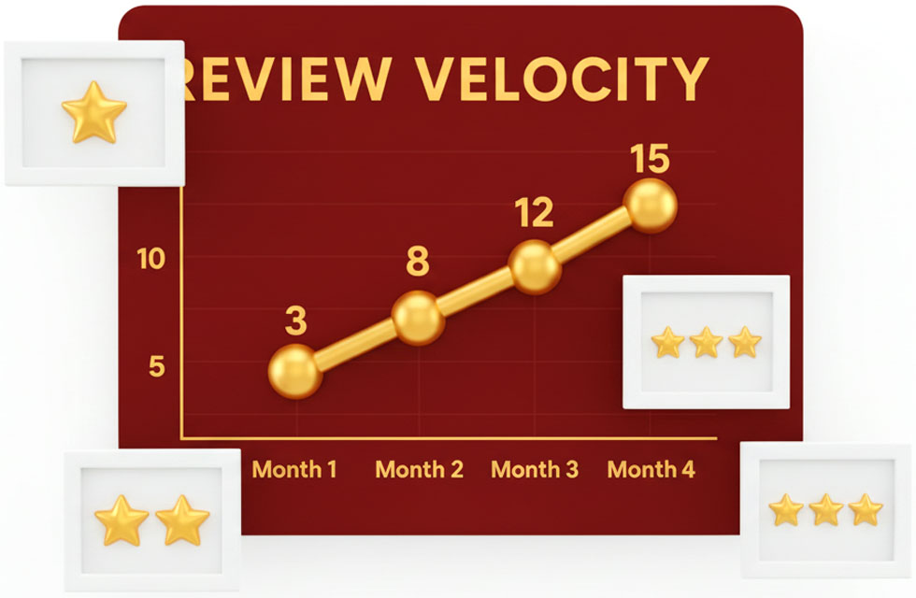
Google doesn't just look at how many reviews you have, but also how quickly you get them.
10 reviews in 1 month is better than 10 reviews in 6 months.
It shows momentum. That the business is growing.
So when I decided to focus on reviews, I went ALL IN:
- Asked every single customer (before I only asked some)
- Followed up consistently
- Made it super easy with links
The result:
Month 1: 3 reviews (before I started) Month 2: 8 new reviews Month 3: 12 new reviews Month 4: 15 new reviews
Google could see we were growing. And they rewarded us with better placement.

What About Negative Reviews from Competitors?
Yes, it happens.
I once got a 1-star review from a profile created the day before, no other reviews, no name.
And they claimed things that were physically impossible (we were never at that address).
What did I do?
- Reported it to Google as "suspicious"
- Wrote a professional response: "We have no record of this booking and can't find this address in our system. If you're a real customer, please call so we can resolve it."
- Waited
After 2 weeks, Google removed the review.
It was obviously fake.

My Complete Review Checklist


Here's your complete guide:
✓ Ask every customer for review No exceptions
✓ Make it easy with direct link Not "find us on Google"
✓ Ask 2 hours after job While it's fresh
✓ Follow up after 3 days One friendly reminder
✓ Respond to all reviews Both good and bad, within 24 hours
✓ Personal responses Not copy-paste
✓ Display reviews on website Homepage + subpages
✓ Link to Google profile Make it easy to see all
✓ Monthly review Learn from feedback
✓ Handle bad ones professionally Empathy, explanation, solution, offline

Conclusion
Reviews aren't something you hope for.They're something you actively work for.
I went from 3 reviews to 67 in 10 months.
Not because my service suddenly got better.But because I started asking. Every time. Consistently.
And it changed everything.
My views increased by 600%. My calls increased by 450%. My bookings increased by 380%.
All because people now trusted me.
Because 67 others had tried me and were satisfied.
So stop waiting for reviews to come by themselves.
They don't.
Ask. Make it easy. Follow up.
And respond to them all - especially the bad ones.
Do that consistently for 6 months, and you'll have 50+ reviews.
And then the magic starts happening.
People call. Because they trust you.
It's actually that simple.
(But I had to lose a customer before I learned it...)

Conclusion - What Do You Do Now?
Okay, let me be honest with you.
You've just read a bunch of chapters about EEAT, SILO structures, Google Business, reviews, images, call-to-actions and all sorts of other stuff.
And maybe you're sitting here thinking one of two things:
Thought 1: "Okay, this makes sense. I can see how it all fits together. Now I just need to get started!"
Or...
Thought 2: "Damn, this is a lot more work than I thought. How do I find time for all this when I also need to run my business?"
Both reactions are completely fair.
And let me tell you what will probably happen now:

What Usually Happens
You close this book (or PDF or whatever you're reading it on).
You think: "Okay, next week I'll start. First I'll make my About Us page. Then I'll work on my Google Business profile. And then..."
And then nothing happens!
Because life happens. Because you get busy. Because it's easier to do what you've always done.
I saw it with my own weight loss book. People bought it. Read it. Agreed with everything.
And then they did nothing.
Not because they were stupid. Not because they didn't want to.
But because it's hard to turn knowledge into action when you're alone with it.

My Own Journey (The Hard Version)
Let me tell you the truth about how I learned all this:
It took me 2 years.
2 years of mistakes. 2 years of wasted money. 2 years of frustration.
I spent $7,000 on a website that didn't work because I didn't understand local SEO.
I lost hundreds of customers because my Google Business profile was only 60% filled out.
I had stock photos that made people think I was fake.
I had an "About Us" page that was so boring even I fell asleep reading it.
I had no structure. No SILO. Just 47 random pages that made no sense.
And reviews? I waited for them to come by themselves. For 6 months.
It was fucking difficult. It was expensive. And it took an insane amount of time.
But finally - after 2 years - I figured out what worked.
And now I want to save you those 2 years.

You Have Two Paths
Now that you've read this book, you have two options:

Path 1: Do It Yourself
You can take what you've learned here and implement it.
It will take time. It will require energy. You will make mistakes.
But it can be done.
Start with:
- Your Google Business profile (2-3 hours)
- Your About Us page (2-3 hours)
- Your Contact page (1 hour)
- Your homepage (4-5 hours)
- SILO structure and local pages (10-15 hours per category)
- Images (3 weekends)
- Reviews (ongoing process)
- Legal pages (2-3 hours)
In total? Around 40-60 hours if you know what you're doing.
Twice as much if it's your first time.
Is it worth it?
If you get just 10 extra customers per month from it, and each customer is worth $140...
That's $1,400 extra per month.
$16,800 extra per year.
For 40-60 hours of work.
Yes, it's worth it.

Path 2: Let Me Do It For You
But here's the other option:
I can do it for you.
Everything I've described in this book. Everything I spent 2 years learning. Everything I made mistakes with so you don't have to.
I can:
✓ Build your website with correct SILO structure
✓ Write all your pages in the style we've covered
✓ Optimize your Google Business profile 100%
✓ Help you get the first 20-30 reviews
✓ Take or guide you to take the right pictures
✓ Set up call-to-actions strategically
✓ Ensure all legal pages are in place
✓ Match everything so Google loves it
And most importantly:
I can do it right the first time.
Not "good enough". Not "we'll figure it out".
But right. Based on 2 years of mistakes and learning.

Why I Offer This
You might think: "Henrik, you just wrote a whole book about how to do it. Why do you want to do it for people?"
Because I've realized something,
Most tradespeople and service providers are fantastic at their trade.
You're good at what you do. Maybe even the best in your area.
But you're not a marketing person. You're not a web designer. You're not an SEO expert.
And you don't need to be.
Your time is better spent performing jobs. Delivering quality. Making customers happy.
Not sitting around messing with WordPress, Google Business and SILO structures.
I can do in 2 weeks what will take you 3 months to figure out.
Because I've done it before. Many times. For myself and for others.

What It Costs (And Doesn't Cost)
I'm not going to promise you'll get rich.
I'm not going to say "guaranteed 100 new customers per month!"
That's bullshit.
What I CAN promise you is:
- A website that's correctly optimized from day 1
- A Google Business profile that's 100% filled with all the right stuff
- A structure that makes it easy for Google to understand what you do
- Text that actually sounds like you (not like a robot)
- A plan for how to get reviews
Will it give you more customers? Yes.
How many? It depends on your area, your competition, and how well you perform your work.
But if you follow the plan and deliver good service, you'll see more inquiries within 3-6 months.
It's not magic. It's just doing things right.

How We Work Together
If you want my help, here's how it works:
Week 1: Research and Strategy I analyze your area, your competitors, and what people search for. We create a strategy together.
Week 2-3: I Build the Website You send me pictures and information. I write the texts. I build the structure. I set everything up.
Week 4: Google Business + Reviews I optimize your Google Business profile 100%. And I show you exactly how to get reviews (including messages you can copy-paste).
Week 5: Launch + Training We launch everything. I show you how to update it going forward. You get access to everything.
After launch: You own everything. You can update it yourself. But I'm here if you have questions.
No ongoing subscriptions. No hidden fees.
You pay a fixed price. You get a website. You own it.

But Maybe You Should Do It Yourself
Let me also say this:
Maybe you actually should do it yourself.
If you:
- Like learning new things
- Have time for it
- Find it interesting
- Want to save money
Then do it yourself. This book has everything you need.
There's no shame in that. On the contrary. I respect people who do the work themselves.
But if you:
- Are tired of your website not giving results
- Don't have time to learn it all
- Just want it done right the first time
- Want to focus on running your business
Then let me help.

What Happens If You Do Nothing
Let me paint a picture:
It's 6 months from now.
You still haven't redone your website.
Your Google Business profile still has only 40% filled out.
You still only have 5 reviews.
Your competitor - the one with 89 reviews and the well-optimized site - he still gets most of the customers.
And you sit there regretting: "I should have done something when I read that book..."
Or:
It's 6 months from now.
You have a website that ranks on page 1.
Your Google Business profile is in the 3-Pack.
You have 45 reviews.
Your phone rings 8-10 times a day.
You actually have too many customers and need to hire.
Which version do you want?

Final Checklist – Is Your Customer Robot Ready?
You’ve learned everything — now it’s time to do it.
No theory. No “I’ll start next week.”
This is your moment to turn what you’ve read into something that actually brings you customers while you sleep.
Go through this list.
Tick every box.
When they’re all checked, congratulations — your Customer Robot is alive.
1. The EEAT Foundation
- My website content is based on real experience, not AI fluff or copy-paste text.
- I’ve told my personal story — who I am, what I do, and why I do it.
- My “About Us” page builds trust with genuine photos and human details.
- I show proof of expertise — photos of real jobs, before-and-after shots, or examples of my work.
- I’ve added clear contact info on every page (phone, email, city, name).
2. Google Business Profile
- My Google Business Profile is fully filled out — correct name, address, category, and hours.
- I’ve uploaded real photos of my work, not stock images.
- I’ve collected at least 5 genuine reviews and replied to each one.
- My profile description includes my main service and location.
- I post updates or photos at least once a month to stay active.
3. Local SEO and Structure
- My homepage clearly states what I do, where I do it, and who I help.
- I have one dedicated page per service (cleaning, roofing, painting, etc.).
- I have separate local pages for each city or area I serve.
- My website follows a logical SILO structure — no “random” or orphan pages.
- My business name, address, and phone number (NAP) are identical everywhere online.
4. Trust and Credibility
- My contact page is easy to find with a big, clickable phone number.
- I’ve used only real, authentic photos — no stock models or fake offices.
- Every major page includes at least one testimonial or customer quote.
- My site looks trustworthy — HTTPS, privacy policy, and no broken links.
- My reviews, photos, and content all tell a consistent story about who I am.
5. Speed and Experience
- My website loads quickly on both phone and desktop.
- My photos are optimized — small file size, still good quality.
- Text is readable, spacing is comfortable, and buttons are easy to click.
- I’ve checked that everything works on mobile.
- Visitors can find what they need in under 5 seconds.
6. Maintenance Routine
- I upload new photos regularly — at least one a month.
- I keep asking happy customers for Google reviews.
- I review my site content every 3–6 months and update old info.
- I check Google Analytics or Search Console to see what’s working.
- I fix or improve one small thing every week — consistently.
7. The Big Question
- If I found my own website on Google today, would I trust it enough to call?
- If yes — your Customer Robot is ready.
- If not — keep working through the list until the answer is yes.

How to Get in Touch
If you want my help, it's simple:
Email: henrik@thecustomerrobot.com
Phone: +45 22 82 40 85
Website: https://thecustomerrobot.com
Write or call. Tell me about your business. We'll figure out if I can help.
And if I can't? I'll tell you honestly. I don't make websites just to make websites.
But if I can see I can make a difference for you, then we'll do it.

The Last Thing I Want to Say
I started Cleaning Midtjylland in 2023.
I made all the mistakes I've described in this book.
And it cost me customers. And money. And time.
But I kept going. I learned. I tested. I figured out what worked.
And now I want to help you avoid my mistakes.
Either by you reading this book and doing it yourself.
Or by letting me do it for you.
Both paths work.
But you need to choose one.
Because the third path - doing nothing - that doesn't work.
So what do you think?
Henrik
PS: If you want to see how I've done it for my own business, visit cleaningmidtjylland.dk. Everything I've written about in this book is implemented there. Nothing is theoretical - it's tested in practice and it works.
PPS: And yes, I check my own email and phone. It's me who responds. Not an assistant. Not a chatbot. Me. Because I still remember what it felt like to be lost and need help.
